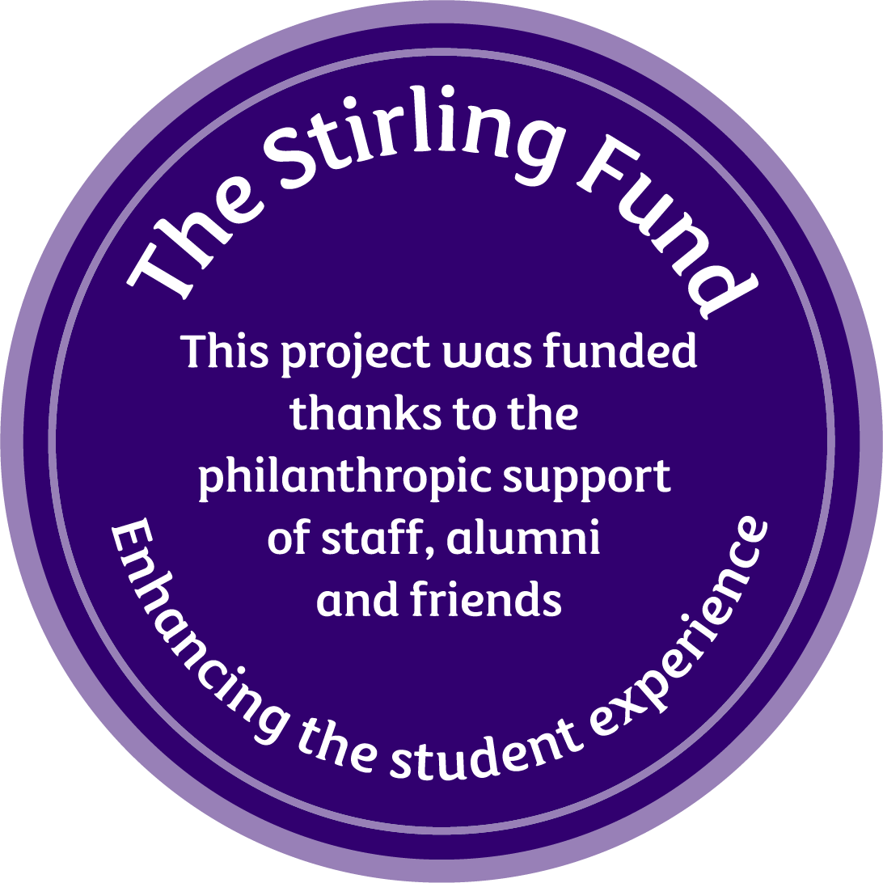

**Data protection**  
By completing the form below you are consenting to us processing your personal information for these purposes; if you are not content with this, please do not proceed. Your data will be stored securely and will only be accessible to relevant staff in the Development and Alumni Relations Department and members of the selection panel. You can read our Privacy Statement at <https://www.stir.ac.uk/alumni/about-us/dataprotectionstatement/>

|  |  |
| --- | --- |
| **PROJECT TITLE** |  |
| Amount being applied for £ |  |
| Your name |  |
| Faculty, Department, Club or Society |  |
| Your position in above |  |
| Phone |  |
| Email |  |
| If you are a **student** of the University (year, subject) |  |
| If you are a **member of staff** your faculty/department/  directorate |  |
| Has this project received support from the Stirling Fund or Vice-Chancellor’s Fund in the past? **Yes No**  ***If your answer is 'Yes', please provide the project name, year of application, and brief overview of the project*** |  |

Please give a full description of the project, outlining key objectives and highlighting how the project would enhance the student experience at the University of Stirling (max 500 words).

|  |
| --- |
|  |

How many students are you expecting to benefit from this project?

|  |
| --- |
|  |

Is your project targeting a particular group or category of students (international students, LGBT+, minorities, etc..)? If yes, please describe how. (max 100 words)

|  |
| --- |
|  |

Please provide a budget with estimated costs, showing how you would use a grant from the Stirling Fund. Please also include if other funding has been secured or if you have applied for additional funding. Should you be successful, you will be asked to provide a detailed report on expenditure following the completion of the project.

|  |  |  |  |  |  |  |  |  |  |  |  |  |  |  |  |  |  |  |
| --- | --- | --- | --- | --- | --- | --- | --- | --- | --- | --- | --- | --- | --- | --- | --- | --- | --- | --- |
| |  |  |  | | --- | --- | --- | |  |  |  | |  |  |  | |  |  |  | |  |  |  | |  |  |  | | **Total** |  |  |   **The Stirling Fund Budget** |

**CONDITIONS OF THE AWARD**

These grants are intended to enhance and enrich the student experience, and these are stories that we need to share with our donors, staff, friends, and supporters of the University of Stirling. A condition of accepting this grant is that Project Managers must provide written feedback and photos regarding the success of the project for future marketing purposes. This should be sent to [philanthropy@stir.ac.uk](mailto:philanthropy@stir.ac.uk). The project must be promoted through the use of the Stirling Fund icons, which will be provided to successful projects. The Development and Alumni Relations Team will request a progress report at regular intervals.

**REFERENCES**

**Ensure that your references align with your project's goals.** If your project involves resources from a different department, such as estates or sports, remember to obtain a reference from that department. This will enable them to understand your project's requirements and provide appropriate assistance.

**Students’ Union projects**: If the project is student-led and part of the Students’ Union, your referee should be the Activities and Volunteer Coordinator, the Sports Development Coordinator, the VP Communities, or the Sports President.

* If you are applying as part of a club, society, or sports team, it is strongly recommended that you discuss your application with the Activities and Volunteer Coordinator or Sports Development Coordinator before submission.

**Academic projects**: Student projects with an academic focus must provide a reference from the relevant faculty. For example, a psychology project requires a referee from the Psychology Department.

**Authority to sign off**: All projects must be signed off by a member of university staff (academic or professional) who has the authority to approve your project.

* **Your project must have faculty or staff approval to proceed, and any additional funding must be formally signed off by the relevant faculty.**
* **Their approval confirms that the university is aware of your proposal, that it is authorised to proceed, and that any financial impact is either not applicable or covered by an existing departmental budget.**
* Referees should be aware that DAR will contact them directly.

**Cross-departmental projects**: If your project requires resources from another part of the university, such as Estates or Sport, you must obtain a referee from that department to confirm feasibility and support.

* Referees cannot be committee members, peers, or friends. Previous employers may only act as referees where directly relevant to the project.

|  |  |
| --- | --- |
| Reference One | Reference Two |
| Name: | Name : |
| Position: | Position : |
| Address: | Address: |
| Phone : | Phone : |
| Email : | Email : |
| Referee Signature: | Referee Signature: |

**APPLICATION CHECKLIST**  
Before submitting your application, ensure the following criteria are met by ticking the boxes:

|  |  |
| --- | --- |
| ☐ | The project benefits the student experience at the University of Stirling |
| ☐ | The project has been approved by the necessary departments/faculties and does not provide facilities or undertake work which would reasonably be considered the responsibility of a faculty or other University service, or of a Club or Society. |
| ☐ | The project has been signed by two referees, both of whom are members of staff of the University. |
| ☐ | The application is thought through, with a clear plan to incorporate the Vice-Chancellor’s Fund's objectives and offer positive publicity for the Fund and the University. |
| ☐ | The budget is accurate and adds up correctly. |
| ☐ | The project timeline is realistic, and any urgent needs have been highlighted. |
| ☐ | You agree to provide a written report and photos after the project’s completion for marketing/fundraising purposes. |
| ☐ | All fields have been completed. |

*Please review this checklist and ensure each item is checked before submitting your application.*

**USEFUL CONTACTS**

**STIRLING STUDENTS’ UNION**

Union President ([president.union@stir.ac.uk](mailto:president.union@stir.ac.uk))

VP Communities ([communities.union@stir.ac.uk](mailto:communities.union@stir.ac.uk))

VP Education ([education.union@stir.ac.uk](mailto:education.union@stir.ac.uk))

Sports President ([sports.union@stir.ac.uk](mailto:sports.union@stir.ac.uk))

**ESTATES AND CAMPUS SERVICES**

[ECSAdmin@stir.ac.uk](mailto:ECSAdmin@stir.ac.uk)

**Please see the** [***Stirling Fund’s***](https://www.stir.ac.uk/about/our-people/alumni/support-stirling/the-stirling-fund/apply-to-the-stirling-fund/) **webpage for closing date**

**Please ensure you rename your finalised application document to the title of your project.**

Once ready, please email your completed application(s) to [philanthropy@stir.ac.uk](mailto:philanthropy@stir.ac.uk).

**THANK YOU FOR YOUR APPLICATION**