Athena Swan Silver application form for Universities

# Applicant information

|  |  |
| --- | --- |
| Name of university | University of Stirling |
| Date of current application | April 2024 |
| Level of previous award | Bronze |
| Date of previous award | 28th April 2017 |
| Contact name | Justine Dashwood |
| Contact email | Justine.dashwood@stir.ac.uk |
| Contact telephone | n/a |

|  |  |
| --- | --- |
| **Section** | **Words used** |
| An overview of the university and its approach to gender equality | 2,498/2500 |
| An evaluation of the university’s progress and success | 1,760/2000 |
| An assessment of the university’s gender equality context | 3,740/3500 |
| Future action plan* |  |
| Appendix 1: Culture survey data* |  |
| Appendix 2: Data tables* |  |
| Appendix 3: Glossary* |  |
| **Overall word count** | 7,998/8000 |

*These sections and appendices should not contain any commentary contributing to the overall word limit

**Overall word limit: 8000 words**

Applicant information 1

Section 1: An overview of the university and its approach to gender equality 2

1. Letter of endorsement from the head of the university 3

2. Description of the University and its context 5

3. Governance and recognition of equality, diversity and inclusion work 11

4. Development, evaluation and effectiveness of institutional policies 13

5. Athena Swan self-assessment process 15

Section 2: An evaluation of the university’s progress and success 17

1. Evaluating progress against the previous action plan 18

2. Evaluating success against the university’s key priorities 20

Section 3: An assessment of the University’s gender equality context 22

6. Culture, inclusion and belonging 23

1.1 Representation 23

1.2 Academic Staff 23

1.3 Professional, technical and operational staff 24

1.4 Recruitment, Pay and Progression 24

1.5 Research Culture 27

1.6 Student Experience 27

1.7 Improving our evidence base 30

2.Key priorities for future action 30

Section 4: Future action plan 30

7. Action plan 31

Annex 1 – Stirling’s 2016/17 Action Plan 56

Appendix 3: Glossary 72

Transformed Athena Swan Charter Application Feedback 73

Conditions Request and Response 78

# Section 1: An overview of the university and its approach to gender equality

## Letter of endorsement from the head of the university

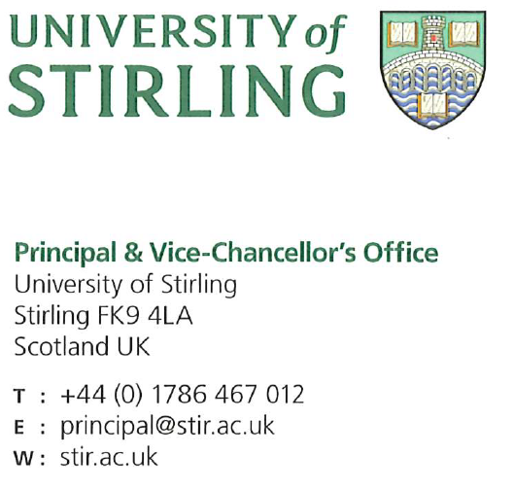

27 March 2024

Advance HE Equality Charters Team

Dear Dr. Gilligan,

At Stirling we value ability, not background. We are a place where people transform both their lives and the lives of others. Inclusion is key to this vision; our rapid progress on EDI has been achieved through our people and their commitment, and I am incredibly proud of this.

In the time since our last award, the University has significantly advanced. In terms of gender equality, this submission highlights our many successes, from our sector-leading approach to [gender-based violence](https://www.stir.ac.uk/student-life/support-wellbeing/student-support-services/sexual-violence/gender-based-violence/), to our [Agile Working Framework](https://www.stir.ac.uk/about/professional-services/human-resources-and-organisation-development/working-at-stirling/agile-working-at-stirling/) and [gender-balanced leadership](https://www.stir.ac.uk/about/our-people/senior-officers/). Investment in our academic staff has increased by 5% since 2022 and representation of women has also increased, growing our pool of female academic leaders by 5.2% between 2018-2024. Forty-four percent of our Professors are now female, 60% of our executive team are women, and our gender pay gap has also narrowed by an impressive 4.8% in the past three years alone.

Our commitment is not restricted to gender and takes an increasingly intersectional approach. Our strategic approach to [anti-racism, race equality and interculturalism](https://www.stir.ac.uk/about/professional-services/student-academic-and-corporate-services/policy-and-planning/equality-diversity-and-inclusion/anti-racism-race-equality-and-interculturalism/) has demonstrably contributed to student experience; I am delighted to see that Black, Asian or Minority Ethnic students have been more likely to continue past their first year of study, in comparison with the overall non-continuation rate, since 2017-18.

Similarly, our strong support for disabled students has led this population to be more likely to continue past their first year of study, and the proportion of disabled students attaining good degrees has also increased. This inclusive approach continues as students move into employment. The University of Stirling’s Enterprise Programme is enhancing engagement with entrepreneurship, illustrating how diversity drives innovation through the [See it, Be it](https://seeitbeit.stir.ac.uk/) pilot, and the University’s Careers and Employability Service recently achieved a prestigious Silver Charter Award from LGBT Youth Scotland.

Students at Stirling believe in the inclusive culture we are creating. In 2024, 91% of 1st-3rd year undergraduates surveyed believed that the University is “committed to equality, diversity and inclusion”. Our work on inclusive curriculum is also having demonstrable impact; in 2023, 84% of students responded positively that “the delivery, content and assessment was inclusive for students from all backgrounds”.  I am particularly pleased to note this positive feedback stems from evaluations across all modules and levels, meeting our institutional ambitions to embed inclusive practice across all areas of the University. This inclusive environment is also key to our external recognition; in 2024, our work on inclusion led Stirling to join the top 100 universities globally for Equality and Health & Wellbeing in the QS Sustainability Rankings.

Our ambitions do not rest on our current success. We have engaged with staff, students, and external stakeholders through the development of our new Strategic Plan to shape our shared vision towards 2030 and beyond: **to make an impact on people’s lives and be a force for good in the world**. Each of our five key areas of focus (staff; students; research; engagement; health and well-being) are drawn together with this inclusive thread; our resolution to **be the difference**.

Our vision affirms and inspires our commitment to the Athena Swan Charter. Now is not a time to pause. Despite our progress in tackling inequalities, I, and my senior colleagues, acknowledge more work is needed to address gender inequality, and we are committed to this through an ambitious action plan.  I am particularly proud to be leading the evolution of the University’s commitment to end gender-based violence as a [White Ribbon ambassador](https://www.stir.ac.uk/news/2023/12/giant-white-ribbon-to-light-up-stirling-campus-in-commitment-to-end-gender-based-violence/).

I wholeheartedly endorse the University of Stirling's Institutional Athena Swan Silver submission and can confirm that both the qualitative and quantitative information provided is a true representation of the University of Stirling.

Yours sincerely



**Professor Sir Gerry McCormac FRSE, FSA, FRSA, FHEA**

Principal and Vice-Chancellor

## Description of the University and its context

**Figure 1:** Institutional Achievements

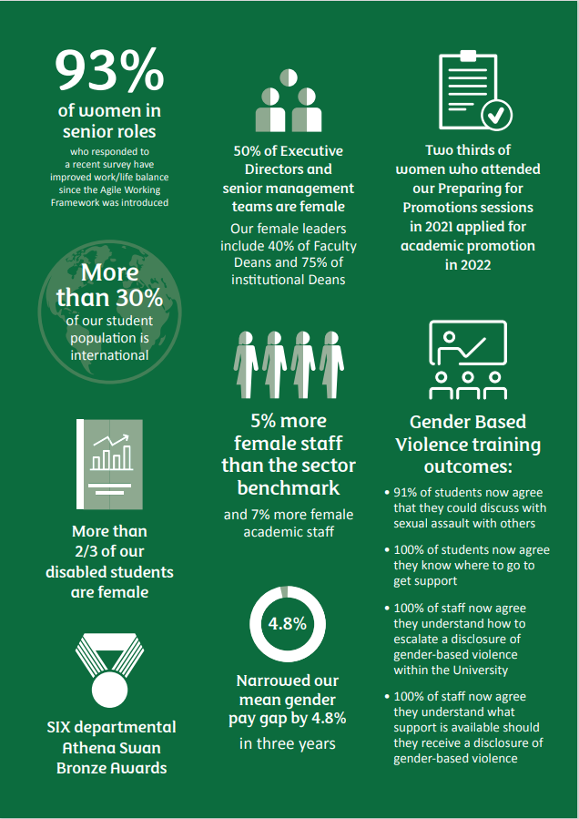

The University of Stirling was established in 1967 and is Scotland’s University for Sporting Excellence. Our first Chancellor, Lord Robbins, focused on **‘education with a purpose’, declaring that university places 'should be available to all who were qualified for them by ability and attainment'.** The Robbins Report widened access to higher education, and his transformative thinking continues to inform our mission, vision and values.

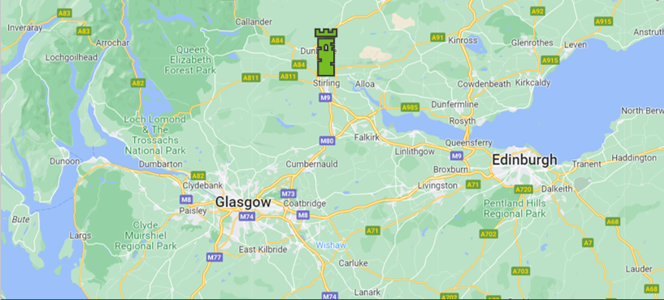**Figure 2:** Campus Location

Situated in the heart of Scotland, our 330-acre campus has been ranked 1st in the UK and 3rd in the world for campus environment (International Student Barometer 2022). Known as the 'Gateway to the Highlands', Stirling is shaped by the beauty of the Ochil Hills. As both the safest student city in Scotland (Complete University Guide 2023) and one of the top 3 happiest places in Scotland to live (Rightmove), we're proud to call Stirling our home.

**Figure 3**: University of Stirling

The University comprises five academic [faculties](https://www.stir.ac.uk/about/faculties/), and an [Institute for Advanced Studies](https://www.stir.ac.uk/research/research-degrees/institute-for-advanced-studies/), supporting postgraduate learning and research skills development.

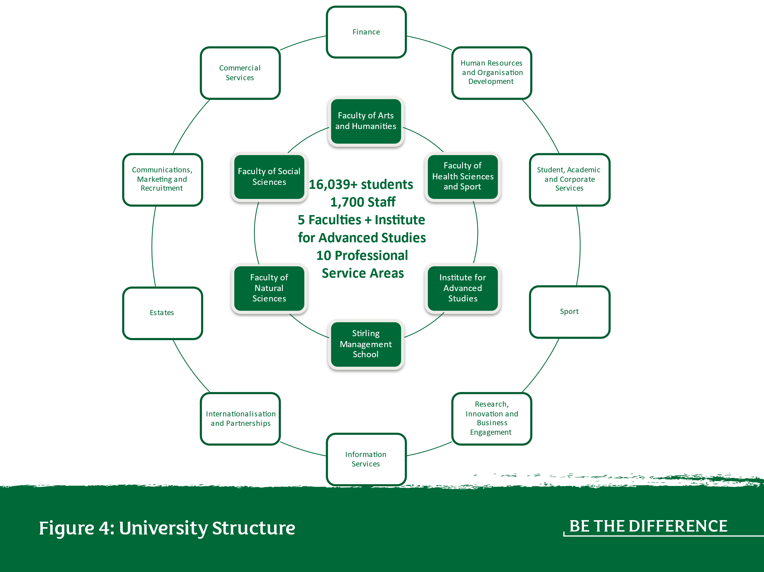

Our focus on inclusion demands gender-balanced leadership. This comprises the Senior Management Team (48% female), Deans (55.5% female) and Executive Directors (50% female). In addition to Faculty Deans (40% female), four Institutional Deans (67% female) provide focus on areas of strategic priority, including EDI (Figure 5).

**Figure 5:** Institutional Senior Management Team

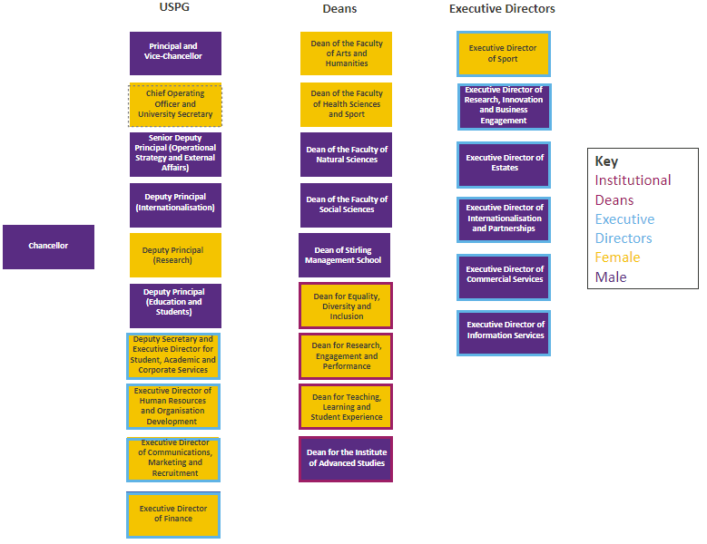

Within SMT, the University Strategy & Policy Group ([USPG](https://www.stir.ac.uk/about/our-people/senior-officers/), 60% female) is a distinct strategic forum comprising:

**Figure 6**: USPG Membership

|  |  |
| --- | --- |
| **Title** | **Gender** |
| Principal and Vice-Chancellor | Male |
| Senior Deputy Principal (Operational Strategy and External Affairs) | Male |
| Deputy Principal (Education and Students) | Male |
| Deputy Principal (Internationalisation) | Male |
| Deputy Principal (Research) | Female |
| University Secretary and Chief Operating Officer | Female |
| Deputy Secretary and Executive Director of Student, Academic and Corporate Services | Female |
| Executive Director of Communications, Marketing and Recruitment | Female |
| Executive Director of Finance | Female |
| Executive Director of Human Resources and Organisation Development | Female |

We are proud of our work to recruit students inclusively; while there has been a 5% decrease in the proportion of female students since 2018, overall representation of female students remains strong, despite significant changes to our overall student demographic (Figure 7). Unregulated student numbers have increased by 47% since 2014/5, our international students now account for >30% of our overall population and the number of students disclosing a disability increased by 3.8% between 2018/19 and 2023/24.

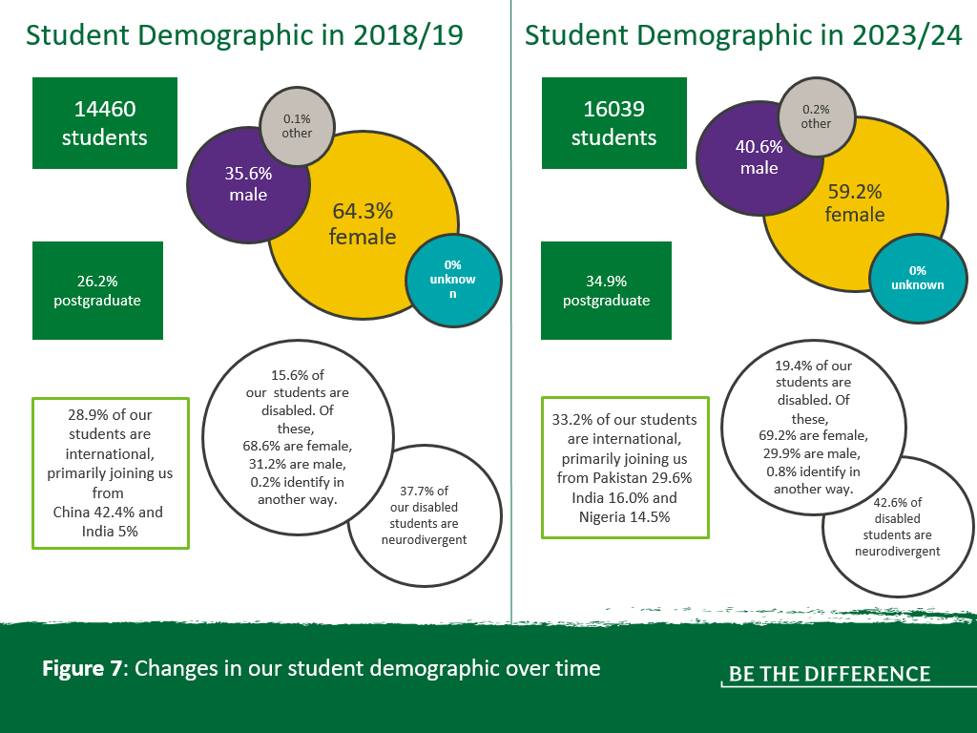

**Our Athena Swan Journey**

Stirling was awarded a Bronze institutional award in 2017. We have made significant progress on gender equality, despite a turbulent external environment since our last submission. The pandemic, Brexit, economic uncertainty and social movements like BLM and Me Too have created huge shifts in the way we teach, learn and work that our previous action plan could not have predicted. This context required us to adapt quickly, finding innovative, sector-leading solutions to continue our progress on gender equality. While our 2016/17 action plan is included in this submission, this was largely superseded by new actions that moved us forward. Key successes include:

* introduction of the [Agile Working Framework,](https://www.stir.ac.uk/about/professional-services/human-resources-and-organisation-development/working-at-stirling/agile-working-at-stirling/) which has demonstrably progressed our inclusive working culture, maximising flexibility to empower everyone to achieve success;
* our action on [gender-based violence](https://www.stir.ac.uk/student-life/support-wellbeing/student-support-services/sexual-violence/gender-based-violence/), which has been transformative;
* dedicated academic promotions training focused on underrepresented demographics, contributing to even greater representation of women at a senior level.

Our commitment to gender equality is evidenced by our departmental progress. The Faculty of Health Sciences and Sport, the Faculty of Social Sciences and the Stirling Management School have all gained Bronze awards. Within the Faculty of Natural Sciences, the division of Psychology, division of Biological & Environmental Sciences, and the Institute of Aquaculture have all gained Bronze awards. The Faculty of Arts and Humanities will submit a departmental Bronze application in 2024, and the Faculty of Health Sciences and Sport will submit a departmental Silver application this year **[Action: A10].**

## Governance and recognition of equality, diversity and inclusion work

Accountability for our commitment to [equality, diversity and inclusion](https://www.stir.ac.uk/about/professional-services/student-academic-and-corporate-services/policy-and-planning/equality-diversity-and-inclusion/) is vested in University Court, our governing body. Consideration of EDI feeds up to Court and Academic Council via the Joint Policy, Planning and Resource Committee (JPPRC) to support the integration of academic and corporate governance.

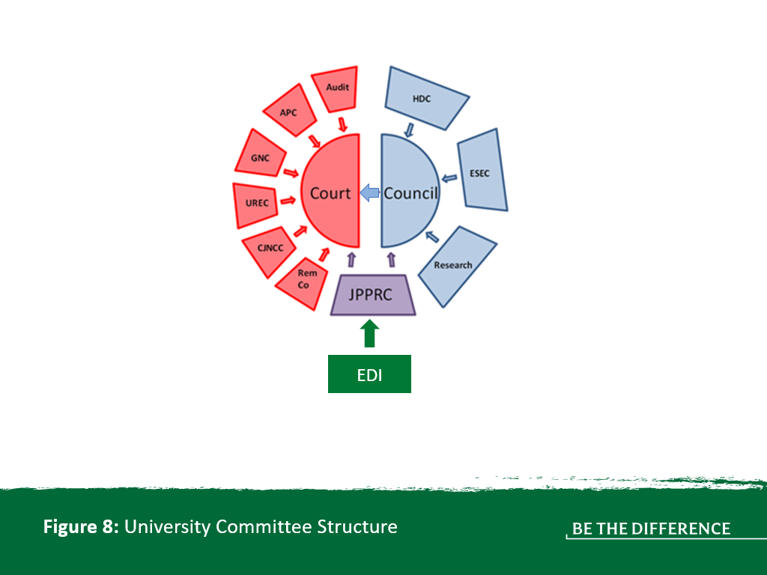

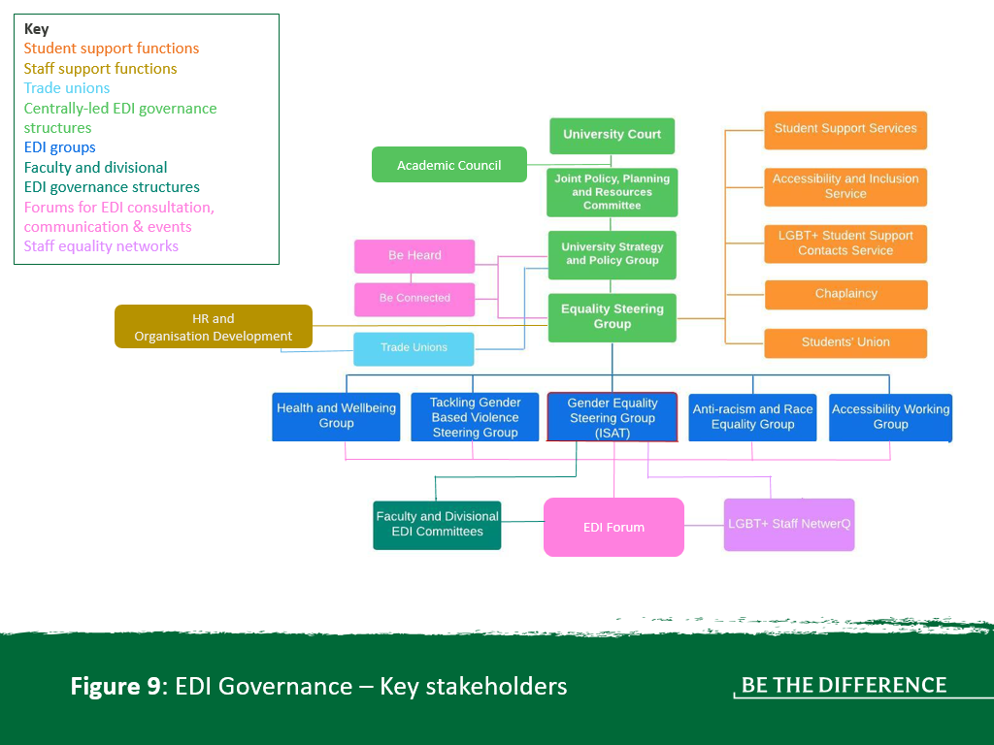

Chaired by the Senior Deputy Principal, with both staff and student representation, the Equality Steering Group (ESG) is a strategic advisory group that ensures effective delivery of the University’s equality outcomes. ESG delegates responsibility for operational development and implementation to several EDI groups:

* **Health and Wellbeing Group:** coordinates work relating to staff and student wellbeing, including the delivery of our Mental Health Strategy.
* **Tackling Gender Based Violence Group:** oversees the joint strategy with Students’ Union on preventing and tackling GBV.
* **Anti-Racism and Race Equality Group:** oversees the Anti-Racism and Race Equality Strategy.
* **Gender Equality Steering Group:** serves as our Institutional Self-Assessment Team (ISAT), this group coordinates institutional work on gender equality.
* **Accessibility Working Group**: coordinates institutional work on accessibility and disability inclusion.

Our EDI Forum operates with a broad membership, providing an opportunity to highlight current projects and discuss emerging concerns. Increasing engagement with, and recognition of, colleagues involved in EDI activity would strengthen this work. A new EDI Community of Practice providing regular development opportunities will add value for our community **[Action: A1, A3].**

EDI contributions from academic staff are accounted for within their workload allocation model (WAM). The work portfolios of professional, technical and operational (PTO) staff are not measured by a WAM, therefore EDI work is allocated through line managers as part of wider resource planning. It is challenging to sustain broad representation from PTO areas on EDI groups that are static and centred on identifying characteristics rather than distinct projects. Moving to a model of action-focused, short-life working groups underpinning ESG, including time-limited membership, succession planning and transparency about the scope of involvement required, will strengthen our EDI approach. This restructure will enable a more diverse membership and avoid placing an undue burden of work or emotional labour on particular staff or student groups **[Action: A1].**

Faculty and Divisional level EDI committees feed into the Gender Equality steering Group, which acts as the ISAT. However, learning from the challenges of our previous submission, the revised ISAT will have a focused remit on Athena Swan, with accountability for actions shared across multiple role holders and levels of governance, including ESG members **[Action A1]**.

Stirling introduced an Institutional Dean for Equality, Diversity and Inclusion in 2017. This role provides strategic leadership in EDI, creating a culture where equity is embedded into all that we do. In 2022, the University increased operational investment, establishing the role of EDI Manager.

Currently, EDI work is formally recognised within the Recognition Award Scheme (providing special recognition to staff (below grade 10) whose contribution, on a sustained basis or on a specific project or task, has been exceptional) and in Academic Promotions processes. In 2023/24, 16 applications explicitly referenced leading or contributing to EDI work as evidence to support meeting promotion criteria. However, this could be more clearly articulated **[Action: A3].**

## Development, evaluation and effectiveness of institutional policies

Our institutional Policy Review Schedule accounts for both internal and external factors, such as changes in legislation, to ensure policies adapt to changing circumstances and remain effective. Policy owners keep policies under review between the official review cycles and are responsible for making amendments where required. A new Policy Governance Framework will provide consistency and strengthen consideration of equality in policy development, including approaches to EQIA, accessibility requirements and inclusive language **[Action: A1].**

Our ‘Be Heard’ staff engagement approach helps to ensure that diverse perspectives are fully considered in policy development. Using ‘pulse’ surveys, ‘Be Heard’ enables regular feedback, moving us from a reactive ‘one and done’ model to a proactive ‘always listening’ approach. Staff participate in surveys on different topics throughout their employment journey **[Action: A13]**.

**Figure 10:** Increasing the staff voice (*22 words*)

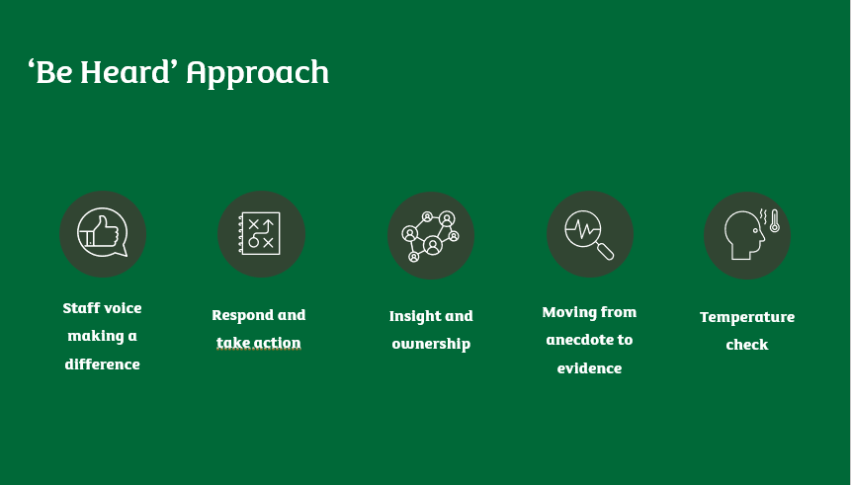

Once the issues that require attention have been identified, revised policies are submitted to governance committees for consideration and approval. For example, JPPRC reports to University Court and its remit includes scrutiny of new or revised policies, and the necessary resources allocated to support implementation. JPPRC membership includes students, lay members (including the Chair of Court), academics and professional services representatives. Court considers and approves policies on recommendation from JPPRC.

EQIAs are required to be undertaken to ensure that our policies support an inclusive culture. Support for this is available via the Policy and Planning team, but a refreshed approach comprising additional training and resources will empower staff to identify intersectional inequalities and assess impact more effectively **[Action: A1].**

A future survey willfocus on EDI. There is a particular focus on increasing disclosure rates of equality characteristics to enhance employee data and better understand our staff demographic **[Action: A1, A2, A4, A13].**

The consultation and engagement framework associated with the development of the new Strategic Plan provides an example of how the University captures and embeds the views of staff and students in institutional strategy and policy. Engagement events held throughout 2023 included cross-institutional World Café events, cross-professional services workshops, Dean-led faculty sessions, and student ‘pop-up’ events. Outputs informed the values, strategic direction and ambitions of the University.

The University has an LGBT+ Staff Network, the NetwerQ, offering peer support and insight into the experiences of our LGBT+ community. Establishing further staff equality networks will strengthen our policy development and practice **[Action: A1, A13].** We recognise from staff and students with protected characteristics that these networks are only sustainable when this work is demonstrably valued by the institution, and recognition of EDI work will be strengthened at Stirling **[Action: A3].**

Actions to better understand our trans community **[Action: A16],** those with caring responsibilities **[Action: A17]** and neurodivergent staff and students **[Action: A18]** by encouraging further disclosurewill strengthen our ability to develop policies that support all members of our community.

## Athena Swan self-assessment process

Our Gender Equality Steering Group acted as the ISAT, meeting four times per year, chaired by the Dean for EDI, and reporting to ESG. Members include representatives from professional services, faculties, and students (Figure 11).

**Figure 11:** Membership and Composition of the Gender Equality Steering Group

|  |  |  |
| --- | --- | --- |
| **Name** | **Role** | **Gender identity** |
| Jill Stevenson | Dean of Equality, Diversity and Inclusion; GESG Chair | Female |
| Moray Nichol | Corporate Governance and Policy Manager; GESG Secretary | Male |
| Sara Brown | Quality and Accreditations Manager, Stirling Management School; Faculty Lead for Gender Equality/Athena Swan | Female |
| Claudio Rocha | Senior Lecturer, Faculty of Health Sciences and Sport; Faculty Lead for Gender Equality/Athena Swan | Male |
| Eilidh Cage | Lecturer, Faculty of Natural Sciences; Faculty Lead for Gender Equality/Athena Swan | Female |
| Jennifer Dickie | Senior Lecturer, Faculty of Natural Sciences; Faculty Lead for Gender Equality/Athena Swan | Female |
| Catherine Grainger | Teaching Assistant, Faculty of Natural Sciences; Faculty Lead for Gender Equality/Athena Swan | Female |
| Sonia Rey Planellas | Associate Professor, Faculty of Natural Sciences; Faculty Lead for Gender Equality/Athena Swan | Female |
| Liz Forbat | Professor, Faculty of Social Sciences; Faculty Lead for Gender Equality/Athena Swan | Female |
| Alenka Jelen | Associate Professor, Faculty of Arts and Humanities; Faculty Lead for Gender Equality/Athena Swan | Female |
| Shona Barrie | Director of Admissions and Access | Female |
| Linsey Dickson | Director of Research Services | Female |
| Katharine Reibig | Research Development Manager | Female |
| Emma Darling | Head of Communications | Female |
| Jacqui Lenaghen | Head of Student Support & Operations | Female |
| Jennifer Paton | Head of HR Business Partnering | Female |
| Lesley Fraser | Director of HR Services | Female |
| Lauren Wilson | Head of People Systems & Data Insights | Female |
| Tash Miller | Students’ Union President 2022/23 | Female |
| Jess Reid | Students’ Union Vice President for Communities 2022/23 | Female |
| Katie Perrin | Head of Student Services Development | Female |
| Kelly Marriot | Student Support Officer | Female |

This forum allowed for a combination of consultation, exchange of good practice and identification of emerging themes. However, during the process of self-assessment, additional contributors were engaged (Figure 12).

**Figure 12:** Expansion of the ISAT

|  |  |  |
| --- | --- | --- |
| **Name** | **Role** | **Gender identity** |
| Justine Dashwood | Equality, Diversity and Inclusion Manager | Female |
| Amanda Hopwood | Head of Employee Experience & Development | Female |
| Lynn Caldwell | Data Analyst | Female |
| Graeme Duff | Head of Policy and Planning | Male |
| James Adamson | Analytics and Reporting Manager | Male |
| Ali Clark | Head of Student Recruitment | Female |
| Alan Waddell | Student Recruitment Manager | Male |
| Alison Green | Professorial Fellow and Dean for Teaching, Learning and Student Experience | Female |
| Leen Ali | Students’ Union President 2023/24 | Female |
| Peter Matthews | Professor in Social Policy – Faculty of Social Sciences; LGBT+ NetwerQ Lead | Male |
| Fiona McMillan | Careers Consultant | Female |
| Ceitidh Lavin | Senior Systems & Data Insights Analyst | Female |
| Emily Mitchell | Senior Employee Experience and Development Partner | Female |

Together, this group brought a variety of lived experiences to the process:

**Figure 13:** Lived experiences of the ISAT

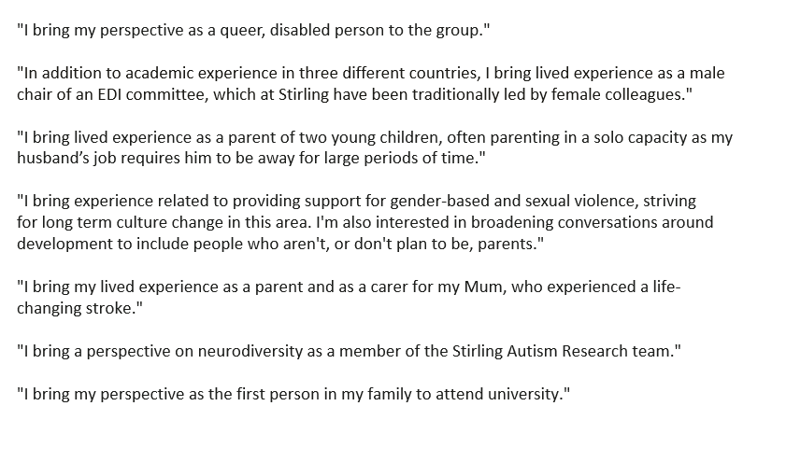

Additional contributors had a positive impact on the diversity of the ISAT, increasing the gender balance (91% of the initial group were female, compared to 83% of the combined ISAT) as well as bringing additional intersectional perspectives and a focus on operational responsibility.

Going forward, the ISAT will be revised to better reflect a diverse range of experiences in terms of sex, gender identity and intersectional perspectives, as well as representation from different job functions and grades **[Action: A1].**

The ISAT considered a wide range of evidence including quantitative data **(Appendix 2)**, surveys and module evaluations **(Appendix 1)**. Benchmarking sources included HESA data (isolating data from Scottish universities where a narrower focus was more useful) and Advance HE Statistical Reports. Adding to our evidence-base for EDI has been identified as an area for improvement **[Action: A1, A2, A10].**

|  |
| --- |
| **Theme 1: Infrastructure to embed inclusion**  **Priority 1: EDI activity is aligned and responsive**  **Actions A1, A2, A3**  **Building upon our existing evidence-base for EDI, crafting action-focused structures that represent the diverse community, and recognising and rewarding contributions will engage our community, foster good practice, and enhance collective capabilities** |

An identified weakness of our previous action plan was action ownership. To strengthen accountability, responsibility for actions will be shared amongst identified post holders, members of ESG, and members of the revised ISAT. This will minimise risks associated with tying actions to one individual whose workload and priorities may change over time **[Action: A1].**

# Section 2: An evaluation of the university’s progress and success

## 1. Evaluating progress against the previous action plan

Please see Annex 1 for our fully detailed RAG-rated action plan from 2016/17.

**Review of 2016/17 Action Plan**

Our 2016/17 action plan was superseded as we responded to significant changes in the external and internal environment. While our focus shifted to emerging priorities (e.g. tackling gender-based violence), our ambition also grew significantly. Of the 28 actions in this plan, 21 are rated as green and there have been significant achievements in progressing gender equality outside the scope of this document (e.g. our Agile Working Framework and ‘Be Heard’ staff engagement approach). We take pride in the progress that has been made and the demonstrable impact our actions have had, including narrowing our gender pay gap by 4.8% over the last three years and an improved work life balance for our female senior leaders. A breakdown of the RAG-rated actions is provided in Figure 14.

**Figure 14**: Overview of RAG-rated actions from the 2016/17 action plan

A table displaying the green actions (21) and the amber actions (7) from the 2016/17 action plan. 

**Green-rated actions and facilitating factors**

From the 2016/17 action plan, 75% of our actions are rated green. A number of actions succeeded as a result of the strong collaboration across the University. For example, the review of flexible working practices (2.28) and the subsequent introduction of the Agile Working Framework required a culture shift, made successful by the buy-in from managers across faculties and professional services ensuring their teams adopted the framework appropriately. Strong institutional support from senior leaders led to the achievement of many actions (e.g. 2.3, 2.15, 2.20) combined with acting on feedback from the University community to prioritise activity that felt most meaningful. For example, consultation clearly indicated that staff wanted to see an improvement in our approach to induction (2.15). A number of actions were achieved because the associated data could be analysed centrally (e.g. 2.1, 2.2, 2.10, 2.19).

There were several green-rated actions that were revised during the previous award cycle. The success measures associated with action 2.3 were adapted to account for the pause in promotions during Covid-19. Action 2.13 to run ‘Taking Control of your Career’ workshops was amended following review and we instead pivoted towards investment in Aurora. Action 2.18 (to create an internal award to celebrate and recognise women across the institution) was refined to focus on promotions processes and the existing recognition award scheme, to ensure the action appropriately reflected the aim of tackling inequalities. Action 2.25, to undertake a scoping exercise to identify equality implications of increasing Transnational Education, was superseded by the establishment of the Directorate of Internationalisation and Partnerships in 2018. Consideration of equality is incorporated into annual programme and partnership reviews completed by this Directorate.

**Amber-rated actions and barriers to success**

Seven actions (25%) were rated as amber, with several actions impacted by Covid-19, either due to competing priorities during the pandemic resulting in a slower pace of activity than anticipated (2.23, 2.24) or because our thinking had evolved in a post-covid, agile working environment (2.4). On the latter, the action to investigate secondments across the institution has been superseded by a more integrated programme of development opportunities. This is taken forward in the new action plan under **Action A4.**

Whilst Stirling exceeds the sector average in the use of open-ended contracts for academic staff (69% vs. 67%, Advance HE 2023), our use of fixed-term contracts did not fall, with women accounting for 59% of fixed-term contracts in 2023/24 (2.11). The increase in fixed-term contracts responded to the rapid growth in student numbers experienced during the pandemic. Work is underway to progress a reduction through a contract review project **[Action: A10].**

There were other actions where work had been undertaken to move them in the right trajectory, but over time, they did not quite meet the target (e.g. 2.12, 2.21). This is partly due to a lack of clear ownership (2.12), and the under-estimation of the time required for change to occur (2.21). For example, whilst a professorial pay audit was carried out and the associated gender pay gap did reduce (2.21), it did not meet the target set. Similarly, while shared parental leave was promoted (2.27) this did not result in the increased uptake we aimed for.

**Overall reflection and lessons learned**

We have made considerable headways in our EDI initiatives with our achievements going beyond our original plan. However, there are still areas that require improvement. Lack of clear ownership of actions within the plan due to changing priorities and workloads as well as staff turnover, especially during the Covid period, proved challenging. Learning from this, we will strengthen action ownership by allocating actions across multiple post holders, including members of ESG and the revised ISAT, to reduce risks associated with assigning actions to a single individual whose workload and priorities may evolve over time **[Action A1].**

A high number of actions in our previous plan prioritised data analysis to enhance our understanding of the community. While crucial for identifying inequalities (with our new plan continuing to strengthen this aspect), the emphasis of our new plan is on taking SMART action to address identified issues and achieve positive outcomes.

## 2. Evaluating success against the university’s key priorities

The University has achieved significant success in three areas since 2016/17.

1. ***Review flexible working practices to ensure that formal/informal processes are mutually beneficial to individual and institutions* (2.28)**

Since our previous application, we have succeeded in reforming our working practices to prioritise inclusivity, wellbeing, and organisational agility.

The pandemic imposed radical change on conventional working practices. The noteworthy and significant successes achieved during this time - such as unprecedented growth in teaching and research activities - were the result of the commitment, collaboration and agility demonstrated by the staff community. As the focus shifted to transition and reset post-pandemic, the University took the opportunity to embrace the disruption and culture change, and set a different tone in relation to working practices.

The Agile Working Framework (AWF) was established in 2021. This principles-based approach empowers leaders and teams to co-create effective working practices that suit local business needs. The AWF has garnered positive feedback, with 79% of staff responding favourably (2022 pulse survey). Notably, it has widened opportunities for women in senior roles, with 93% reporting improved work/life balance. Feedback highlights its role in attracting and retaining women in senior positions, fostering an inclusive and progressive culture.

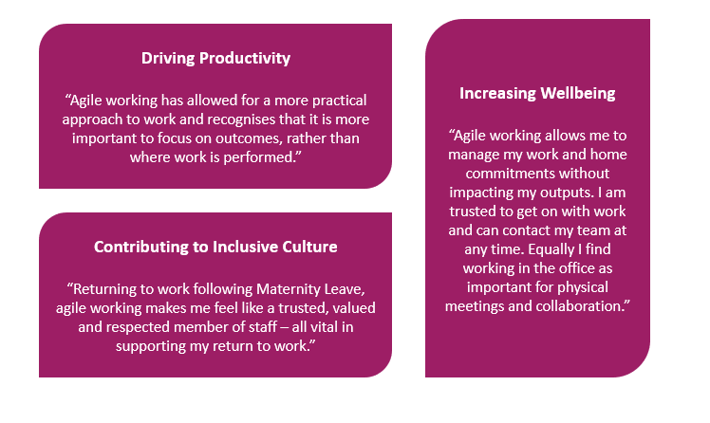**Figure 15:** Feedback on the Agile Working Framework (*109 words*)

The AWF supports individuals who may need to adapt working patterns due to equality considerations. Women aged 45-54 consistently expressed higher satisfaction than average, with one commenting, *“It was incredibly helpful to be able to adapt my working patterns recently while dealing with symptoms of perimenopause - I really appreciated it. I also felt trusted to be working without being physically on campus”.*

For disabled staff, 87% reported that agile working improves their ability to meet priorities, 3% above the norm.

The AWF had cross-cutting impact, with its implementation responding to and strengthening several actions in the previous action plan (e.g. 2.7, 2.23, 2.26, 2.28).

1. ***Supporting mid‐career women academics to prepare for successful promotion* (2.3)**

Our previous application focussed on supporting career development through training, support and mentoring. Since then, we have progressed from offering faculty-level support to a cross-institutional approach, with a particular focus on underrepresented groups.

We have developed a comprehensive Academic Promotions SharePoint site, as well as tailored training sessions for female staff, presented by senior colleagues, that provide an overview of the Academic Promotions process and explore the criteria and the preparation required to submit a strong application. Notably, over two-thirds of women who attended *Preparing for Promotions* sessions in 2021 applied for promotion in 2022.

We have implemented specific women-only sessions, with one colleague saying:

*“Thanks for leading the promotions session for women. I found it so valuable. The speakers were personable, encouraging and realistic. I found the women only session to be much more applicable and empowering to me, personally. The speakers proactively mentioning the additional information section and personal information really helped me relate and see that my crazy life (kids, caring responsibilities and general life) shouldn’t be a hinderance for my career or ambition.”*

Success in this area is evident, with more women applying for promotion (42 in 2021/22 compared to 19 in the previous year), and their success rate increasing from 95% in 2018/19 to 100% in 2022/23. Applications from women for Professor positions also increased from 4 in 2020 to 10 in 2022/23, with all being successful.

Whilst this work has contributed to greater representation of women at a senior level, analysis has identified a gender disparity by age. Table 8.2 (appendix 2) shows that in 2022/23, females were most likely to apply for promotions between the ages of 45-54 (53.3%) and males between the ages of 35-44 (46.4%). Female staff aged 45–54 have a lower success rate in promotion applications compared to males (56.3% vs. 77.8%). Further work will be conducted to understand the impact of age on promotion rates and address these imbalances **[Action: A11].**

1. ***Tackling and preventing gender-based violence***

Significant progress has been made in our approach to tackling and preventing gender-based and sexual violence in all its forms.

Collaborating with the Students’ Union, our first ‘Preventing and Tackling Sexual Violence and Misconduct’ Strategy was published in 2017. With substantial investment, and in collaboration with local and national partners such as Glasgow Caledonian University, the University and Students’ Union together developed a nationally recognised approach to tackling gender-based violence. Aligned with the Scottish Government’s Equally Safe Strategy, our institutional Gender-Based Violence Strategy 2021-24 addresses all forms of GBV, providing a unified narrative that dispels myths, directs individuals to resources, and focuses on prevention efforts targeting perpetrators.

Informed by consultations with the University community, including GBV survivors, we embraced the Erase the Grey campaign, originally developed by Glasgow Caledonian University. This campaign confronts stereotypical attitudes and behaviours while unequivocally promoting a zero-tolerance stance on GBV. Future focus groups will tailor campaigns for specific groups (e.g. student sport clubs, international students, disabled women, mature students, LGBT+ women, and widening participation students) to better understand their GBV experiences **[Action: A22].**

Investment in training Sexual Violence and Misconduct Liaison Officers (SVMLOs) and First Responders resulted in a 156% increase in the proportion of staff stating they understood how to access support and escalate disclosures. An innovative and bespoke online GBV module for students called “Don’t be a bystander, be a friend” saw a 106% increase in the proportion of students who agreed they had the skills to discuss sexual assault. Utilisation of the Report and Support system has increased, reflecting growing confidence in disclosing incidents and seeking support. Expanding the system and targeted campaigns will further support our staff and students **[Action: A22, A23].**

The University has joined key organisations across the region to support the White Ribbon Scotland Campaign, which encourages reflection and discussion that leads to personal and collective action among men to end violence against women. Professor Sir Gerry McCormac, Principal and Vice-Chancellor, is leading the University’s commitment to the campaign as a White Ribbon Scotland Ambassador.

|  |
| --- |
| **Theme 3: Inclusive Experience**  **Priority 5: Continued action to tackle and prevent gender-based violence**  **Actions A22, A23**  **We are increasingly conscious of the need to ensure that our approaches to GBV, harassment and abuse continue to meet the needs of our community and that mechanisms for supporting survivors and those supporting them are robust and inclusive. Together, we are committed to continuing to raise awareness of the realities of GBV.** |

# Section 3: An assessment of the University’s gender equality context

## Culture, inclusion and belonging

Our [institutional vision for inclusion](https://www.stir.ac.uk/about/professional-services/student-academic-and-corporate-services/policy-and-planning/equality-diversity-and-inclusion/) states that we will develop a culture that:

* Actively prevents and tackles discrimination, harassment and abuse;
* Respects and celebrates diversity and inter-culturalism;
* Enables our staff and students to thrive and achieve their potential, regardless of their background; or identification with a protected characteristic(s);
* Identifies and eradicates systemic barriers to equality.

### 1.1 Representation

At Stirling, women constitute 60% of staff, surpassing the sector average of 54.6% (Table 10, Appendix 2). Women hold significant leadership roles within the institution, comprising 47% of Grade 10 and 50% of Grade 9 positions (Table 10.5). The institutional averages mask inconsistency across Faculties, Directorates, and role functions **[Action: A9, A10].**

### 1.2 Academic Staff

Stirling has a higher proportion of female academics compared to sector norms and many Scottish universities (Table 2.2). Targeted initiatives such as promotions training and the Agile Working Framework contribute to our leading position among Scottish pre-92 institutions in female senior academic representation.

The percentage of Grade 10 female academics has risen from 39% in 2018 to 44% in 2024 (Table 2.3), surpassing the sector average of 30% (Equality in Higher Education Statistical Report: Staff, Advance HE, 2024). However, vertical segregation persists, particularly in Teaching & Research roles (Table 2.1), with a considerable drop in female representation from Grade 7 (59%) to Grade 10 (45%), indicative of the sector-wide "leaky pipeline" issue recognised by Advance HE (Dataset 11). Actions to support female leaders, explore the experience of mid-career women, and refresh our induction and development offering will positively influence this **[Action: A4, A5, A7, A9, A10, A11, A12].**

Women hold a higher proportion of fixed-term contracts (59%) compared to open-ended contracts (53%), highlighting an 18% gender disparity favouring females in fixed-term roles (Table 3). While Stirling exceeds the sector average in the use of open-ended contracts for academic staff (69% vs. 67%; Equality in Higher Education Statistical Report: Staff, Advance HE 2023), discrepancies exist across academic contract functions, with the use of open-ended contracts being 99% for Teaching & Research staff, 46% for Teaching & Scholarship staff and 19% for Research staff (Table 3.2). Moreover, there is a higher proportion of women in Teaching & Scholarship (57%), and Research (64%) roles (Table 2). The University's response to increased student numbers during the pandemic led to a surge in short-term fixed-term engagements to swiftly meet teaching demands (Table 3.2). Efforts are now underway to better align contract types with strategic objectives and business needs **[Action: A10].**

Table 10.2 shows a higher proportion of Black, Asian and minority ethnic staff in academic roles comparison to PTO roles, with slightly more male staff (Female 12%; Male 14%). Notably, 9% of academic staff have not declared their ethnicity, with a higher proportion of male staff at grade 10 choosing not to disclose this (27%; Table 3.3). We anticipate that ongoing efforts to modernise our approach to data collection **[Action: A2]** will lead to increased disclosure rates.

### 1.3 Professional, technical and operational staff

The proportion of female professional services staff mirrors the overall staff demographic and slightly exceeds sector norms. However, there's noticeable occupational segregation in certain role types, with lower-graded operational roles predominantly occupied by females (albeit some functions within that grouping are occupied mainly by men), while technical roles in Grades 6-9 are predominantly held by males (Table 4.1). This reinforces the need to address inequalities in career pipelines across roles and functions **[Action: A6, A9, A10, A11]**.

Use of fixed-term contracts for PTO staff has markedly decreased, with 97% of Operations and Facilities staff, 93% of support staff and 85% of Professional and Managerial staff now on open-ended contracts. In contrast, the use of fixed-term contracts in technical jobs has risen, alongside our success in research grant income capture, and there is a gender imbalance in contract types with more female technical staff on fixed-term contracts compared to males (32% vs. 13%; Table 5) **[Action: A9, A10].**

Analysis reveals a lack of Black, Asian and minority ethnic representation at higher PTO grades (Table 4.2). Initiatives to increase representation include developing tailored leadership opportunities, such as sponsoring a Grade 9 male staff member to attend AdvanceHE’s Diversifying Leadership programme in 2023/24, with plans to fund five places annually from 2024/25 **[Action: A5]**. The low proportion of male staff at grade 10 choosing to disclose ethnicity (18%) underscores the need to improve our equality data **[Action: A2].**

### 1.4 Recruitment, Pay and Progression

1. **Recruitment**

Application, shortlist and appointment processes have been working successfully to recruit female academic staff (Tables 6.1 to 6.5), affirming the decision to prioritise our actions to address the pipeline on development and retention **[Action: A5, A9].** Measures that have contributed to our success in recruiting inclusively include encouraging hiring managers to monitor gender balance on recruitment panels and increasing uptake of ‘Recruitment and Selection’ training to support a fair, transparent and inclusive process (Table 12).

We consistently shortlist a higher proportion of female candidates than the application average, with females being more successful at Grades 6-8. At Grade 9, there's a progressive increase in the representation of female candidates from application to shortlisting. The gender balance in Grade 9 appointments has improved notably from 28.6% in 2018/19 to 50% in 2022/23 (Tables 6.1 and 6.5), with additional efforts to increase the number of female applicants to these positions underway **[Action: A9].**

For PTO posts, recruitment data (Tables 7.1 to 7.6) reflects vertical segregation across Grades. Targeted actions will address gender imbalances in the recruitment process, rectifying career pipeline inequalities **[Action: A9, A10].**

There has been a notable increase in the proportion of recruited Black, Asian, and minority ethnic staff, from 5% for women and 6% for men in 2018/19 to 11% for women and 12% for men in 2023/24.

1. **Pay**

We remain committed to Fair Work principles, paying the Real Living Wage since 2015.

In 2020, our mean gender pay gap was 18.7% (18.6% median) in favour of men. By 2022/23, the mean gap decreased to 14.1% and further to 13.9% by February 2024, with a concurrent decrease in the median gap from 16.2% to 12.4%. This narrowing trend, better than other Scottish universities (Mainstreaming Equality Report, 2023), is reflective of a 20% increase in women applying for and achieving promotion since 2019, alongside a rise in Grade 10 female staff. Despite this, the average salary for women at Grade 10 remains lower, in part due to the average length of service being higher for men, although the gap has narrowed from 5.6% in 2022/23 to 3.8% in 2024. The University's Grade 10 framework enables agility and competitiveness in talent recruitment and retention, underpinned by benchmarking to ensure a considered and informed approach, with salaries monitored and reviewed by the Remuneration Committee.

Vertical segregation persists, with a larger proportion of women in lower-grade levels (Grades 1-6; Table 4.1). Although women now make up almost half of Grade 10 staff, their concentration at lower grades perpetuates the gender pay gap.

The mean ethnicity pay gap favours white staff by 10.4%, while the median pay is equal. This may be due to a high proportion of Black, Asian, and minority ethnic staff in mid-level grades (6 & 7), with nearly 8% of overall staff not disclosing ethnicity, and 22% at Grade 10. Further examination of gender and ethnicity trends **[Action A2]** will inform strategies for gap reduction and increased representation at higher grades across academic and professional staff **[Action A9].**

1. **Recognition**

The Recognition Award Scheme (RAS) is an annual opportunity to acknowledge and celebrate staff whose exceptional contribution deserves particular recognition. Successful nominations to RAS have included individuals who have led, or contributed to, EDI initiatives. The Scheme is open to staff in all role types in Grades 1-9. Analysis of nomination data shows that of all nominations received a higher proportion of those are for women. This is not representative of the overall population by gender therefore further analysis is required to identify why this imbalance occurs **[Action A3]**.

The Remuneration Committee process also provides a yearly mechanism through which Grade 10 staff can be nominated for a pay award on the basis of exceptional contribution, in the form of a one-off payment or a consolidated increase. The process provides a framework to review senior staff salaries on an annual basis through a gender equality lens and identify any disparities. Ongoing work in this area has contributed to a narrowing of the gender pay gap at Grade 10.

1. **Development, progression and support**

Our new institutional People Strategy commits us to creating a culture where every staff member can achieve their ambitions. Individual development needs are addressed through annual "Achieving Success" conversations, ensuring achievements, objectives and career ambitions are discussed. The process also provides the opportunity for individuals to discuss their contribution to EDI initiatives. Deans of Faculty and Executive Directors are responsible for ensuring managers are confident in undertaking these conversations and reviewing all completed forms **[Action A4, A6, A7, A11].**

Previously, development needs were addressed locally. Capturing institutional data on development requests will be key to informing inclusive practice. Priorities include tracking access to learning opportunities, including the identification of trends/biases in who is benefiting from opportunities, and scoping skills gaps **[Action: A4]**.

We are committed to supporting the development of a pipeline of female leadership. Since 2018, 77 female employees have been supported through Aurora, and we commit to continuing this investment, targeting areas of need **[Action A5]**.

There are currently no formal career pathways for PTO staff. Since 2023, a pilot programme, Skills Canvas, has been initiated to establish a framework for personal and professional development, based on international best practices and adapted from Scottish Apprenticeship standards **[Action A6]**. This initiative aims to enhance visibility of skills across the University and create PTO career pathways, with the pilot implemented in the Student and Faculty Operations team, mainly comprising female staff (83%).

**Figure 16:** Case Study - “Skills Canvas” pilot in SFO. *(97 words)*

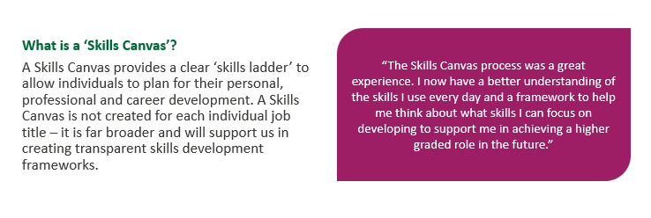

Since 2020/21, 24 individuals (54% female)have been supported through the Financial Support for Further Education Scheme, which offers staff funding for undergraduate or postgraduate qualifications. Eligibility criteria for funding has been updated, with applicants now required to demonstrate how qualifications undertaken will have a direct and positive impact on their role at the University **[Action: A4].**

Engagement with support for staff through Stirling’s Employee Assistance Programme (EAP) has been notable, with 15% utilisation between 2022 and 2023 compared to a UK average of 12% (EAPA UK, 2022), predominantly by females (77%). The introduction of the ‘Peppy’ app for menopause and men’s health support saw positive reception, with 159 registrations surpassing the average usage rate. Registrations relating to menopause are above target, with 61% of users reporting increased positivity towards the University for providing Peppy, and 28% experiencing improved menopause symptoms after 180 days. Efforts will focus on increasing men’s health engagement in 2024/25 **[Action: A12].**

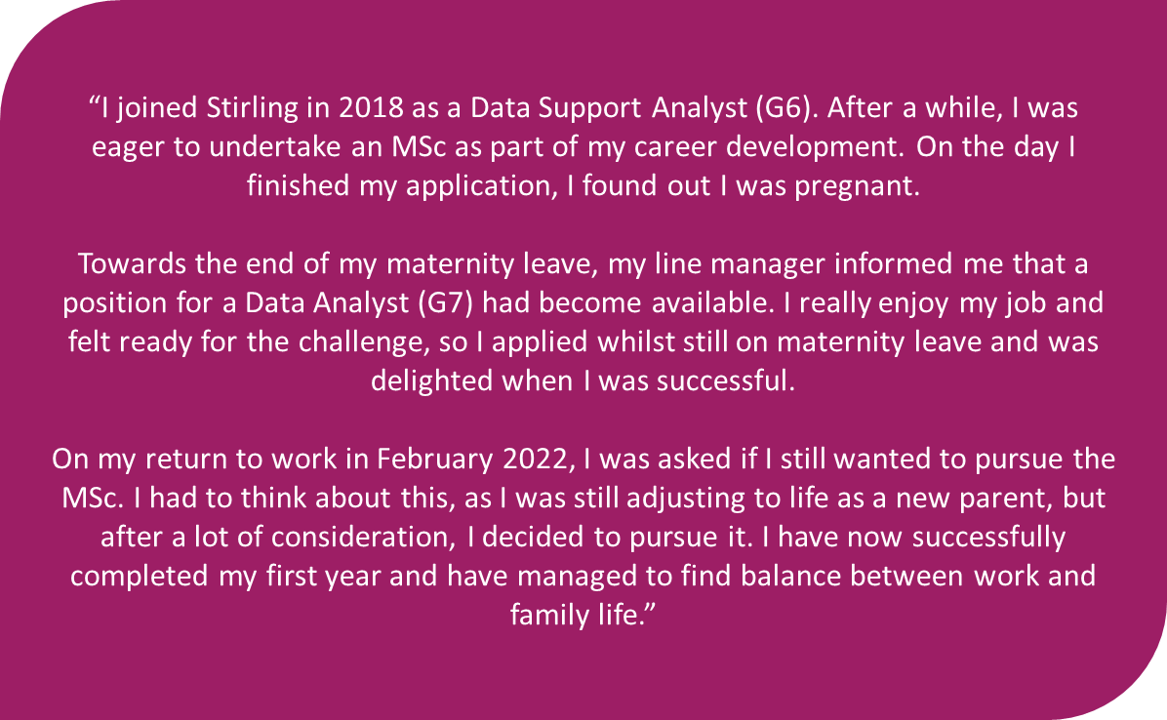**Figure 17:** Case study - Financial Support for Further Education Scheme *(155 words)*

1. **Academic Promotions**

In addition to the progress and identified next steps highlighted in section 2.2, we have taken considered action to mitigate unconscious bias in the promotions process, including: merit-based assessment in accordance with agreed promotion criteria, with impact judged relative to an individual’s career stage; gender-balanced panels, with a panellist from a different area of the University to ensure a diverse range of viewpoints; and regular unconscious bias training for all involved **[Action: A11].**

A number of successful promotions applications have highlighted the applicant’s contributions to EDI. Although individuals are supported to submit an application to the grade they feel is most appropriate, should an individual demonstrate and meet the criteria for a higher grade, promotions are awarded at the fitting level.

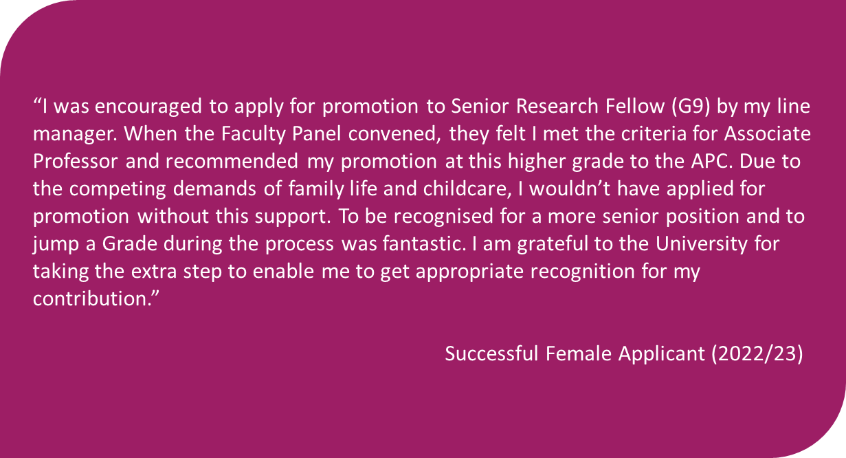**Figure 18**: Case Study – Academic Promotions (*103 words*)

### 

### 1.5 Research Culture

A new Research & Innovation Strategy was approved in December 2023 and work has commenced to embed this. Monthly Research Culture Conversations offer opportunities to feed into policies and create solutions for change. Annually, the University holds a Festival of Research to stimulate discussion and provide a platform for researchers to learn about the diverse nature of research. This includes the Research Culture Awards, an opportunity to recognise those who positively contribute to our research culture. New actions including a research group manifesto, edi training for researchers, and embedding EDI into delivery of our new strategy will strengthen our culture further **[Action: A15].**

Stirling’s results in the Culture, Employment and Development in Academic Research Survey (CEDARS) have been broadly in line with sector findings. In 2022/23, female research staff scored consistently lower than the University average when surveyed on their experiences (2022 Pulse Survey: Agile Working Framework, 2023 Pulse Survey: Induction, 2022 CEDARS Survey). We will take action to strengthen our professional development offer for researchers across the pipeline **[Action: A7, A15].**

|  |
| --- |
| **Theme 2: Organisational Culture**  **Priority 2: Skills growth, career development and building inclusive leadership capability**  **Actions A4, A5, A6, A7**  Providing development and skills growth to meet the needs of our community. Impactful career development for current and future leaders, developing our researchers from postgraduate level onwards, and targeted development for PTO staff, will enable staff to thrive and achieve their potential.  **Priority 3: Attracting, recruiting and retaining a diverse community**  **Actions A8, A9, A10, A11, A12, A13, A14, A15**  Recruiting, growing and retaining a diverse community is essential to our mission of creating “global citizens” who will “identify and meet the needs of a changing society”. By taking action to address gender imbalances, including in identified priority areas such as vertical segregation, and addressing how we recruit and support students in subject areas where persistent inequalities remain, we will further narrow our gender pay gap and create an environment where everyone has a voice. |

### 

### 1.6 Student Experience

Our student population is changing. Between 2018/19 and 2023/24, applications for postgraduate study increased by more than 280%, over 1/3 of students are now international, almost 20% of our students are disabled, and our non-binary population has doubled. Our progress on inclusive curriculum is having a demonstrable impact on our students’ experience of teaching and learning. In 2023 module evaluations, 84% of students agreed that “the delivery, content and assessment was inclusive for students from all backgrounds”. Inclusive assessment practices include embedding a 24-hour assessment window as standard practice, which received positive feedback (Figure 19), particularly benefiting students with caring responsibilities and mental health conditions.

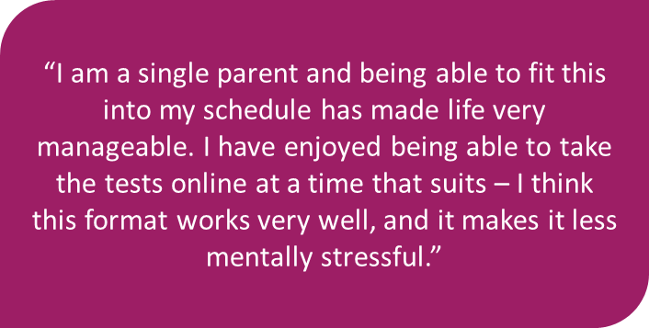**Figure 19:** Feedback on Flexible Assessments *(48 words)*

Women account for 85% of sole carers for children and 65% of sole carers for older adults (Source: Business in the Community, 2022). Our students come from diverse locations and have complex lives, increasingly including caring responsibilities. Student-facing staff reported an increase in the number of queries about processes to support student parents and learners with caring responsibilities in 2023/24 - to better support this emerging community, a short-life working group will take a holistic approach to children on campus, creating guidance for student parents and staff who support them **[Action: A17]**

Recognising that not everyone has the same path to university, and that lived experience is not always visible, the division of Biological and Environmental Sciences (BES) created the Visibility of Inclusion for Boosting Equity initiative (VIBE). Staff Visibility Champions provide students with support and information across a range of EDI areas, listening to student concerns and signposting relevant resources. Symbols representing five key VIBE areas (Figure 20) are used as stickers on office doors of participating staff and a photo directory of the Visibility Champions is available to students.

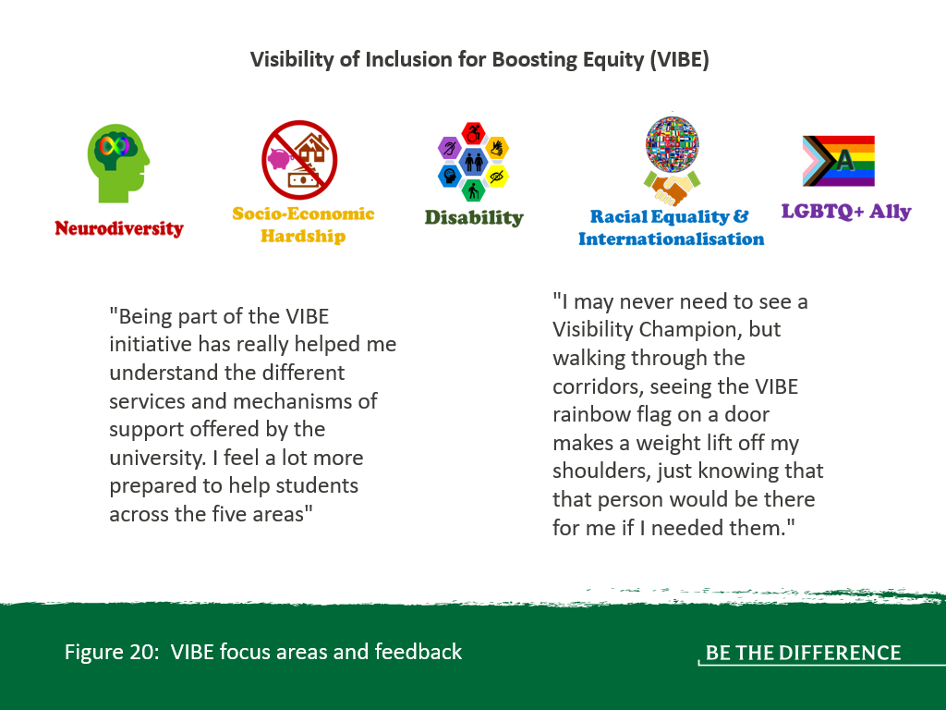

Feedback indicates that VIBE is having a positive impact on staff and students (45% of students surveyed reported being aware of the strategies BES is pursuing to improve equity and inclusion) and is giving new insight – 38% of contacts in the pilot related to neurodiversity, so the division will pilot an ADHD student support group **[Action: A18]**, and VIBE will be expanded across the University **[Action: A1, A21].**

Despite our progress, LGB students, disabled students and female students currently report lower overall satisfaction when surveyed (NSS, SES, PTES, PRES 2022/23). To meet the needs of our increasingly complex population, co-creating support that directly involves students will better embed inclusion. Actions will include refreshing our Student Ambassadors programme and creating a Student Assistant Crew to offer targeted support to students with certain protected characteristics. **[Action: A14].**

The majority of students in UK HE in 2022/23 were female (Advance HE Higher Education Statistical Reports), including 59.3% in Scotland, and 59.2% at Stirling. However, several of our programmes have gender imbalances greater than 75%, higher than sector norms (Table 1.1). Action to support progress will include a Zero Gravity mentoring scheme, refreshing our Student Ambassadors scheme and targeted support to encourage progression to postgraduate study **[Action: A8]**.

While female students gave consistently lower satisfaction scores than male students across all surveys, this difference is greatest at postgraduate level (-10.6% for PGRs). Targeted group coaching sessions and a female-led journal club will aim to build a greater sense of community among our female PGRs, while focus groups with PGR supervisors will inform new, specific support for researchers within the existing Student Support Hub. **[Action: A7].**

Research from Stonewall suggests that some lesbian, gay and bisexual students hide their identities in universities, while transgender hate crimes increased in Scotland by 87% in 2021/22 (Crown Office, 2022). This indicates an increasingly challenging environment to be ‘out’ in Scotland. At Stirling, 2023 survey results indicate LGB student satisfaction was lower than then sector average (-10%). Our non-binary population has also doubled since 2018/19. The University’s LGBT+ Student Support Contacts Service links students with LGBT+ staff who have volunteered to offer support, but survey results indicate low awareness of this service. Trans and non-binary students have also raised concerns about IT systems and the provision of gender-neutral facilities on campus. Working with the Students’ Union to research LGBT+ student experiences, forming a short-life working group to address the needs of our trans community, and working with local stakeholders to create community events for LGBT+ staff and students will enhance our environment for LGBT+ people **[Action: A16]**.

The notable rise in women diagnosed with ADHD and Autism indicates an increasing need to consider our approach to neurodivergence. In 2023, 42.5% of disabled students at Stirling were neurodivergent. Neurodivergent people rate a flexible schedule highly as a reasonable adjustment at work (Birkbeck, Neurodiversity at Work 2023), so our Agile Working Framework is likely to attract our neurodivergent postgraduates to remain. Developing Stirling-specific training to meet the needs of neurodivergent learners and providing targeted careers advice for this demographic will help our progress towards neuroinclusion **[Action: A18]**.

Mental health and wellbeing are key factors in retaining an engaged learning community. Recent initiatives include increased investment in the Mental Health, Wellbeing, and Counselling Team, implementing a 'One at a Time' counselling model which reduces waiting times, and launching a Mental Health First Aid (MHFA) training programme for staff. Despite this investment, evidence suggests disparities in the way that students with different identities experience our mental health and wellbeing support services.

Only 21% of students accessing counselling and 36% of students accessing mental health support in 2021/22 identified as male, and only 1% of students accessing counselling or mental health support identified their gender in another way than male or female. Less than half of our LGB students felt that mental health support services were well communicated (44.9%, NSS 2023). In 2023/24, 19.4% of students were disabled. Of these, 34% disclosed a mental health condition such as schizophrenia, depression or anxiety disorder. Initial evidence from the VIBE (Visibility of Inclusion for Boosting Equity) initiative indicates Visibility Champions for disability are often approached about mental health. Research suggests that experiences of minority identity and belonging to an outgroup are associated with increased incidence of poor mental health (UCL, 2022) and we need to better understand differences in uptake and experience of wellbeing support. Actions to address this include targeted campaigns to reach underserved audiences and staff development on working with students with different identities **[Action: A19, A20, A21]**.

Our disabled population has increased significantly, and in 2023/24 almost 1/5 of our student population were disabled. Disabled students were less likely to be satisfied across student surveys than non-disabled students (-5.7% at undergraduate level, rising to -9% at postgraduate level). 1/3 of disabled students reported low satisfaction at undergraduate level, and enquiries from students relating to disability and accessibility increased in 2023/24. Implementing a digital campus map platform, developing disability awareness and skills for frontline staff (including BSL skills) and equipping staff to respond effectively when student disclose disability will enhance disabled student experience **[Action A21].**

Our students come from diverse locations and have complex lives, increasingly including caring responsibilities. There has been an increase in the number of queries about processes to support student parents and learners with caring responsibilities. Women account for 85% of sole carers for children and 65% of sole carers for older adults (Source: Business in the Community, 2022); to better support this community, a short-life working group will take a holistic approach to create guidance for student parents and staff who support them **[Action: A17]**.

### 1.7 Improving our evidence base

As part of our Be Heard approach, we are modernising our equality data collection for staff. Changes so far have included introducing new fields for disability and refining our language around caring responsibility, gender identity, and BSL users, ensuring the collection of meaningful data that will allow us to better identify differences in experience.

Since the changes in September 2023, over 900 staff records have been updated, with an increased disclosure rate of equality characteristics. Staff identifying as being disabled increased to 8% in 2023/24 from 5% in 2022/23, surpassing the 5% average in Scottish HEIs (Advance HE, 2022). The proportion of staff with undisclosed disability information decreased by 9%. In 2024, the proportion of female staff identifying as being disabled (8%) was higher than that of male staff (6%). The proportion of staff disclosing a mental health condition increased to 3% (1.5% rise from 2023, 4% female, 2% male). The proportion of Black, Asian and minority ethnic backgrounds increased from 7% to 8%, with the proportion of staff whose ethnicity is unknown decreasing by 7% since 2022/23.

Currently, evidence linking non-progression and student experiences of accessing support services is limited. Given survey feedback suggesting students from underrepresented demographics have lower satisfaction with how mental health and wellbeing support services are communicated (NSS 2023), a new Progression Data Dashboard will enable us to better understand and act on this. **[Action A19].**

|  |
| --- |
| **Theme 3: Inclusive Experience**  **Priority 4 Progressing our approach to an inclusive student experience**  **Actions A16, A17, A18, A19, A20, A21**  As our student demographic evolves, we need to respond proactively to emerging concerns to prevent inequalities. Improving our evidence bae, and using this to support our LGBT+ community, student parents, and our disabled community, including neurodivergent students, will enhance student experience. |

## 2.Key priorities for future action

Please note that themes and priorities are embedded within the submission, highlighted in text boxes as above.

# Section 4: Future action plan

## Action plan

|  |  |  |  |  |  |  |  |  |
| --- | --- | --- | --- | --- | --- | --- | --- | --- |
| **Action ID** | **Objective** | **Rationale** | **Action** | **Milestones** | **Success criteria** | **Accountability** | **Date** | **Timeline** |
| **THEME: 1: INFRASTRUCTURE TO EMBED INCLUSION** | | | | | | | | |
| **Priority 1: Ensuring our future EDI activity is aligned, evidence-based and responsive** | | | | | | | | |
| **A1** | Develop effective EDI structures that enable progress. | Inclusive practice is essential to the shared vision in our Strategic Plan “To make an impact on people’s lives and be a force for good in the world.”    Evidence suggests that women place higher importance on workplace diversity and inclusion when considering job opportunities. (Source: YouGov report, DEI in the workplace, 2023)    Diverse leadership increases organisational effectiveness.    Formalising routes for peer support can help minimise exclusion. Networking during working hours broadens access to populations who experience barriers to informal social networks e.g. those with caring responsibilities, LGBT+ people who aren’t out at work.   Creating opportunities to share best practice and expand activity across Faculty, departmental and professional service levels will have a positive impact for staff and students.  Feedback indicates the VIBE pilot has had a positive impact on staff and students. | A1.1 Review the structures underpinning Equality Steering Group, creating new, short-life working groups to progress inclusion. These flexible structures will focus on aspects of equality that staff and students are telling us matter to them and that data indicates are a priority.   A1.2 Create an approach to membership that is time-limited with succession planning.   A1.3 Revise our institutional Athena Swan Self-Assessment Team, including establishing principles and ways of working that mitigate the potential for workload to be disproportionately borne by those most affected by inequalities.   A1.4 Create a new EDI group bringing together EDI leads in Faculties and Directorates.    A1.5 Review Terms of Reference of EDI groups to ensure transparency in the level and scope of involvement required.    A1.6 Pulse survey focussed on establishing current levels of staff awareness of EDI activity and understanding of opportunities to contribute to EDI work undertaken to provide baseline for measuring future progress.    A1.7 Schedule for revising/reviewing EDI policy and guidance included within Policy Governance Framework. Training provided on EQIAs to ensure policies address EDI.   A1.8 Maintain current gender balance where at least 50% of non-executive members of University Court are women.    A1.9 Review current engagement opportunities for EDI community such as the EDI forum, bringing together stakeholders involved in individual strands of equality work such as gender equality to form an overarching community of practice. Host four EDI CoP events per year.   A1.10 Expand VIBE (Visibility of Inclusion for Boosting Equity) initiative to become an institutional mechanism for EDI visibility and support.  A1.11 By 2028, support the creation of two new equality networks for staff. | **Autumn 2024**  Review lay member of Court person specification and appointment process to encourage a greater diversity of applicants.   ISAT is revised and priority owners identified. EDI Faculty leads group is convened. Terms of References have been reviewed.    EDI Pulse survey is launched and data analysed.    **Spring 2025**  Launch EDI community of practice.  **Autumn 2025**  VIBE initiative expanded to Faculty of Health Sciences and Sport and Student, Academic and Corporate Services.    **Autumn 2026**  VIBE initiative expanded to all faculties. Evaluate impact in SACS and revise/expand to other teams as appropriate  **2024-2028**  Ongoing process of reviewing and revising EDI policy and guidance. Delivery of EQIA training as and when required.    **Spring 2027**  EDI Pulse survey re-run and compared to 2024 baseline data. | Revised EDI structures meet the needs of a diverse, inclusive community, as indicated by improvement to 2024 pulse survey baseline question asking staff about their awareness of our existing EDI structures/fora.   Institutional Athena Swan self-assessment team meets at least four times per year. Equality Steering Group receives a progress update on the institutional action plan at least once per semester.    Measurable increase in staff awareness of EDI activity and understanding of opportunities to contribute to EDI work. ISAT to determine SMART target for inclusion in this action plan following initial EDI Pulse survey in 2024.   At least 50% of non-executive members of University Court are women.  Policies and guidance related to inclusion are regularly reviewed and updated, as indicated by compliance with schedule.  Success of expanded VIBE initiative is evidenced by qualitative feedback.    At least three equality networks are available for staff.    The EDI community of practice supports our EDI community, as evidenced by event feedback, and participation in and evaluation of training and events. | EDI Manager   Head of Policy and Planning   Chair of Equality Steering Group (Senior Deputy Principal)    EDI Chair, Biological and Environmental Sciences    EDI Chair, Faculty of Health Sciences and Sport    Executive Director of Sport | 2024 | 5 years |
| **A2** | Strengthen our staff EDI data to evidence our decision-making on equality, diversity and inclusion. | We have seen an initial increase in personal characteristics disclosure since we launched our modernised methodology in September 2023, although areas for improvement remain with a particular focus on increasing declarations related to ethnicity. 20% of Grade 10 staff have not declared their ethnicity. This is a barrier to intersectional work on gender equality.    Data relating to EDI is drawn from several systems and sources. Feedback from staff involved in EDI activity suggests there are opportunities to refine how EDI data is accessed and provided to support evidence-based action. This will support future assessments of gender equality.    Currently, we do not hold recruitment data on sex for a small number of candidates at application, shortlisting and appointment stages. | A2.1 Reduce the percentage of unknown responses to staff personal characteristics questions to increase intersectional reporting capabilities.    A2.2 Plan and launch annual communications to all staff, specific to areas of low disclosure, to remind them to update their data on personal characteristics.    A2.3 Collation and sharing of case studies detailing the positive impact increased disclosure has had on key aspects of staff experience.   A2.4 Revise approach to providing EDI data to colleagues involved in activities to progress inclusion. Create a data working group to consider data provision and access within available parameters.   A2.5 Gender pay reporting is broadened using new data to better understand intersectional experiences. Ethnicity and disability pay gap reporting to be included from our 2025 gender pay gap analysis onwards. | **February and October annually**    Continued awareness campaign to encourage disclosures and raise awareness of how personal data impacts institutional activity and strategy. Targeted communications to Grade 10 staff focussing on the strategic importance of disclosure of personal characteristics.    **October 2024**  Data Working Group created  **From March 2025**    Broadening understanding of gender pay gap reporting to include ethnicity and disability pay gap.    Collation and sharing of case studies detailing the impact of increased personal characteristics disclosure on staff experience    **Ongoing from 2024**   Review approach to access and provision of EDI data, implement identified changes. | Increase in disclosure rate of protected characteristics from staff year on year:    Decrease ethnicity and disability non-disclosure for grade 10s year on year with a target of 10% decrease by 2026.    Decrease disability and ethnicity non-disclosure for all staff to 5% by 2028.     Embedded, regular forum where relevant colleagues consider EDI data, including identifying changes to improve our approach. Outcomes of these meetings feed into institutional planning annually.  Baseline data for ethnicity and disability pay gap reporting established. Provide Institutional and Faculty intersectional data/gaps annually.    Establishment of recruitment baseline data through obtaining more comprehensive data on protected characteristics for those applying. | Director of HR Services   Head of Policy and Planning   Associate Dean of Research  Faculty of Health Sciences and Sport  (or nominated member for research on Equality Steering Group) | 2024 | 5 years |
| **A3** | Embed institutional awareness of existing routes for reward and recognition of EDI activity. | Progress on inclusion is essential to our vision of “Enabling our staff and students to thrive and achieve their potential”.    In 2023/24 Academic Promotions round, 16 of 48 applications (33%) explicitly referenced work in leading or contributing to EDI work as evidence to support meeting of promotion criteria.   Staff and students have a range of competing priorities; to engage our community with actions to progress inclusion, the value of activity to increase gender equality needs to be clearly articulated. | A3.1 Scope and implement process to consistently identify individuals who demonstrated commitment to EDI work as part of successful Academic Promotion application.    A3.2 Work with identified individuals to create case studies detailing the approach taken to integrate EDI work into successful promotions applications. Share case studies via dedicated Academic Promotions SharePoint site.    A3.3 Invite identified individuals to present at annual ‘Preparing for Promotions’ sessions to share how they successfully utilised their EDI contributions within their applications with staff considering promotion.  A3.4 Communicate the potential to recognise EDI work as part of staff Recognition Award Scheme (RAS), engaging with managers making nominations to ensure EDI work is appropriately considered as a factor in who is nominated.   A3.5 Within the Academic Promotions process, continue to ensure the positive impact of EDI is considered by panel members. | **September – November 2024**   Stakeholder engagement on EDI recognition within RAS.    **November 2024**  Build EDI perspective into Preparing for Promotion sessions to raise awareness.    **July – August 2025**  Scope and launch process to identify individuals successful in Academic Promotions who demonstrated a commitment to EDI work within their application.  Create EDI impact case studies and make live on Academic Promotions SharePoint site.    **Annually, June – August each year from June 2025**   Monitor for increase in RAS nominations where EDI is a key factor. In year three, use data to evidence whether this approach is successful or needs further action.    **Annually, January each year from 2025**  Monitor for increase in Academic Promotions applications where EDI is a key factor. In year three, use data to evidence whether this approach is successful or needs further action. | A minimum of one new and relevant case study detailing the impact of EDI work in relation to successful APC application is available on Academic Promotions SharePoint site each year.    Preparing for Promotions sessions contain a dedicated speaker focussing on demonstrating impact of EDI work in applications from 2024/25 onwards.    Percentage of Academic Promotions applications referencing EDI activity increases to >40% by 2028.    Percentage of RAS nominations referencing contribution to EDI activity increases to 20% by 2028. | Director of HR Services  Head of Employee Experience and Development  Dean of Faculty on Equality Steering Group |  |  |
| **THEME: 2: ORGANISATIONAL CULTURE** | | | | | | | | |
| **Priority 2: Skills Growth, career development and building inclusive leadership capability** | | | | | | | | |
| **A4** | Provide development and skills growth opportunities to meet the needs of our community. | Through our institutional People Strategy, our commitment is to create a culture where every staff member can achieve their ambitions. This means creating opportunities and investing in our people to build future-proof skills, expertise and innovation, equipping our people to grow their careers and make impact with work that really matters. (People Strategy; 2024)    Individual development needs are currently addressed locally through annual ‘Achieving Success’ conversations. There is currently no formal mechanism to capture development needs at an institutional level.    Currently the University does not have a consistent approach to meet ongoing development needs around equality, diversity and inclusion throughout the staff and student journey. A strategic framework would support increased operational effectiveness in this area.    Female respondents in the ‘Professor’ employee sub-group were less likely than the university norm to feel they 'knew where to find opportunities available to them'(22% [– 54%]) and reported a less favourable experience of institutional induction than the institutional norm (2023 Pulse Survey: Induction).   Since 2021/21 the University has supported 24 individuals (54% female) to undertake further funded study through the Financial Support for Further Education scheme. | A4.1 Develop and launch pulse survey for all staff focused on skills growth and career development opportunities at the University.    A4.2 Scope and implement a strategic skills gap analysis approach for the University, including skills and knowledge development in EDI.    A4.3 Design an enhanced approach to personal development review conversations (currently ‘Achieving Success’) in collaboration with staff to ensure a more consistent approach to ongoing performance and development across directorates and faculties.    A4.4 Launch of updated eligibility criteria for funding through the Financial Support for Further Education scheme to ensure investment in learning is linked to individual skills development, succession planning and organisational need. Applicants will be required to demonstrate that any qualification undertaken will have a direct and positive impact for the individual’s role at the University.   A4.5 Utilise outputs of strategic skills gap analysis (incl. information from Achieving Success) to integrate development opportunities for EDI into the design of a new continuous professional and skills development programme for staff.  A4.6 Evaluate the impact of the programme of professional development opportunities, including evaluation of how skills development is experienced by different demographics (protected characteristics, career stage). | **May 2025**   Launch of pulse survey focussed on skills growth and career development opportunities at the University to establish baseline data.    Monitoring of applications to ensure oversight of equal opportunity to Financial Support for Further Education scheme.    **October 2025**  Strategic skills gap analysis approach is scoped and implemented.    **November2025**  Initiation of review of current Achieving Success process to ensure alignment of personal objectives to organisational strategy.    **November 2025**  Review existing EDI learning materials for relevancy.     **June 2026**  Design of continuous professional and skills development programme including EDI.    Launch of enhanced approach to ongoing personal development review conversations for all staff, increasing consistency of approach to discussing development needs across the University.    **2025-2028**   Refinement of EDI training based on strategic skills gap analysis and review of existing materials. Launch of new opportunities as identified through these processes.     **August 2026**   Launch of continuous professional and skills development programme.     **2027**   Evaluation data is used to inform enhancements to development opportunities. | Baseline data established with annual monitoring/review to enable ongoing assessment of the impact of strategic skills development opportunities.    An inclusive University-wide programme of continuous professional and skills development opportunities is designed and implemented based on skills gap analysis for all staff, including tailored opportunities for underrepresented groups.  Evaluation (surveys, uptake of learning, feedback from learning) indicates increased satisfaction with professional development offer.    The current Achieving Success process is superseded by a more consistent model of ongoing personal development review conversations aligned to People Strategy objectives.    EDI knowledge and skills awareness offer is evidence-based and effective (feedback from participants and EDI community, staff satisfaction with development opportunities as measured by surveys).    >70% of staff from across the University will engage in the enhanced personal development review process by 2028. | Executive Director of HR & OD (or nominated member for HR on Equality Steering Group).   Head of Employee Experience and Development  **EDI Manager** | 2024 | 5 years |
| **A5** | Ensure impactful career development for women in current leadership roles and prepare future leaders. | Inclusive practice is essential to our vision of “Enabling our staff and students to thrive and achieve their potential”   38% of female respondents reported having access to structured networking and peer-to-peer learning opportunities to support their transition into a leadership role. (2023 Pulse Survey: Induction).  Diverse leadership increases organisational effectiveness.   Qualitative feedback from female respondents indicates that the Framework played a key role in attracting women to work in senior roles at the University of Stirling and supporting the retention of female staff in senior roles at the University.   Table 4 (Appendix 2) shows that women are underrepresented in the Technical job family overall (4%), and Table 4.1 (Appendix 2) shows this at grades 4 and above in both the Technical and Operations and Facilities job families. | A5.1 Continued investment in Aurora, the development programme for female staff, targeting investment at areas of need.    A5.2 Establish baseline data and monitor the extent to which Aurora alumnae are successfully applying for promotion (academic staff only).  A5.3 Scope and implement an Aurora alumni network to enable greater networking and peer-to-peer learning opportunities for women in, or developing into, leadership roles.   A5.4 Revitalise a central mentoring programme for the University, complemented by the addition of mentoring software that will support staff through their mentoring relationship and make available key institutional data and trends as related to mentoring.   A5.5 Launch dedicated support offer for staff returning after a period of absence, including parental leave.   A5.6 Develop our understanding of the experiences of female mid-career staff at the University through a research project led by the Stirling Management School.   A5.7 Add a dedicated page on Agile Working to the “Working at Stirling” webpages and including case studies from a range of staff discussing what agile working looks like in practice for them. Add an agreed descriptor of our agile working approach to all job adverts.    A5.8 Continue to centrally fund up to 5 places annually on Advance HE’s ‘Diversifying Leadership’ programme to support staff from a minority ethnic background in developing their leadership potential. | **Annually from June 2024**   Continue to centrally fund Aurora spaces, working across the University to identify high-priority areas to benefit from Aurora investment.    **May – October 2024**  Phase 1: Investigate experiences of female mid-career academic staff.    **October 2024**  Launch internal Aurora network, providing £1000 central funding per annum to support CPD opportunities through this network.    Launch of revitalised staff mentoring programme      **December 2024**  Finalisation of report on experiences of female mid-career academic staff. Report to inform development of future actions required.    **February 2025**  Agile working materials added to web and job descriptions.  Phase 2: Investigate experiences of female mid-career professional services    **August 2025**   Launch dedicated support offer for staff returning after a period of absence, including parental leave.    **October 2025**  Internal Aurora network hosts 3 events annually.    **2026**  Identify actions arising from research into experiences of mid-career women. | Central mentoring programme and associated software made live for all staff.     Year-on-year growth of women in engaging in mentoring partnerships.    Percentage of female staff in leadership roles reporting having access to structured networking and peer-to-peer learning opportunities to support their transition into a leadership role increases to 60% by 2028.  Analysis of Aurora participation data and regular monitoring of outcomes (annually) provides comprehensive information on the benefits of this programme and its impact on career progression for female staff.    Data reveals positive promotion rates for academic Aurora alumnae within three years of participation in the Aurora programme.  Launch of Aurora alumni network.    A minimum of 3 events held annually for Aurora alumni network     Feedback from staff engaging in dedicated support offer when returning from leave indicates this has had a positive experience on their career at the University.     Data on mid-career experiences enables us to identify meaningful future actions to support this demographic.     Gender pay gap continues to narrow. Decrease median gender pay gap to <10% (below HE sector; ONS, 2023) by 2027. | Executive Director of HR & OD   Head of Employee Experience and Development   Associate Deans of Wellbeing, Inclusion, Diversity and Equality (WIDE), Stirling Management School | 2024 | 3 years |
| **A6** | Develop skills frameworks for professional and support staff to support increased understanding of career progression opportunities at the University. | There are currently no formal career pathways for PTO staff at the University.    Career progression for PTO staff is usually through successful application to a higher graded role, or re-grading following increased responsibility in an existing role. When analysing data (Appendix 2), the percentage of female staff in the Professional and Managerial Job Family has slightly decreased from 69% in 2018 to 64% in 2023/24. Feedback from PTO staff indicates a desire for a framework for individuals to understand their current skills, behaviours and knowledge and plan for future personal, professional and career development.    The 2022 FHSS Culture survey indicated that only 55% of PTO staff agreed their development needs were regularly reviewed. In the same survey, academic staff responding positively about career development increased to 87%. Comments in open questions requested a greater focus on development. Departmental SAT members reflected that greater awareness between job functions may uncover new opportunities for shared development. | A6.1 Continue to develop our ‘skills mapping’ approach to develop a Skills Canvas for defined job roles.    A6.2 Review and update of existing Professional Behaviours Framework, with a focus on incorporating leadership behaviours and aligning development opportunities.    A6.3 Revive institutional mentoring programme **[Action: A5]**    A6.4 Enhanced approach to personal development review conversations (currently ‘Achieving Success’) [**Action: A4]**    A6.5 Run dedicated workshops across the University to build skills required and improve manager’s confidence in conducting effective performance and goal setting conversations with a focus on discussing and supporting career progression.    A6.6 Pilot a cross-function mentoring programme between PTO and academic staff in the Faculty of Health Sciences and Sport. | **Academic Year 2024/25**  Continued pilot of approach with Student Faculty Operations    **May 2025**  Establish benchmark through pulse survey for PTO staff against question: “I know what skills I need to develop for future roles to enable me to grow my career at the University of Stirling”.    Establish benchmark through pulse survey for PTO staff against questions: “I have regular discussions with my line manager about my skills and development needs” / “My line manager supports me to successfully engage in skills development activity”    **December 2025**  Conclusion of skills mapping approach with Student Faculty Operations.  Evaluation of skills mapping pilot, skills Mapping exercise to be undertaken for other PTO roles within the University, prioritised based on need.    Cross-function mentoring pilot in Faculty of Health Sciences and Sport.    **November 2026**  Evaluation of use of Skills Canvases within Student Faculty Operations    **May 2027**  Re-pulse on staff groups with access to relevant Skills Canvas on 2024 pulse survey question: “I know what skills I need to develop for future roles to enable me to grow my career at the University of Stirling    Re-pulse on staff groups with access to relevant Skills Canvas on 2024 pulse survey questions: “I have regular discussions with my line manager about my skills and development needs” / “My line manager supports me to successfully engage in skills development activity”. | Skills Mapping exercise to be complete for Student Faculty Operations roles by end 2025, with each Grade having a defined ‘Skills Canvas’.    Review of skills mapping pilot demonstrates high levels of satisfaction with the approach.    Skills Mapping exercise to be undertaken and completed for prioritised roles within the University.    Improvement from 2024 baseline in identified pulse questions (N.B. target metrics for improvement cannot be identified until pulse survey completes in summer 2024).    By 2028, 70% of relevant staff indicate that the available skills frameworks (Skills Canvas) support them in understanding career progression opportunities at the University. | Executive Director of HR & OD (or nominated member for HR on Equality Steering Group).  Head of Employee Experience and Development  EDI Chair, Faculty of Health Sciences and Sport | 2024 | 4 years |
| **A7** | Develop our career development offer for researchers throughout the pipeline, from postgraduate researchers through to established research staff. | Research staff were less likely to feel that the Agile Working Framework had improved their work/life balance (-5%). For female research staff, this disparity in reported experience increased (-16%). (2022 Pulse Survey: Agile Working Framework).  Research staff were less likely to agree that their line manager discussed their specific learning needs when starting a new role with supervisory responsibility (-24%) (2023 Pulse Survey: Induction).   Research staff were less likely to feel they knew where to find access to information on opportunities available to them, including development (-23%) (2023 Pulse Survey: Induction).  Female students gave consistently lower satisfaction scores than male students across all surveys and this difference is notably greater at postgraduate level (-10.6% for PGRs).  A higher proportion of postgraduate female students at Stirling also considered leaving their course (24.6%) compared to male students (18.2%). | A7.1 Develop fellowship scheme to support those returning to research.  A7.2 Create spaces for greater informal and formal conversations around career development for women. Hold at least one event per year (tied into Festival of Research) targeted at Women in Research with a Teams channel to facilitate further peer support for female researchers throughout the year.    A7.3 Pull existing development opportunities for researchers together into one, streamlined development programme that will improve the pipeline of skilled researchers, proving a clear pathway for progression into leadership roles. Develop a strand on researcher development within the Festival of Research.    A7.4 Shape a framework for recognising inclusion within research and innovation in personal development review conversations (currently ‘Achieving Success’) for researchers.    A7.5 Add targeted support for research grant funding (delivered through our Researcher Development Programme) for returners.    A7.6 Action to address concerns identified in previous CEDARS survey: Build consideration of workload allocation approach into agenda of Faculty Planning Meetings (c.5 per annum, per Faculty) to support colleagues in identifying opportunities for greater flexibility (for example periods of focus primarily on research).  A7.7 Review Research Leave Scheme to address concern that access to research time is reduced following periods of leave, in particular parental leave.  A7.8 Enhance support for PGRs through group coaching sessions targeted at women and a female-led journal club, looking at literature around issues that this group experience.  A7.9 Run a focus group with PGR supervisors to better understand challenges they are facing in terms of providing support, use this feedback to build specific support for postgraduate researchers aligned with the Student Support Hub. | **Academic year 2024/25**  Implement targeted support for research grant funding (delivered through our Researcher Development Programme) for returners.    Run focus group with PGR supervisors.  Create an MS Teams channel for Women in Research on career development where peer to peer conversations can occur.  Launch support for women in research at Festival of Research 2024, followed by events annually.  **Autumn 2025**  First fellowship scheme cohort appointed.    Implement group coaching for female PGRs.  Refreshed researcher development programme launched with communication and engagement plan to socialise this with staff.    **Spring 2026**  Framework for recognising inclusion within research and innovation in personal development review conversations (currently ‘Achieving Success’) for researchers.    **2024-2028**  Annual review of Festival of Research to identify further opportunities to support inclusion. | Returners engaged with research activity, measured by engagement with targeted support, fellowship scheme applicants, improved perception of opportunities for research indicated by survey responses.   Gender pay gap continues to narrow. Decrease median gender pay gap to <10% (below HE sector; ONS, 2023) by 2027.    Increased engagement the refreshed development programme, measured by attendance. ISAT to determine updated SMART target for increased engagement at mid-review point (Spring 2027).   Increased engagement with the enhanced Festival of Research, measured by attendance. Spring 2025: Action owner to provide updated quantitative target to ISAT following 2024 data on attendance.  Female postgraduate satisfactions scores improve by 5%. Fewer female postgraduate students consider leaving their course. | Director of Research Services   Associate Dean of Research  Faculty of Health Sciences and Sport  (or nominated member for research on Equality Steering Group)    Dean for the Institute of Advanced Studies | 2024 | 5 years |
| **Priority 3: Attracting, recruiting and retaining a diverse community** | | | | | | | | |
| **A8** | Support courses with significant gender imbalances to retain and recruit a diverse student population. | At the University of Stirling, five programmes have gender imbalances greater than 75% and greater than sector benchmarks. (Sources: Advance HE Equality+ higher education Statistical Reports; HESA data.)   The gender profile of the student population in 2023/24 was 59.2% female, 40.6% male, 0.2% identifying in another way. This is 5% less female students compared to 2018.   Data indicates that the percentage of female undergraduates studying Economics at the University of Stirling has consistently decreased over the past five years. | A8.1 Develop strong local partnerships in the Forth Valley region with schools and colleges. Pilot a Zero Gravity mentoring scheme matching University students with students from selected local schools in the Forth valley area, targeting subjects with gender imbalances.   A8.2 Identify high performing undergraduates in subjects with gender imbalances to discuss progression to postgraduate study and offer support to encourage those students to progress.   A8.3 Survey undergraduate and postgraduate leavers from subjects with gender imbalances with a view to identifying barriers to progression.   A8.4 Monitor the gender-balance of staff and students representing the University at open days and offer-holder days.   A8.5 Ensure diverse imagery is used in recruitment and advertising materials at subject and school/divisional levels in both published information and online. Consider ways to highlight the experiences of students from under-represented groups in recruitment and advertising materials.   A8.6 Implement an Economics scholarship aimed at supporting a first-generation female student as a form of evidence-based positive action.  A8.7 Work with the Armed Forces Community and the Career Transitions Partnership to promote educational opportunities for service leavers, into a range of courses, including Mental Health Nursing. | **2024-2026**  Build relationships with targeted local schools through identified careers events.   **Spring 2026**  Student Ambassadors co-host targeted Instagram Live events, for example with the careers service.   **Spring 2027**  Pilot Zero Gravity mentoring scheme. | Gender imbalances on identified programmes (gender imbalances greater than 75% + greater than sector benchmarks in 2024) reduce by 5% by Autumn 2027 semester.  Capacity to understand contributing factors is increased by starting to capture the gender of respondents to surveys of accepters/decliners from 2025.  As the University does not control several factors contributing to subject choice, a mid-award review of courses with significant gender imbalances by the ISAT in the Autumn 2026 semester will support our capacity to shift our focus/optimise planned activity.  Students are aware of the benefits of participating in outreach work, as evidenced by interaction with the refreshed Ambassadors programme.   Zero gravity mentoring pilot completed and evaluated.   University events linked to student recruitment are facilitated by a diverse group of staff and students. Imagery on recruitment materials is representative and diverse.  Economics scholarship is implemented and student(s) recruited. | Head of Student Recruitment   Director of Admissions and Access  Dean of Faculty on Equality Steering Group | 2024 | 4 years |
| **A9** | Review staff recruitment procedures to ensure we actively reduce the potential for bias in the recruitment process and recruit from the widest possible talent pool. | Through our institutional People Strategy, our commitment is to continue to build on our diverse community by finding ways to attract and retain the best talent to deliver on our strategic priorities. (People Strategy; 2024)    Female Academic and Research candidates are more successful than their male counterparts at Grades 6 to 8. The University recognises applications from female staff to Grade 9 posts remains proportionately low and so we require dedicated action to increase the number of female applicants. | A9.1 Define a recruitment strategy that signals our ambition and enables us to respond to competitive markets whilst modernising our approach to attracting and retaining the  best talent.    A9.2 Regularly benchmark and monitor trends related to protected characteristics to inform activity related to recruitment strategy, remaining flexible to target specific groups to support inclusivity where required.    A9.3 Establish process to review how we advertise posts across grades to ensure adverts are appealing to a diverse range of groups.    A9.4 Establish process to review language of job adverts. Actively seek feedback as to whether language and terminology appeals to a range of groups.    A9.5 Increase balance of staff from Black, Asian and minority ethnic backgrounds across Grades by taking considered action to attract to those posts through ensuring two visible case studies of Black, Asian and minority ethnic background staff from outside Grades 6 and 7 on our recruitment pages.    A9.6 Continue to ensure recruitment panel members complete the Recruitment and Selection and Unconscious Bias eLearning (LearnUpon) | **November 2024**  Implement improvements to LearnUpon to increase consistency and accuracy of reporting of completion of Recruitment and Selection and Unconscious Bias eLearning.    **November 2025**  Define, develop and approve new institutional recruitment strategy.    Identify and develop case studies showing Black, Asian and minority ethnic staff thriving in roles at Stirling (outside Grade 6 and 7).    Recruitment and Selection and Unconscious Bias eLearning reviewed to ensure continued relevance.    **2026 - 2028**  Establish defined processes to review job adverts to ensure these remain as attractive and inclusive as possible.    Examine recruitment practices to minimise the risk of importing gender or ethnicity pay differentials | Through the establishment of baseline information, the University obtains more comprehensive data on protected characteristics for those applying to vacancies. The University is therefore better able to target advertising/recruitment on underrepresented groups.  Measurable improvement in gender balance of successful applicants.    Case studies live on ‘Working at Stirling’ webpages.    Continued narrowing of gender pay gap and ethnicity pay gap.    Establishment of baseline reporting data of engagement in relevant eLearning through LearnUpon.    Minimum 80% of interview panel members to have completed Recruitment and Selection and Unconscious Bias eLearning within last 3 years. | Executive Director of HR & OD (or nominated member for HR on Equality Steering Group).    Director of HR Services    Head of Employee Experience and Development | 2024 | 5 years |
| **A10** | Take action to identify and address gender imbalances across the career pipeline. | At an institutional level, gender balance at Grade 10 is almost half (47% female & 53% male) and at Grade 9 is 50/50. However, this gender balance is not consistent across Faculties, Directorates and functions within the University.   Representation of women in Research roles is currently at least 50% across all grades. The percentage of female research staff decreases as the grades increase, suggesting potential for additional action to develop future leaders.    Analysis has identified a gender disparity by contract type for academic staff. In 2023/24, 60% of all academic fixed-term contracts were held by women, compared to 53% of open-ended contracts. This is 18% more female than male academic staff holding fixed term contracts.    While the average use of open-ended contracts for academic staff at Stirling 69% 2023/24 which is greater than the sector average of 67% (Advance HE Equality in Higher Education Statistical Report: Staff, 2023). | A10.1 Investigate the potential influencing factors where gender imbalance exists in particular disciplines or job functions.   A10.2 Continued refinement and delivery of training for staff on the academic promotions process, with a particular focus on equipping women and those in underrepresented groups for promotion.  A10.3 Develop and implement a People Strategy that enables the delivery of key strategic priorities.   A10.4 Support all Faculties to hold departmental Athena Swan awards and embed gender equality actions at local levels. Support Bronze departmental award holders on the journey to Silver. Support staff involved with departmental applications through revised EDI structures. **[Action: A1]**   A10.5 Understand and examine the use of contract types with a view to consolidating resource with business need and strategic objectives, reducing the use of short-term fixed-term engagements.    A10.6 Continue to communicate the availability of shared parental leave.   A10.7 More detailed statistical analysis to be undertaken to enable better understanding of where targeted action may be required to address gender imbalances across the institution within role groups.   A10.8 Specific focus to be given to vertical segregation within T&R Contract Group to understand the "leaky pipeline" and identify targeted actions to address this. | **June 2024**   Commencement of Contract Review project.    Design and approval of institutional People Strategy.     Process established for undertaking detailed statistical analysis to enhance understanding of areas where targeted action is required in relation to gender balance.     **By end 2025**   Targeted actions and success measures identified in relation to addressing gender imbalances across contract types and Faculties.    **August - September 2026**  Communications campaign targeted to Research staff highlighting the benefits of engaging in enhanced approach to ongoing personal development review conversations, linking to career development and Academic Promotion opportunities.     **October 2026**  Dedicated ‘Preparing for Promotion’ session designed and delivered for Research staff ahead of opening of APC 2026/27.    **2028**   All faculties hold a departmental Athena Swan award, at least one Silver departmental award. | Factors influencing gender imbalances are identified and monitored annually. Where possible, actions are implemented to reduce gender imbalances within Faculties, Directorates and Job Families.     People Strategy is approved by Court and live for all staff from AY 2024/25. People Strategy KPIs (baseline to be established throughout 2024/25) ensure impact of Strategy is monitored across demographics where possible.  All faculties hold a departmental Athena Swan award, at least one Silver departmental award.    Establish a baseline analysis of maternity leave, paternity leave, shared parental leave by end 2025 review annually for trends to inform future actions.    Increase the proportion of women applying for APC to Professor (T&R) by >50% by 2026.    Increase the proportion of women applying for APC for and from Research Fellow by >50% by 2027.     Hold and maintain an equal gender proportion of Professors .    Reduce the number of fixed term contracts. Reduce the proportion of women on academic fixed term contracts by >10% by 2028. Numbers monitored annually through Faculty People Planning process. | Executive Director of HR & OD   Head of Employee Experience and Development   Chair of Equality Steering Group (Senior Deputy Principal)    EDI Manager | 2024 | 5 years |
| **A11** | Identify and overcome any potential barriers that may be creating imbalances within the Academic Promotions process | Through our institutional People Strategy, our commitment is to ensure our people feel proud to work for the University and feel valued, supported and recognised. We will continue to build fair, transparent and sustainable reward and recognition processes that will position us as an employer of choice, enabling us to attract, recruit and retain talented people. (People Strategy; 2024)    Data outlines that academic female staff proportionately apply for promotions between 45-54 (53.3%), while male academics have a higher application proportion aged 35-44 (46.4%).    Female staff in the 45 – 54 age grouping are less likely than their male counterparts to be successful in their promotion application (56.3% vs 77.8%). Male staff aged 55 – 64 are the least likely of any grouping to be successful when applying for promotion (40%). | A11.1 Establish a short life working group with female academic staff to understand the impact of age on promotion application rates and identify meaningful actions to support female staff to apply for promotion when they meet the criteria, regardless of age.    A11.2 Scope and deliver specific Preparing for Promotions session for staff age 55+.    A11.3 Ensure all academic staff have the opportunity to engage with a mentor to support them in drafting their Academic Promotion application, with a particular focus on ensuring individuals aged 45+ are matched with an appropriate mentor.    A11.4 Integrate discussion of promotion aspirations into new approach to personal development review conversations (currently ‘Achieving Success’) to ensure a consistent approach to ongoing performance and development conversations for all staff **[Action: A4].**    A11.5 Ensure all members of Promotion Panels and Committees have undertaken Unconscious Bias training within the last two years. | **September 2025**  Short life working group established and concluded.    **November 2025**  Implement process to monitor completion of Unconscious Bias learning for members of Academic Promotions panels and committees.  Scope and deliver specific Preparing for Promotions session for staff age 55+    Provide all staff 45+ considering promotion in 2025/26 the opportunity to engage with a mentor to support them in being successful in their promotion application.    **From 2026**  Use of enhanced approach to personal development review conversations to ensure all academic staff have the opportunity to discuss and reflect on promotion opportunities and considerations in discussion with their line manager.  **May – June 2026**   Monitor for potential increase in successful promotions applications for staff in 55+ age grouping. Adjust planned activity if required. | Short life working group concluded and meaningful actions identified.    Proportion of female staff applying for, and being successful in, promotion in the 35 – 22 age bracket increases by 10%.    The proportion of male staff aged 55 – 64 being successful in promotion increases by 10%.    100% of Academic Promotion panel members have completed Unconscious Bias training within the last two years. | Executive Director of HR & OD  Director of HR Services  Head of Employee Experience and Development | 2024 | 3 years |
| **A12** | Review and improve induction experience for all staff, including supporting ongoing induction activity at key career transitions | Staff who disclosed having a disability scored below institutional average in relation to their experience of welcome and induction at the University (2023 Pulse Survey: Induction).    There is no current induction for new managers. Feedback from staff confirms this is leading to inconsistency in the application of policies and behaviour (2023 Pulse Survey: Induction)    Our Welcome and Induction pulse survey (2023) confirmed a significant variance of staff experience in relation to welcome and induction at a local level.    Staff disclosing a mental health condition reported a significant variance in their induction experience, with this being particularly evident for female staff in this grouping (2023 Pulse Survey: Induction). Men who disclosed a mental health condition were slightly more likely to feel welcomed to their team or division (100% favourability) than women (91% favourability; 5% lower than institutional norm).    . | A12.1 Design and launch an enhanced induction for new staff based on Induction survey outcomes to include:     * 1. Design, development and launch of a new Welcome and Induction event to enable new staff to learn more about the University of Stirling. This event will play a key role in helping to deepen our sense of community, highlighting the key role our people play in enabling us to be an employer and study destination of choice, and ensure our new staff are equipped to support one another to deliver excellence in all we do.   2. Design, development and launch of an online ‘Induction Hub’ that will make key information accessible for all staff including induction checklists for line managers to increase consistency of induction experience across staff groups.     A12.2 Ensure a diverse range of staff are featured at the induction event and on the ‘Induction Hub’ to increase a sense of belonging amongst our staff community.    A12.3 Introduce a ‘Joiner Survey’ to enable new staff to evaluate their induction experience and respond to comments for improvement. Joiner survey to use Welcome and Induction pulse survey (2023) as benchmark and continue to enable intersectional reporting on induction experiences.    A12.4 Outline ‘best practice’ induction approaches for different staff groups (i.e. Research, Teaching and Learning, Professional Services) to increase consistency of local level induction experience.    A12.5 Launch a ‘HR&OD Hub’ site to act as a central point of information for staff, including Wellbeing initiatives, our Employee Assistance Programme, Peppy, people-related policies and processes, and skills development opportunities.    A12.6 Devise an induction programme for  new managers to enable a successful transition into their role, including relaunch of Manager’s Network **[Action A13].** Evaluate programme after 12 months. | **May 2024**  Launch of revised in-person Welcome Event for all new staff.    **September 2024**  ‘Induction Hub’ made live for all staff.    Aligned best practice induction approaches available to all line managers at the University through HR&OD Hub.    **November 2024**  Evaluation process for in-person Welcome Event scoped and made live to ensure ongoing monitoring of staff experience of induction (including intersectional reporting capability).      **May 2025**  Develop a targeted induction programme for new managers.    Joiner survey made live for all new staff (to be issued at month 6 of employment).    **September 2024; then annually**  ‘Induction Hub’ and ‘HR&OD Hub’ reviewed to ensure they continue to meet required accessibility standards.    **August 2026**  Evaluate effectiveness of new manager induction programme. | New staff induction event to run at a minimum of two instances per year from 2024 onwards.    Induction Hub live for all staff from 2024.    >90% of respondents to joiner surveys are positive about their induction experience.    >5% increase from 2023 benchmark data in women disclosing a mental health condition reporting feeling welcomed to the University community upon joining via joiner survey questions.    Answer to 'I knew where to find key information about working at the University' benchmark question (2023) increases to 85% positive response rate by 2028.    Answer to 'I had access to the institution led Manager’s Network as part of my induction' (new managers) benchmark question (2023) increases to 85% positive response rate by 2028. | Executive Director of HR & OD   Head of Employee Experience and Development | 2024 | 5 years |
| **A13** | Develop meaningful opportunities for staff to engage at key points across the employee journey. | Providing opportunities for feedback, access to peer support networks, and evidence-based actions are key to creating and maintaining an inclusive culture.   Feedback from staff as part of the strategic plan development sessions (April - May 2023) indicated a desire for more opportunities to engage on key issues relating to life at the University.   Institutional engagement rates with 'Be Heard' pulse surveys were 51% and 43% in 2023; a baseline of 50% is required to ensure valid data from each pulse survey.   In 2023, 81% of male staff agreed with the statement "I knew where to find key information about working at the University", compared to 74% of female staff (2023 Pulse Survey: Induction). | A13.1 Refine and formally launch a Staff Engagement Framework.   A13.2 Investigate and scope an approach to wider employee voice, developing a diverse staff group for consultation (the "Stirling 100") and taking an agile consultation approach. Using these approaches to take account of staff feedback during strategic planning conversations.   A13.3 Review approach and identify opportunities to facilitate peer support networks (including refresh to the previously existing Manager's Network).   A13.4 Continue to embed the 'Be Heard' staff engagement approach, offering dedicated staff engagement touchpoints across the academic year.  A13.5 Enhance existing exit survey to provide a deeper understanding of the reasons why staff leave in order to identify actions to increase retention where appropriate, with a particular focus introducing mechanisms to disaggregate exit survey results by protected characteristics. | **2024 – 2028**  Be Heard opportunities to be offered regularly each academic year    **June – September 2024**    Review approach to staff networks and peer support groups    **November 2024**  Enhancements to existing exit survey made live     **March 2025**   Formal launch of Staff Engagement Framework    Approach to employee voice is launched and embedded.     **September 2026**  Exit survey approach reviewed and improvement actions implemented     **Academic Year 2027/28**   Holistic review of approach to employee voice and ongoing improvement actions identified | Staff engagement framework is launched.     An approach to gathering employee voice is launched and embedded.     Staff networks formed based on identified need. Each network hosts regular events and communications with members.     Dedicated engagement touchpoints are made available under 'Be Heard' each academic year.     Engagement rates in 'Be Heard' pulse surveys are consistently over 50% for both academic and professional services staff.    50% of all new staff complete a joiner survey to share their induction experience and inform development of improvements.    80% of female staff agree with the statement “I knew where to find key information about working at the University” by 2027.  30% of all staff leaving the University complete an exit survey by end 2025. | Executive Director of HR & OD   Head of Employee Experience and Development | 2024 | 5 years |
| **A14** | Engage students in embedding inclusion. | The student population is changing. Between 2018/19 and 2023/24 applications for postgraduate study increased by over 280%, over 1/3 of our students is now international, almost 20% of our students are disabled, and our non-binary population has doubled.   Hearing the views of our students is essential to identifying barriers and creating inclusion. Student demographics have changed significantly post-pandemic and co-creation enables us to better meet the needs of our evolving student community.  LGB students, disabled students and female students currently report lower satisfaction when surveyed (NSS, SES, PRES, PTES 2023), but in 2023 module evaluations 84% of students responded positively that the “The delivery, content and assessment was inclusive for students from all backgrounds” This may indicate a need to focus on inclusive university experience rather than teaching and learning.  Currently, the student GBV training module is highly recommended, not mandatory. | A14.1 Refresh Student Ambassadors scheme, including how we articulate the benefits for current students of participating in outreach work. Identify further opportunities to 'add value' that will assist with recruiting a diverse pool of Student Ambassadors.    A14.2 Recruit a Student EDI Ambassador (paid) with a specific focus on inclusion. This new role will include facilitating student consultation on EDI issues and communicating EDI activity to students.    A14.3 Create a Student Assistant Crew (paid) who can plug the gap in terms of community building for students with certain protected characteristics. Working alongside the Steer Mentoring Programme managed by the Students Union, these students will offer targeted support to help others access social aspects of university life and support them to make genuine connections.   A14.4 Identify opportunities for student involvement in the Be Connected university events programme.   A14.5 Ensure students are represented in EDI structures and in consultation frameworks (e.g. EDI working groups, EDI Community of Practice).    A14.6 Implement a suite of mandatory online student training modules for new and returning students at the start of the academic year outlining University expectations in terms of student behaviour, respect and creating an inclusive and welcoming campus. | **Academic year 2024/5**  Review and refresh Student Ambassadors scheme.    **Spring 2025**  Student Assistant Crew launched.  Mandatory online student training launched.    **Spring 2026**  Evaluate success of new student engagement opportunities.  **Academic years 2024-2028**  Views from across the student community are represented on relevant short-life working groups. | Students are engaged with refreshed Ambassador programme, as evidenced by participation/attendance.    Student EDI Ambassador recruited.   Students are represented in EDI structures and in consultation activities.   Student survey results indicate increased awareness of our commitment and action on EDI. +5% increase in scores on EDI questions in NSS and SES surveys. (75.4% in 2022, SES,75.9% in 2023, NSS).  Surveys indicate gap in satisfaction between female and male student satisfaction narrows by 5% as indicated by student surveys. | Head of Student Recruitment    Head of Student Services Development   Dean of Faculty on Equality Steering Group | 2024 | 5 years |
| **A15** | Use evidence and data to identify priorities and develop an inclusive and equitable research environment and culture. | Addressing inequalities and promoting inclusion is key to attracting and retaining excellent researchers and staff creating a sense of belonging.    Female research staff score consistently lower than the university average when surveyed on their experiences (2022 Pulse Survey: Agile Working Framework, 2023 Pulse Survey: Induction, 2022 CEDARS Survey). | A15.1 Ensure inclusion is embedded within the new Research and Innovation strategy and Delivery Plans for each area of strategic focus.    A15.2 Create a research group ‘manifesto’ setting out principles around research integrity, bullying and harassment, and inclusive ethos, aimed at building inclusive relationships with both internal and external audiences.    A15.3 Add requirement to undertake appropriate EDI training into induction handbook for all RIBE (research and business engagement) staff.    A15.4 Raise awareness with researchers about the Enterprise Programme, which provides opportunities for staff to collaborate externally (with business, industry, HEI partners). Highlight opportunities for female research staff to contribute to the Women in Business’ enterprise skills programme in its pilot expansion into the Stirling and Clackmannanshire area.    A15.5 Review the University position against Equality Diversity Advisory Panel (EDAP) feedback and ensure presence of colleagues with EDI expertise (e.g. EDI Manager) in Research Excellence Framework working groups going forward. | **Spring 2024**  Scoping and consultation with internal and external partners to inform manifesto development.    EDI commitment included in induction materials.  Baseline data captured through a variety of sources including a Pulse survey on research culture, environment and community.  **Autumn 2025**  Delivery plans and EQIA completed.     Baseline data captured through a variety of sources including a Pulse survey on research culture, environment and community.    **Autumn 2026**  All staff engaged in research activity to have attended appropriate training and participated in events on EDI and EQIA. | Endorsement of R&I Strategy by University community, measured by Pulse survey responses.   Delivery plans are embedded across RIBE, broader professional services and Faculties.     Research group ‘manifesto’ setting out principles around research integrity, bullying and harassment has been implemented.   Improved sense of belonging and access to opportunities, monitored through Pulse survey responses.    Greater awareness of enterprise programme amongst researchers. | Director of Research Services   Associate Dean of Research  Faculty of Health Sciences and Sport  (or nominated member for research on Equality Steering Group) | 2024 | 4 years |
| **THEME: 3: INCLUSIVE EXPERIENCE** | | | | | | | | |
| **Priority 4: Progressing our approach to an inclusive student experience** | | | | | | | | |
| **A16** | Understand and meet the needs of our LGBT+ community. | In 2023, students who identified as LGB reported less satisfaction with their university experience (64.9%) than heterosexual students (72.9%). This was also lower than the sector average for LGB students (-10.4%).    When asked “how well communicated was information about your university’s mental wellbeing support services?”, less than half of our LGB students felt the services were well communicated (44.9%) compared to 65.3% of heterosexual students.    Providing a supportive environment for the LGBT+ community as a whole is likely to encourage students with minority gender identities to engage with university support services.  Transgender hate crimes rose by 87% in Scotland in 2021/22. In 2022/23, Sexual orientation aggravated crime was the second most commonly reported type of hate crime in Scotland (Crown Office).    Increasing our support for trans people on campus will enhance our overall approach to gender equality. | A16.1 Raise awareness of gender-neutral facilities on campus and increase provision where needed.    A16.2 Students’ Union to offer a work placement for a student to investigate the reasons for low LGBT+ student satisfaction and identify further actions to address this.    A16.3 Raise awareness of the LGBT+ Student Support Contacts Service through a panel event with representatives from the service.  A16.4 Address disparities in experience of student support services **[Action A20]**  A16.5 Hold focus group(s) with trans staff and students, convene a short-life working group to address the needs of our trans community, including ensuring policies and practices are inclusive of all genders.    A16.6 Review IT systems to identify opportunities for trans inclusion.  A16.7 Demonstrate commitment to LGBT+ equality through community building in Stirling. | **September 2024**  Inaugural Stirling Pride event.    **September 2024**  Student Union work placement for investigating LGBT+ student experiences commences.    **Spring 2025** Digital, interactive campus map launched.    **Autumn 2026**  Focus group(s) with trans community, short-life working group convened to address findings on trans experience. | Increased perception of inclusive environment indicated by rising student satisfaction among LGBT+ students. LGBT+ student satisfaction increases by 10% from NSS 2023 baseline, as measured by student surveys.  At least two digital systems or processes are identified for change and include specific measures to increase trans inclusion (e.g. use of ‘known-as' name fields.)  By 2025, trans people on campus can identify gender neutral facilities using digital maps of campus. By 2028, any gaps in the provision of appropriate toilets and changing spaces on campus have been identified and addressed.  Increased local social events provide a greater opportunity for our LGBT+ community to thrive. Three events are co-delivered annually with community partners. | EDI Manager    Head of Product Development, IT Services   Chair of Equality Steering Group    Student Voice Manager, Student’s Union | 2024 | 5 years |
| **A17** | Enhance support for student parents. | Women in the UK are more likely than men to be solely responsible for providing care to a child/family member, impacting their career and educational opportunities. Women account for 85% of sole carers for children and 65% of sole carers for older adults (Source: Business in the Community, 2022).  Enquiries increased over 2022/23 from staff about student parents and how to support them. The university does not currently have written guidance relating to supporting student parents.  At Stirling, female students gave consistently lower satisfaction scores than male students across all surveys. Increasing our support for student parents will positively impact female student experience. | A17.1 Convene a short-life working group to develop support and guidance for student parents.  A17.2 Include consideration of postgraduate students in working group scope **[Action A7]**    A17.3 Undertake a survey to establish a baseline for staff confidence in supporting student parents currently as part of working group activity. | **Autumn 2024**  Working group for student parents.  **Spring 2025**  Guidance launched for student parents and staff supporting them.    **Autumn 2026 onwards**  Collect student parent status at point of enrolment. | Survey of staff confidence provides a baseline for improvement. Working group to agree specific, measurable target for inclusion in this action plan based on the survey findings.    New resources are utilised by staff in supporting student parents, as measured by traffic to a new Sharepoint site + 2026 survey outcomes indicating increased confidence compared to 2025 baseline.    Surveys indicate gap in satisfaction between female and male student satisfaction narrows by 5% as indicated by student surveys, for example the Student Experience Survey.    From 2026, student parent status is collected at point of enrolment, enabling targeted support.    Establish mechanism for measuring student wellbeing by **Autumn 2025**. ISAT will use this to establish a baseline for the wellbeing of student parents/carers and identify a further SMART target for improvement under this action. | EDI Manager    Head of Student Services Development   Chair of Equality Steering Group/ Senior Deputy Principal | 2024 | 2 years |
| **A18** | Understand and meet the needs of neurodivergent students. | There has been a notable rise in the number of women and girls identifying as neurodivergent in the UK. Annual NHS prescribing data shows the number of female patients being prescribed medication for ADHD more than doubled between 2015/16 and 2022/23.    At Stirling, in 2022/3, 21% of our female student population were disabled compared to 13% of our male student population. Of that disabled population, in 2023/4 more students were neurodivergent (42.5%, defined by HESA disability fields 51 and 53) than any other disabilities.    A 2023 study found that neurodivergent people in the UK rated a flexible schedule as the most helpful adjustment (Birkbeck, Neurodiversity at Work 2023). The University of Stirling's Agile Working Framework is likely to attract this demographic.    Until recently, women have been less likely to be diagnosed with neurodivergent conditions, and evidence suggests differences in how people of different genders experience these conditions. Given the University’s growing neurodivergent student population, actions to support neuroinclusion will enhance gender equality within our disabled community.  NSS feedback comments from students spoke about staff as 'welcoming', 'helpful' and 'kind'. However, some comments noted differences in ways information was communicated across modules, use of different systems, and finding aspects of study 'overwhelming'. | A18.1 Develop University of Stirling specific training on neurodiversity, including consideration of how teaching and learning approaches can be adapted for neuroinclusion.  A18.2 Pilot an ADHD student support group within the Biological and Environmental Sciences division.  A18.3 Provide targeted careers advice for neurodiverse students on entering the workforce. | **Spring 2025** Pilot an ADHD student support group within the Biological and Environmental Sciences division.  **Autumn 2025**  Careers sessions for neurodivergent students hosted via Instagram Live.  **Spring 2026**  Develop training on neuroinclusion for teaching staff, piloted within Academic Development programme. Assess impact of pilot and identify opportunities to extend/adapt development for staff.    **Autumn 2026**  Using learning from pilot, develop guidance on neuroinclusion for staff. | Awareness of the experience and needs of neurodivergent students is increased through learning from the support group and consultation during guidance development, leading to the provision of additional resources and guidance centred on lived experience.    Overall student satisfaction for neurodivergent students increases by 10% from NSS 2023 baseline, as measured by student surveys.  Establish mechanism for measuring student wellbeing by **Autumn 2025**. ISAT will use this to establish a baseline for neurodivergent student wellbeing and identify a further SMART target for improvement under this action. | EDI Manager   Chair of Equality Steering Group/ Senior Deputy Principal    EDI Chair, Biological and Environmental Sciences | 2025 | 5 years |
| **A19** | Enhance our evidence base in relation to student progression and experiences of student support services. | The University does not currently understand any link between non-progression – leaving University/failed modules, reasons cited (e.g. declining mental health) and whether a student accessed support. Differences by sex and gender are unknown.   The University needs to better understand any differences in uptake of mental health and wellbeing services and impact by sex and gender.    In 2023/24, 19.4% of students were disabled. Of these, 34% disclosed a mental health condition such as schizophrenia, depression or anxiety disorder.  Experiences of minority identity and belonging to an ‘out group’ are associated with increased incidence of poor mental health and lowered resilience. Research shows that young individuals who identify as sexual, gender and/or ethnic minorities have higher rates of mental ill-health (such as depression, anxiety and suicidality) and poorer wellbeing. (UCL, 2022). | A19.1 Develop a progression data dashboard with capacity to identify trends by gender, ethnicity and disability.    A19.2 Cross reference student progression data with students accessing mental health and wellbeing support to identify differences in experience based on identity.  A19.3 Analyse and report on differences in experience between students of different gender identities who access University and Spectrum Life mental health and wellbeing support (Student Support Services data). E.g. analyse presenting issues of students accessing Counselling to identify trends.   A19.4 Evaluate services offered to students to ensure they effectively safeguard and enhance their mental health and wellbeing, including consideration of intersectional experiences.   A19.5 Discuss results and recommendations of analysis of data at appropriate committees including Equality Steering Group, University Strategy and Policy Group, Education and Student Experience Committee and University Court. | **Spring 2025**  Refine requirements for progression data dashboard.  Foundations for dashboard established (identifying data that will best enable us to produce meaningful outputs).   **Autumn 2025**  Launch mental health and wellbeing dashboard.  Mental health and wellbeing data informs the progression of equality outcomes for 2025-2028.   **Spring 2026**  Midpoint review, actions identified from evaluation of support services. | Better understanding across a range of internal audiences of progression trends relating to sex, gender and other relevant characteristics.   New evidence base informs tangible developments in service provision, promotion and communication plans, University resource planning rounds.   Evidence influences strategic and operational planning; communications; EDI strategic communications; and the Be Connected events programme.   NSS Survey and Pulse surveys indicate increased awareness of mental health support services. | Head of Student Services Development   Head of Policy and Planning | 2025 | 3 years |
| **A20** | Address disparities in how students of different identities experience mental health support services. | Only 21% of students accessing counselling and 36% of students accessing mental health support in 21/22 identified as male.  Only 1% of students accessing counselling or mental health support identified their gender in another way, despite evidence that higher proportions of people with minority gender identities are likely to need such support.   Initial evidence from the VIBE (Visibility of Inclusion for Boosting Equity) initiative indicates Disability Visibility Champions are often approached about mental health.   Experiences of minority identity and belonging to an ‘out group’ are associated with increased incidence of poor mental health and lowered resilience.    Less than half of our LGB students surveyed in 2023 felt the services were well communicated (44.9%, NSS).   The majority of care-experienced students at Stirling are female (75% in 2022/3). NSS 2023 results indicate care experienced students have low satisfaction with the communication of mental health support services (41.7%).   NSS 2023 results indicate female students at Stirling who identify as female had lower satisfaction with the communication of mental health support services (58.6% compared to 61.7% overall). | A20.1 Engage with male students and those identifying in another way to better understand why they don’t access mental health services.    A20.2 Evaluate mental health communications and promotional activities to ensure they are reaching all students.   A20.3 As part of EDI strategic communications for mental health and wellbeing, include at least one awareness raising campaign per year, targeting identified demographics (people who identify as male, care-experienced, LGBT+, or neurodivergent).  A20.4 Provide development for staff in mental health support roles on supporting identified target demographics.   A20.5 Increase awareness among staff of differences in how students of different genders and identities engage with mental health and wellbeing services. | **Autumn 2024**  Awareness campaign on male mental health.  **Autumn 2025**  Awareness campaign on socioeconomic impact on mental health    **Autumn 2026**  Awareness campaign on trans mental health    All mental health support staff have undertaken training on supporting target demographics.  **Autumn 2027**  Awareness campaign on neurodivergence and mental health  Identifiable positive trend in NSS satisfaction scores regarding mental health support services. | The proportion of male students accessing University mental health services increases by 10%.   By 2026, ISAT uses new data on non-progression **(Action A19)** toestablisha SMART target fordecreasing the number of male students or students identifying in another way citing mental health as the reason for withdrawal/non-progression.   VIBE initiative participants (staff) are confident in acting as first responders to mental health concerns and signposting further support.   Data from feedback/evaluations from training indicates increased understanding of the needs of student demographics that underutilise mental health support services from pre-training baseline.    +10% increase in female satisfaction with mental health support services from 2023 baseline, as indicated by NSS survey results.   +5% increase in care-experienced student satisfaction with mental health support services from 2023 baseline, as indicated by NSS survey results. | Head of Student Services Development   EDI Chair, Biological and Environmental Sciences   Dean of Faculty on Equality Steering Group | 2024 | 5 years |
| **A21** | Enhance our support for disabled students. | Disabled students were notably less likely to be satisfied across student surveys than non-disabled students (-5.7% at undergraduate level, rising to -9% at postgraduate level). 1/3 of disabled students reported low satisfaction at undergraduate level.  In 2023/24, almost 1/5 of our students were disabled.  Increased enquiries from students relating to disability and accessibility in 2023/24.  The population of disabled female students in the Faculty of Health Sciences and Sport increased by 5% between 2018 and 2023. | A21.1 Implement a campus digital map platform to allow our community to easily navigate the campus and find accessible routes.  A21.2 Review the Accessibility Working Group to ensure this forum is empowered to create change.  A21.3 Work with public-facing teams at key touchpoints (e.g. main reception) to build awareness and skills in disability inclusion. Pilot BSL awareness training with Estates and Campus Services.  A21.4 Partner with the Faculty of Health Sciences and Sport in our expansion of the VIBE initiative to support their growing disabled student population **[Action A1]**  A21.5 Implement a programme of roadshows to support staff in responding when students disclose a disability. Roadshows will raise awareness of the support available to disabled students and encourage proactive responses to students who might have a disability or mental health condition.  A21.6 Create a Sharepoint site based on the roadshows as an ongoing resource for staff and students. | **Autumn 2024**  Implement roadshow programme.  Revise Accessibility Working Group.  **Spring 2025**  Campus digital map platform launched.  Sharepoint site created.  **Autumn 2026**  BSL awareness training pilot with Estates and Campus Services.  **Academic years 2024-2028**  Expansion of VIBE initiative increases number of disability champions. | Digital map platform is launched and includes accessibility functions.    Accessibility Working Group is revised.    Increased confidence in responding to disability disclosures (measured by post-roadshow evaluations).    Disabled student satisfaction increases by increases by 10% from NSS 2023 baseline, as measured by student surveys.  Establish mechanism for measuring student wellbeing by **Autumn 2025**. ISAT will use this to establish a baseline for disabled student wellbeing and identify a further SMART target for improvement under this action. | Head of Student Support & Operations    Director of HR Services    EDI Manager    Executive Director of Sport | 2024 | 5 years |
| **Priority 5: Continued action to tackle and prevent gender-based violence** | | | | | | | | |
| **A22** | Ensure approaches to gender-based violence, harassment and abuse meet the needs of a diverse community. | Scottish Government's Equally Safe strategy notes intersectional elements of GBV, including:  - Challenges in relation to some minority ethnic communities, where traditional gender roles can be stronger and cultural practices involving violence such as Female Genital  Mutilation and forced marriage are more prevalent.  - Disabled women and girls are more vulnerable to exploitation and coercion  - Older women may be either caring for, or being cared for by, their abuser.  - Refugee and asylum seeking women and girls may have experienced  particular trauma before or during their journey to Scotland.  - homophobia, biphobia and transphobia can drive (or be used as components of)  abuse by perpetrators  (Source: Equally Safe, Scottish Government)    SVMLO data (2018-2024 to date) shows that 54% of students who requested support from an SVMLO since 2018 (177 students) had disclosed a disability to the University. Of that total, 58% had disclosed a mental health condition.    91% of students requesting support identified as female. | A22.1 Review our approach to student misconduct investigations, disciplinary processes and associated training in line with current guidelines.  A22.2 All Sexual Violence and Misconduct Liaison Officers (SVMLO) will be given disability awareness training including UoS specific process for students with disabilities.    A22.3 SVMLO internal report questions and script updated to include: “We are aware that a high proportion of students requesting support for gender based or sexual violence have identified as disabled. Is this something that affects you?”    A22.4 All SVMLOs will be trained in Mental Health First Aid.    A22.5 Ensure all staff within Accessibility and Inclusion Team working with students with disabilities – Advisors, Needs Assessors, Study Skills Tutors, Mental Health Mentors have had Gender Based Violence First Responder Training.  A22.6 Run focus groups with identified target groups (international students, disabled women, mature students, LGBT+ women, widening participation students) to better understand their experiences of GBV.    A22.7 Ensure student welfare officers are in place in affiliated clubs and societies, with an associated annual training programme. With a focus on male students completing the First Responder training and other associated training/ awareness raising (for example, awareness raising for white ribbon and trans campaigns). | **Academic years 2024-2028**  Focus groups and resulting awareness campaigns [Action A23]. Annual evaluation of data from expanded report and support mechanisms to identify areas for action.    **Autumn 2025**  First annual training for student welfare officers.    **Autumn 2028**  10% increase in staff trained as SVLMOs against existing baseline. | Focus groups inform new awareness campaigns and CPD opportunities for SVLMOs and first responders.  Evaluation/feedback of support provision and training sessions: Staff and students know how to access support about violence, harassment and abuse, report their experience and feel properly supported in doing so.   SVMLOs undertake 1 CPD session per semester.   10% increase in staff trained as SVLMOs against existing baseline by 2028.   +10% increase in number of male first responders.   Increasing uptake of annual training for student welfare officers in student societies. | Head of Student Services Development   Head of Student Conduct and Casework | 2024 | 5 years |
| **A23** | Continue to raise awareness of gender-based violence, harassment and abuse. | As many as one in four female students have reported unwanted sexual behaviour while at University around the UK.  (Source: University of Stirling, NUS <https://www.stir.ac.uk/student-life/support-wellbeing/student-support-services/sexual-violence/gender-based-violence/>)  79% of domestic violence incidents recorded by police in Scotland in 2014-15 had a female victim and male perpetrator.   1 in 3 girls report some form of sexual violence in intimate partner relationships.   In 95% of rape cases reported to police in Scotland in 2014-15, the victim was female.  (Source: Equally Safe, Scottish Government) | A23.1 Amend future GBV/ consent training to include reference to the fact that disabled women are more likely (some studies have shown twice as likely) to experience gender-based violence than non-disabled women.    A23.2 Deliver at least two campaigns within the period with a gender focus.  1) Launching White Ribbon Scotland campaign (men working to end violence against women) with Vice Chancellor as University Ambassador;  2) Campaign to raise awareness of GBV with trans community and encourage trans students to access support.   A23.3 Review University of Stirling implementation of Erase the Grey campaign to ensure it is inclusive of all genders; suggest enhancements to project owners where identified.    A23.4 All students to complete Consent/Bystander training **[Action A14]** | **Autumn 2024**  White Ribbon Scotland campaign.   **Autumn 2025**  Focus on LGBT+ community inc. trans campaign.   **Autumn 2026**  Focus on international students.   **Autumn 2027**  Focus on disabled women   **Autumn 2028**  Focus on mature students, widening participation students, socioeconomic factors contributing to GBV. | Two GBV campaigns completed per annum.   Positive evaluation of campaigns. Key metrics include student/ staff engagement; attendance at events; impact data and qualitative feedback.    GBV/consent training updated to highlight the experiences of disabled people.    All students complete GBV/consent training. | Head of Student Services Development   Head of Student Support & Operations | 2023 | 5 years |

# Annex 1 – Stirling’s 2016/17 Action Plan

|  |  |  |  |  |  |  |
| --- | --- | --- | --- | --- | --- | --- |
| **Action**  **Ref** | **Planned action** | **Outcome** | **Timeframe** | **Outputs/success measures** | **Responsible** | **RAG** |
| **2.1** | Creation of silver Athena SWAN  application data set | Full data set available to use for analysis and planning | By March 2018 | Full dataset ready for analysis to support Silver activity and application | Policy and Planning | **Green** - An Athena Swan dashboard was created on PowerBi to support data analysis and understanding. |
| **2.2** | Increased interrogation of data regarding women under‐ represented in higher grades | Identification of underlying issues relating to grade and particular STEMM disciplines | By Dec 2017 | Underlying issues clear to enable planning/action moving forward. Able to influence the action points below on promotions and leadership opportunities | Policy and Planning, Principal (as Chair of APC) | **Green** - The Athena Swan dashboard provides insight into the experiences of women, and we have progressed to looking at job functions and families rather than discipline mix. |
| **2.3** | Supporting mid‐career women academics to prepare for successful promotion  Roll out successful model in BES  where line managers help identify/actively support staff to put themselves forward for promotion to other divisions/ faculties through discussion with Departmental  SATs/Faculty Deans  A promotions peer‐ mentoring/buddy scheme for those staff who want it across the University between successfully promoted colleagues who wish to support others and those looking for specific promotions support  Continue and expand the number of University‐run (HROD) workshops on the formal promotions process (APC) including one women‐only workshop | Active encouragement for promotions of women through line management structures across all  faculties / divisions  A vibrant promotions peer support process in place for those staff who wish to access it to supplement the line management support within faculties  Well‐attended workshops on the formal APC process | By July 2018  By Dec 2017  Ongoing – run at least twice a year | 20% more women (from 2016 presented figures) put themselves forward for promotions round early 2017  40% more women (from 2016 presented figures) put themselves forward for promotions round early 2018  Equal proportions of women and men putting themselves forward for promotion in 2019 round  Success maintained in terms of equal proportions of women and men being successful in gaining promotion | IASG,  Divisional/  Faculty  SATs,  HROD  Academic Line Managers, Peer Mentors  HROD  Dean E&D | **Green** - Our work on promotions has had a demonstrable impact. We have progressed from offering faculty-level support to centralised promotions sessions, targeted at evidence-based demographics. The promotions process also includes the experiences of successful candidates. The success measures were adapted to account for the pause in promotions during Covid. |
| **2.4** | Investigate how secondments have been/are used across the institution, and how this may support career progression and development of leadership skills  Run and evaluate pilot secondment scheme  Dissemination of impact | Scope and map secondments across the University over the past 5 years  Create pilot secondment scheme  Event to profile scheme and impact | By June 2017  By Dec 2017  By March 2019  By May 2019 | Clear understanding of the added value of secondments for academic and professional services colleagues  10 new secondments for academic women on Grades 7‐9  Evaluation of benefits for those in scheme  University event held to present findings from secondment scheme and share impact on staff  Views gathered at event from wider body of staff on value of secondments in supporting leadership development  Decision about mainstreaming pilot and rolling out to professional services women as well as academics | Operational sub‐group of IASG, Divisional/ Faculty SATs,  HROD | **Amber -** This action has been superseded by a more integrated programme of development, where secondments form only one element of wider career mapping activities. Secondments continued to be managed locally pre-Covid. Representation of women was high, and we took a more inclusive approach in terms of job function (8 from across the institution in 2019 rather than 10 solely academic).  In a post-covid more agile working environment, our thinking has evolved.  *See new action on providing development and skills growth opportunities to meet the needs of our community [Action A4]* |
| **2.5** | Improved engagement with Unconscious Bias (UB) training for APC  All APC members taken UB training  Increasing the representation of women on APC | All members of APC attend training before they serve on Committee | By August 2017  By August 2017  By promotions process 2018 | All new APC members have undertaken UB training before serving on the Committee  Existing members have attended UB training  Increasing representation of women to 40% of the APC membership | Senior Deputy Principal (Operational Strategy and External Affairs), Dean E&D,  APC members | **Green -** All APC committees and faculty panel committees undertake bias training.  The gender makeup of Faculty panel committees was 50% in 2024.  The representation of women on the  APC committee was also 50% in 2024. |
| **2.6** | Monitor the composition of all University staff interview panels, and address any imbalances | Data collected for 2016/2017 interview panels and analysis of any problem areas  Action taken to address any problem areas | By August 2017  Through 2017/ 2018  academic year | Composition of all University (and divisional/faculty) interview panels are gender‐balanced by September 2018 | HR,  Faculty Managers, Directors of Professional Services | **Green** - Gender balance is considered on interview panels and training includes consideration of inclusion & gender equality. The first criteria on Guidance for Appointing Panels outlines: “It is the University’s policy that: Appointing panels should be gender balanced and as far as possible be reflective of the University population”. It is a requirement for each member of the Appointing Panel to complete the Recruitment and Selection online training module before taking part in any recruitment activity to support a fair, transparent, and inclusive recruitment process. This learning re-enforces the requirement to ensure gender balance on panels. The number of panel members completing this learning has risen from 54 in 2016/17 to 147 in 2022/23. |
| **2.7** | Routine review of promotions data to ensure continuing positive progress and maintenance of equal success in promotions (closely tied to the Action 2.3 on supporting applications for promotion for women academics) | Data collected after 2017 promotions round on a faculty / divisional basis and used to identify any continuing actions needed at local or institutional level to ensure equality for women in applying for promotion | Data collected and analysed by Sept 2017 to inform next rounds in 2018 and 2019 | As per action 2.3, data shows increased numbers of women applying for promotion in Spring 2018 and Spring 2019  Equal proportions of women and men applying successfully for promotion  Part‐time working and career breaks have no disadvantage in the promotions process | HR,  Faculty Deans, Policy and Planning | **Green** – There has been an improved balance in promotions success, with women accounting for 51% of promotions in 2022/3.  The Agile Working Framework has had a positive impact on women in leadership roles, with 93% of women in senior roles reporting that their work/life balance had improved as a direct result of the framework. |
| **2.8** | Investigate if career breaks/part‐time work impact on women seeking promotion (connected to other action points on promotions) | Focus groups to explore other relevant factors, e.g. workload inequalities  Event held in University on the subject of career‐breaks and part‐ time work and impact on promotions/  career progression  Actions identified to support this group of staff and rolled out | Data collected and analysed by February 2018  Event in Spring 2018  By Dec 2018 | Clear understanding of the way that career breaks and part‐time working affect academic women’s careers at Stirling  Staff have had the opportunity to dialogue about these issues and enhanced ways to support this group of staff  Actions have been rolled out that come directly from this staff dialogue | IASG,  Dean E&D,  HR | **Green** – Our action on supporting women towards academic promotion has shown clear impact. The implementation of the Agile Working Framework has had a positive impact for staff seeking working patterns that support work/life balance. PTO staff on careers breaks are also supported to access career progression (see case study on page 24) |
| **2.9** | Enhanced support for career transitions including Postgraduate to Postdoctoral, and postdoctoral to substantive academic post (links to action 2.11 on fixed‐term contracts below) | *Women in the Academy*: *Focus on ECR* programme for women PhD students, postdoctoral and ECR researchers: including mentoring, networking opportunities and personal development days | Programme planned in Spring 2017 and run through 2017/2018  Evaluated August 2018 | Postgraduate researchers, postdoctoral researchers state that they feel better supported with their career transitions at Stirling  Researchers’ Forum is supported by the REO to identify and lead work to address job security and career transition for ECR  Communication with staff on fixed‐term contracts is improved through a bespoke email list and opportunities to raise issues by and for this group are scheduled through the year  Annual event held on the issue of support for career transitions for ECR. Chaired by Dean E&D and actions identified for the coming year fed into the IASG | REO,  Graduate School,  Dean E&D, HROD,  Faculty Research PG Directors | **Green –** Following the Women in the Academy programme, a dedicated MS Teams for ECRs now highlights internal and external opportunities (training, development, funding).  We now have an Institute for Advanced Studies, which has a dedicated newsletter and canvas modules for PGRs, and this is a key communication route for our research cohort.  Stirling are co-leads on the BA ECR Network (Scotland) Hub, which is focused on support for ECRs in SHAPE disciplines.  Our Research Environment Group – REG - (which is concerned with our Researchers Concordat activity) has ECR and researcher representation and they are strongly involved in shaping that action plan and delivery.  *See new actions on research culture and development [Action A7, A15]* |
| **2.10** | Analysis of exit interview data | Institution is able to learn from data collected regarding staff leaving and create changes if and where necessary in response | First analysis of data presented to ESG by March 2017  May 2017 | Better institutional knowledge concerning the reasons why staff members leave Stirling  Actions identified if/where changes are needed and IASG take forward with HR / ESG into AS Action Plan | HR,  ESG,  IASG | **Green** – We collect and analyse exit interview data on a monthly basis, and trends and opportunities for learning are fed back to relevant HR Partners to work with leadership teams to ensure action at a local level. The new ‘Be Heard’ pulse survey approach has also enhanced our understanding of the staff experience.  We have identified an improved question set that will allow for deeper analysis.  *See new action on staff engagement [Action A13]* |
| **2.11** | Stirling figures are higher than sector‐wide figures of 48% females on fixed‐term academic contracts (ECU, Equality in Higher Education, Statistical Report 2014)  Development of better understanding of why women are more likely to be on fixed‐term contracts (both teaching and research) at Stirling and across the sector. How much is this women’s choice?  Through Researchers’ Forum, and parallel conversations in faculties and with HR, process for redeployment of staff on fixed‐term contracts to open‐ended contracts assessed | Review sector‐wide trends on fixed term contract use to provide benchmarking statistics and to ensure Stirling is learning from best practice in this area.  Develop a robust ongoing dialogue on job security issues between the Researchers’ Forum and University departments of REO and HR facilitated by Dean E&D  Numbers of women on fixed‐term  contracts reduce because they have been successful in securing open‐ended contracts at Stirling | By September 2017  By November 2017  By August 2019 | Report the comparative analysis between Stirling and the rest of the sector in relation to fixed‐term contracts to IASG and ESG  Clear on what proportion of women are on these types of contracts by choice  Identification of mini‐action plan based on this comparative analysis and dialogues with Researchers’ Forum  Equal proportions of women and men on fixed‐term contracts by August 2019 | HR,  Faculty Deans, Faculty Managers, Researcher’s Forum,  REO | **Amber** – The use of fixed-term contracts has not fallen and is still above the sector average. It has been identified that long-term fixed-term contracts tend to be related to research funding, which indicates these contracts are related to academic job function, rather than inequalities within job functions. We have seen an increase in representation of women in Teaching & Research roles. Figure 2.1 shows female staff occupy the majority in Teaching & Scholarship (57% female), and Research (64% female) role types which are proportionately fixed term (Figure 3.3). Our Research staff on fixed term contracts are engaged to deliver projects that have defined start and end dates.  The current number of fixed-term contracts is reflective of a positive move away from casual staff engagements, with academic staff moving to open-ended contracts.  The increased use of fixed-term contracts responded to rapid growth in student numbers during the Covid-19 pandemic, and we are now looking to consolidate this. Work is now underway to examine the use of contract types with a view to consolidating resource with business need and strategic objectives.  We have seen an increase in the number of women on open-ended contracts since 2018/19 (48% to 53%).  *See new action regarding understanding and examining the use of contract types through a Contract Review Project. [Action A10]* |
| **2.12** | Examination of research leave scheme to ensure the revised scheme meets objectives to effectively support early and mid‐career academic women | All women who have applied for research leave in the last three years asked to contribute to a brief survey on their experiences  Analysis of data fed into Deputy Principal (Research) review of the Research Leave Scheme | By end 2017 | Research leave scheme assessed for its ability to effectively support women’s research careers  Any improvements suggested through this examination put into place | REO,  Deputy Principal (DP) (Research) | **Amber -** The Research Leave Scheme continued to support returners following a review in 2017 but more work is needed. Decisions on leave are currently managed by Faculties and female research staff were less likely (-16%) to feel that the Agile Working Framework had improved their work/life balance (Pulse survey, 2022). This action has been superseded by new actions to support research culture.  *See new actions on research culture and progression [Action A7, A15]* |
| **2.13** | New career planning/ development workshop run to support women in academic and professional services to proactively consider leadership opportunities | *Taking Control of Your Career* workshops run for academic and professional services women across Stirling and evaluated as to impact | By Dec 2017  By July 2018 | *Taking Control of your Career* to run and evaluation carried out  Further roll out /mainstreaming of provision of these workshops if successful | HROD,  Dean E&D | **Green** – This action was amended during the course of the award following evaluation and investment in Aurora was made instead. This has increased year-on-year in recognition of the positive impact it has had. In 2023/24 we enhanced our application process for Aurora, working across the University to identify key divisions, roles and individuals who would most benefit from this programme.  More than two thirds of the 45 women who attended our ‘Preparing for Promotions’ sessions in 2021 applied for promotion in 2022.  *See new action to continue this investment and launch an internal Aurora network. [Action A5]* |
| **2.14** | Ensure an ongoing and effective Gender Forum, or Women’s  Network | Network established and well‐ attended by women academics | By Dec 2017 | Vibrant network established and well‐ attended by women academics across Stirling | IASG and SATs, Divisional/ Faculty Equality Champions | **Green** – We now have a Gender Equality Steering Group, EDI Forum, Research Festival, and a Research Culture Conversations programme. |
| **2.15** | Introduction of university‐wide in‐person induction programme | University‐wide in‐person induction programme available to all new staff | By Dec 2017 | New staff better prepared to take on their roles at Stirling and aware of the range of support for careers and equality initiatives in the University | HROD | **Green** - Throughout the Strategic Plan consultation, induction was consistently identified by staff as an area for improvement. A pulse survey was designed to learn more specifically about how to improve staff induction. The pulse survey informed the development of key aspects of the new approach to induction, including the development of:   * Our new in-person induction events focus on creating structured opportunities for new staff to connect with other new colleagues, understand the wider context of the University, and gain an insight into our strategic vision for today and ambition for future years. These induction events will be held twice per year, with the first event scheduled for 20 May 2024. * A centralised ‘Induction Hub’ to increase consistency of induction experiences and access to key information for new staff, launching in April 2024. This Induction Hub will include dedicated guidance for managers to support them in successfully and consistently managing induction processes for staff.   The information gathered will also provide a benchmark for future comparison. |
| **2.16** | Current levels of mentoring provision will be extended in line with recent evaluations:   * greater recognition for mentors * greater promotion of mentoring * greater support for mentors training and peer‐to‐peer network | All faculties will have mentoring opportunities available to staff in addition to the mentoring available through the University scheme and Aurora | By Spring 2018 | A variety of options available to staff across the institution, academics and professional services, for supportive and constructive mentoring | Aurora Champion (Director for Advancement),  HROD | **Green** – We took action on mentoring at a grassroots level, empowering faculties and directorates to focus mentoring activity on areas of need. Training for mentors has been offered annually through the research and development team. Every person attending Aurora has had a mentor. Following the introduction of the Agile Working Framework and reflections in the induction pulse survey of the need for more support with relationship building in a hybrid environment, a new action will solidify this work and embed a centralised mentoring framework from April 2024.  *See new action A5* |
| **2.17** | Media training for academics | Media training workshops run twice per year for women academics | By Dec 2017 two will have run and this will be continued | 2017 International Women’s Day events to include media training  Subsequent mainstreaming of provision so these workshops are part of the REO provision to researchers | Comms, Marketing & Public Engagement, International Women’s Day Steering Group,  REO | **Green -** A social media bootcamp for research active staff ran annually over 2016-2019 as part of the Researcher Development Programme (RDP), returning over academic year 2022/23 and features twice in the 2023/24 calendar due to popularity amongst PGRs & ECRs.  The Festival of Research 2023 has a media engagement focus, including:   * Social Media for Researchers event to explore best channels for engagement, covering practical elements of content creation and how best to deal with criticism and abuse online. * Practical Media workshop to support research academics to gain confidence and experience in communicating complex ideas effectively to the media, including mock radio and television interviews (12 out of 16 participants were female from across different career stages).   A further Introduction to the Media for Researchers featured in the Researchers Development Programme in Nov 2023. |
| **2.18** | Create internal award to celebrate and recognise women in the institution | Well‐known and popular award scheme running that celebrates and recognises the achievements of women at Stirling. This will be for all women academics and professional services staff. | By Dec 2017 | Good awareness of award scheme and more than 70 staff making recommendations each year.  Women recognised for the diversity of their contributions across teaching, research, administration, leadership, influence on their fields or on their staff groups  Women more effectively recognised for their achievements ‐ both academic and professional services colleagues | IASG,  Directorate for Advancement, Equality Champions | **Green** – As our institutional understanding has developed, this action has been refined. We recognise the mechanism (award for women) was not appropriately targeted as our aim should be to tackle inequalities within existing processes rather than creating a separate stream because women aren’t being recognised (this would also be likely to disadvantage people of other genders). Instead, we worked on promotions processes focused on increasing the support available for women considering promotion at the University.  Our existing Recognition Award Scheme provides an annual opportunity to be considered for an award, either as a one-off cash sum payment (equivalent to the value of a single pay point for recognition for work on a shorter-term specific project or task) or as an accelerated additional increment (for work on a sustained basis over an appropriate period). Analysis of RAS Awards by gender demonstrate that since 2018/19, >70% of individuals recognised through RAS were women (Figure 9.1.)  *See new action on embedding institutional awareness of existing routes for reward and recognition of EDI activity. [Action A3]* |
| **2.19** | Staff survey – ensure future staff surveys can be analysed by Faculty/area and gender | Enhanced breakdown of staff survey data to allow better planning and action regarding inequalities | Next staff survey ‐ March 2017 | Staff survey data broken down by faculty/area and gender to allow enhanced analysis | HROD | **Green** – We designed, launched and embedded enhanced mechanisms to understanding our staff experience through our Be Heard and pulse survey approach. The pulse surveys provide insight into the lived experiences of our staff across the employee journey. Results of pulse surveys are analysed at an institutional level as well as a local level. To ensure that we hear about and understand the experiences of everyone in our community, each pulse asks staff to share demographic data deemed relevant to the topic of the pulse. This enables us to understand any broader patterns that may need addressing and to hear the challenges and difficulties that specific groups may face. The data from these pulses plays a role in driving our equalities work and informing policy changes where needed. Dashboards have been created to share the results with faculty and directorate leadership teams, with the aim of creating meaningful local-level, evidence-based actions for improvement.  *See new action on developing meaningful opportunities for staff to engage at key points across the employee journey [Action A13]* |
| **2.20** | Monitor composition of Faculty Executive Groups regarding gender balance  Continue to monitor institutional committees/SMT to ensure progress made is maintained | Institutional awareness of extent to which all Faculty Executive Groups are gender‐balanced and reported to ESG  Protocol on best practice in this area developed with Faculty Deans and Managers and reported to ESG  Good gender balance maintained at University level committee governance | By June 2017  By Dec 2017 | All Faculty Executive Groups are 40/40/20 by December 2018  Any faculties not able to do this need to report to ESG on why | ESG,  Faculty Deans, Faculty Managers, Dean E&D | **Green** – The University has committed to ensuring gender-balanced leadership. This comprises the Executive Team (USPG, 60% female), Deans (55.5% female) and Executive Directors (50% female).  Consideration is given to promoting gender balance in Faculty Executive Groups. As of AY 2023/24 all Faculty Executive Groups have a minimum gender split of 50:50 |
| **2.21** | To conduct a pay audit of professorial pay and reduce the professorial pay gap from 4.4% to within +/-2%. | To reach a pay gap of +/‐ 2% by end of 2018 | Following promotions cycle 2017‐18 | Pay gap in professorial posts reduced from 4.4% to within +/‐ 2%  Increased women in senior posts so overall pay gap reduces from 21% | HR&OD,  Deans of Faculty, APC | **Amber** – A pay audit was undertaken and we have been successful in reducing the gender pay gap overall.  The pay gap within the University Professoriate is less significant than our institutional gender pay gap at **3.24% mean overall** (2022/23). There are an equal number of men and women in Professorial roles at the University, compared to the sector average which is 29% women. Analysis of length of service in the grade within the Professoriate grouping suggests that there are more men with longer experience in the grade. 46.2% of men within this grouping have more than 6 years’ experience in the grade, compared to 36.2% of women. Further, 27.6% of women in the grade have recently been promoted to Professorial level, compared with 9.6% of men.  A framework for Grade 10 arrangements is in place that enables the University to remain responsive and agile in a rapidly changing external environment. This framework enables us to retain flexibility and competitiveness to support recruitment and retention of the right senior talent, underpinned by benchmarking to ensure a considered and informed approach. Salaries at Grade 10 are monitored and reviewed by the Remuneration Committee. |
| **2.22** | Ensure that preparations for REF2021 are free from gender bias  The mock REF that is being undertaken through 2016‐2017 will actively consider the issue of gender and analyse this early data to investigate any gender bias.  Where proportions of women and men are unbalanced, clear actions will be taken forward. | Ensuring that processes are free from bias ensures that the University is able to select the most capable researchers, regardless of gender, and enhance institutional research performance and ranking  Action plan developed and presented to the Research Committee if the mock REF shows problems regarding gender balance of academics with required papers. | Internal Mock REF – Spring 2017  REF prep – by Dec 2018 | Women academics at Stirling are equally likely to be selected for REF2021 as men | REO,  DP (Research), Dean E&D,  ESG,  University Research Committee | **Green** – Feedback indicated that there was not a sufficient focus on EDI during the REF 2021 exercise, and as a result, the EDI Manager is now a member on the REF working group to ensure EDI is a key feature going forward. EDI consideration has also been built into the new Research and Innovation Strategy, which has a focus on developing a research culture and environment that creates opportunities for the whole community to thrive.  *See new action on inclusive research culture [Action 15]* |
| **2.23** | Collect feedback from staff on satisfaction with workload and analyse the impact of actions taken to improve satisfaction with workload following Staff Survey 2014‐15 | Collate actions from school and service action plans from staff survey 2014‐15 on supporting staff workload  Survey 2017 includes questions on workload, permits analysis by gender, contract type, academic role etc. to enable faculty‐by‐ faculty analysis of female academic staff perceptions | Agree survey - by Jan 2017  Analyse staff survey results ‐ Summer 2017 | Staff from across faculties and services reporting higher levels of satisfaction with workload, support from line managers and work‐life balance  If trend continues to require improvement then IASG will take this forward as a priority | HR&OD,  Deans of Faculty, Directors of Professional Services,  IASG | **Amber** – An all-staff survey was conducted in 2017 in partnership with Capita with a 74% response rate. Faculties and directorates used the results of this survey to create local level action plans in 2018/19 which included actions on workload where required. Ownership of monitoring of completion of actions was devolved to leadership teams. Delivery of action plans was impacted by the onset of the Covid-19 pandemic.  In 2023 a short-life working group was established in the Faculty of Health Sciences and Sport with the aim of identifying actions to improve satisfaction of academic staff within the faculty with their workload. Actions from this working group were summarised and are being carried forward by the faculty.  The institutional approach to staff surveys has since changed with the introduction of Be Heard. The pulse survey on the topic of the Agile Working Framework demonstrated positive feedback, with 84% of respondents reporting that agile working has enhanced their ability to deliver their priorities effectively.  *See new action on staff engagement [A13]* |
| **2.24** | Audit of faculty / divisional workload models to ensure fairness and equity across the institution in models used following a completion of a full academic year of implementation | Confidence in workload allocations from academic staff across the University and in senior officers/ governance committees that the policy is being implemented fairly  Equity in workload allocations enables fairness to be achieved in other processes e.g. research development, promotion opportunities | By Dec 2017 | Audit identifies fairness and equity OR audit identifies inequity and revisions are made to the process to improve it in advance for Academic Year 2018‐19 | ESG,  Faculty Deans, Faculty Managers, Dean E&D | **Amber** – A review of faculty workload allocation models in 2018 found that there were wide variations in the interpretations of the principles and associated parameters. As a result, in 2018/19 the University invested in Simitive, a workload allocation modelling platform. Although progress was initially slow due to a number of competing priorities during the pandemic, the platform has now been successfully piloted in the Faculty of Health Sciences and Sport, and all key administrators across each faculty have now completed training. EDI work is accounted for in the non-academic workload allocation. EDI work is also recognised through the Recognition Award Scheme and via the Academic Promotions Process. |
| **2.25** | Scoping exercise to identify equality implications of increasing Transnational Education (TNE) | Consultation with current staff involved in such developments on equality implications of TNE  Faculty/divisional SATs liaise with IASG on developing best practice in TNE via national benchmarking and HR  Best practice guidance finalised and published on the HR website regarding appointments to such TNE programmes  Faculty/divisional SATs to feedback the impact of the guidance on their faculties and any issues arising that need to be further considered. | By June 2017  By June 2017  By Sept 2017  Ongoing | All appointments to teaching programmes that involve TNE provision have been made following best practice guidance developed between faculties, IASG and HR by the end of 2017 | Deputy Principal (Internation‐ alisation and Graduate Studies),  Policy & Planning,  HROD | **Green** – This action was superseded during the period with the establishment of a Directorate for Internationalisation and Partnerships (DIP) in 2018. We have introduced a number of measures to ensure a holistic approach to the assurance and enhancement of academic quality and the consideration of equality. These include processes for systematic due diligence; programme and partnership approval and review processes; and consideration of staff and student feedback.  TNE by its nature is about creating opportunities for international students to experience higher education without leaving their country. This is particularly attractive to those who cannot come to study in Scotland for a variety of reasons. This in itself is consistent with our commitment to inclusive education. At Stirling, most of our TNE partnerships are of a franchise nature, where partners are in control of who they engage to deliver on our programmes, although we do play a role in approving their professional credential prior to programme delivery. |
| **2.26** | Publicity regarding new scheme to support staff on/returning from maternity/parental leave | Create an FAQ, put on website and disseminate actively through online staff newsletter and through Faculty Managers and line managers  Question asked in staff survey about staff awareness of scheme in 2017 and again in following survey | By March 2017  By March 2017 | Staff report knowing about the support after leave scheme in the staff survey  Funds directly support women to maintain their research activities despite taking career breaks and have a positive impact on the number of applications for promotions from women who have career breaks  Uptake of scheme in line with national benchmarks | Internal Comms Manager,  HROD,  Faculty Managers | **Green** – Support for staff returning from maternity/parental leave was strengthened through the implementation of the Agile Working Framework, with a focus on productivity rather than presenteeism. Further, the University has since introduced other family friendly policies, such as the Time Off for Dependents Policy, introduced in 2021, which entitles all employees to paid leave for up to 5 days a year for emergency time off to care for dependents.  *See new action increasing our support for staff returning after a period of absence [Action A5]* |
| **2.27** | Raise profile of new shared parental leave option | Create an FAQ, place on website and disseminate actively through online staff newsletter and through Faculty Managers and line managers  Investigate best practice in wider sector and create ongoing actions to enhance awareness of the scheme  Question asked in staff survey about staff awareness of scheme in  2017 and again in following survey | By March 2017  By March 2017  By March 2017 | Staff report knowing about the shared parental leave scheme in the staff survey  Enhanced uptake of the scheme in line with national benchmarks | HROD,  Faculty Managers, Internal Comms Manager | **Amber** – The University’s Shared Parental leave policy was approved in 2016. This is available for all staff to access and read on our ‘Policies and Guidance’ webpages. The policy is accessible from several key lists and signposted within ‘Family Friendly Policies’, ‘Leave and Absence Policies’ and ‘Health and Wellbeing Policies’.  Entitlement to shared parental leave is also clearly referenced in the Code of Practice for Research degrees and Postgraduate Research Regulations to make clear potential entitlement to shared parental leave for research students.  The University has had a total of 10 individuals utilise shared parental leave since first uptake in January 2018.  *See new action to identify and address gender imbalances across the career pipeline [Action A10]* |
| **2.28** | Review flexible working practices to ensure that formal/informal processes are mutually beneficial to individual and institutions | Gather views from staff who have used formal flexible working policy  Work with line managers to assess impact of flexible working and support effective team‐planning to  support flexibility | By June 2017  By June 2017 | If necessary, make amendments to the flexible working policies to improve satisfaction  Consider need for cultural change, rather than policy change, to enable flexible working culture | HROD,  Faculty Managers, Directors of Professional Services | **Green** – The Agile Working Framework was introduced to enable progressive and inclusive ways of working to support staff wellbeing and optimise organisational agility, resilience and growth. Through the framework, leaders and teams are empowered to co-create effective working practices that suit the business need and align to a set of agreed principles.  Feedback from the Agile Working Framework pulse survey showed that 79% of respondents reported a positive experience of the framework, and qualitative feedback showed that it increased individual wellbeing, enabled a culture of equality and inclusivity, and helped to attract and retain staff. |

**Appendix 3: Glossary**

EDI – Equality, Diversity and Inclusion

ESG – Equality Steering Group

USPG – University Strategy and Policy Group

JPPRC – Joint Policy, Planning and Resources Committee

SMT – Senior Management Team

ISAT – Institutional Self-Assessment Team

CEDARS survey - Culture, Employment and Development of Academic Researchers Survey

ELIR – Enhancement-led Institutional Review

RGC – Research Grants and Contracts

REF – Research Excellence Framework

IAS – Institute of Advanced Studies

RIBE – Research, Innovation and Business Engagement

EAP – Employee Assist Programme

SFELTE – Stirling Framework for Evidencing Learning and Teaching Enhancement

NSS – The National Student Survey

CES – Careers and Employability Service

SIMD – Scottish Index of Multiple Deprivation

HR&OD – Human Resources and Organisational Development

RAS – Staff Recognition Award Scheme

SIMD20 – The 20% most deprived areas according to the Scottish Index of Multiple Deprivation

SES – Stirling Student Experience Survey, completed by 1st, 2nd and 3rd year undergraduates

MEQ – Module Evaluation Questionnaire

Pulse – Our staff survey approach

PTES – Postgraduate Taught Experience Survey

PRES – Postgraduate Research Experience Survey

BLM – Black Lives Matter

EQIA – Equality Impact Assessment

SVMLO – Sexual Violence and Misconduct Liaison Officer

Unregulated students – non-Scottish Government funded students

VIBE - Visibility of Inclusion for Boosting Equity

# Transformed Athena Swan Charter Application Feedback

A panel was recently convened to review your Athena Swan application and details of the result and key feedback from the panel is shared below. Please note that the feedback below is not exhaustive and panel assessments are made “in the round”.

|  |  |
| --- | --- |
| **Institution:** | University of Stirling |
| **Level of award applied for:** | Silver |
| **Award type:** | New |
| **Result:** | Award with Conditions |
| **Award round:** | March 2024 |
| **Overall comments** | |
| The panel commends the University’s commitment to gender equality and the progress made against the previous action plan. However, the application does not adequately address criterion C. In order for the award to be conferred, the University is invited to explain how the issues identified (in respect of criterion C) will be addressed during the lifetime of the award (details of the panel’s request are set out on pages 5-7 below).  The panel commends the leadership and senior buy-in which is evident in a number of ways including:   * 1. the authentic letter of endorsement from the Principal and Vice-Chancellor which is powerfully written and impactful (pp. 3-4). The letter communicates a solid institutional commitment to Athena Swan (including personal involvement e.g., as a White Ribbon ambassador), provides an outline of key achievements and explains how the University’s Athena Swan ambitions sit within a broader commitment to consider intersectional inequalities and a strategic approach to race equality and interculturalism (this overview is well considered and frames the subsequent application very well);   2. significant investment in Equality, Diversity and Inclusion (EDI) roles (p. 12) for example the   3. introduction of an Institutional Dean for EDI in 2017 to provide strategic leadership in EDI,   4. establishment of an EDI Manager in 2022 to increase operational capacity;   5. recognition of EDI work through a number of routes including the Recognition Award Scheme and, for academic staff, the workload allocation model and the promotions process (pp. 11-12). The panel is pleased to note the University’s plans to strengthen processes for reward and recognition of EDI activity (A3, p. 35).   The submission demonstrates that EDI is well embedded in University governance structures (pp. 10-12) with accountability lying with senior leaders/committees (e.g., the Equality Steering Group, which is chaired by the Senior Deputy Principal, reports to a subcommittee of University Court).  The University’s processes for developing, evaluating and revising policies appear robust (pp. 12-13). The inclusion of a recent example of a policy evaluated through an equality lens | |

would have supported the panel’s understanding of the way in which processes work in practice to support the inclusion of staff and students of all gender identities. The panel is pleased to note a number of actions to further strengthen processes and practices in this area (e.g., additional training and resources to support staff to consider impact through an intersectional lens; A1.7, p. 33). Through regular pulse surveys, the ‘Be Heard’ approach to staff engagement ensures diverse perspectives are considered in policy development (pp. 12- 13); this is commended.

The ISAT comprises membership from faculties, professional services and the Students’ Union. A reflection on the way in which the composition of the ISAT compares with the profile of the University (in terms of grades and roles) would have been helpful to understand the representativeness of the SAT. There is recognition that the current female/male balance of the ISAT means that female members of the University’s community are carrying an undue burden of the work (p. 16). The panel is pleased to note plans to ensure that the ISAT is more diverse (in terms of sex, gender identity and intersectional perspectives, p. 16) and encourages the University to develop targeted actions, as appropriate, in order to mitigate the potential that gender equality work is disproportionately borne by those impacted negatively by existing structures, policies and cultures.

As a result of the analysis of data (including intersectional analysis) and evaluation of progress, culture, policies and practices, a sound assessment of the key gender equality issues facing the University is presented (section 3.1, pp. 22-32). Five key priorities for the forthcoming award period are identified and these are clearly aligned to the key issues arising from the self-assessment and are justified well with reference to evidence. The panel notes that, while the rationale for each priority is clearly explained in the narrative, priorities are not worded in a way that will support the University to understand whether it has achieved its gender equality objectives. The University may wish to revisit the articulation of its priorities to ensure that, for each, it is clear what the University is trying to change and for whom; this will more effectively support the University to determine, at the end of the award period, the extent to which the priorities have been achieved - in taking forward this recommendation, the University is encouraged to identify the difference it wants to make to the groups specified as needing to benefit from positive change.

The panel commends the use of:

* 1. qualitative data to support a nuanced analysis in areas relating to the development of a culture of inclusion and belonging;
  2. benchmarks to contextualise gender equality challenges and achievements;
  3. quotes/case studies throughout the application to illustrate the lived experiences of staff and students.

The panel recognises and commends the efforts made to provide a comprehensive action plan to support the University’s future priorities. However, the panel considers the action plan to be insufficiently SMART (specific, measurable, achievable, relevant and time-bound) to enable the University to evaluate its success in addressing the gender equality priorities identified; thus a score of 2 (narrowly missed) for criterion C (action plan to address identified key issues) is awarded. A more detailed explanation of the issue and the way in which it can be addressed, within the lifetime of the award, is provided in the conditions request (on pages 5-7 below).

In order to further strengthen the action plan, the panel encourages (but does not require) the University to give further consideration to:

* 1. Specificity of success measures. While the majority of success criteria are measurable, they could, in places, be articulated with greater specificity e.g., through the identification of quantitative targets. In order to support the monitoring of progress

and evaluation of outcomes, the University is encouraged to replace non-specific success criteria such as ‘increase’ (e.g., A2, A20, A22), ‘continues to narrow’ (e.g., A5) with specific quantitative targets where appropriate.

* 1. Timescales. While actions are time-bound (and distributed well over the lifetime of the award), timeframes are broad and comprise the year only. In order to support implementation of the action plan, the panel recommends that timeframes be articulated, where possible, with a higher degree of granularity (e.g., inclusion of a month or semester).

The action plan is aligned to the University’s priority areas with clear accountability for actions (and distribution of responsibility across a range of roles).

The panel commends the:

* 1. comprehensive use of baselines (where they exist) which, alongside specific measurable success criteria (see above), will support the monitoring of the action plan and the evaluation of outcomes;
  2. ambition that is evident in the scale of the action plan and the planned interventions (e.g., strengthening career development provision for researchers throughout the pipeline, A7) – in the light of the scale of the action plan, the University may wish to consider further prioritisation (for example through assigning low, medium and high indicators so that, should it not be possible to complete the actions in the timescales, it is clear which actions take precedence);
  3. intersectional focus in a number of actions (e.g., A2, A19).

Considerable progress on the Bronze action plan has been made with 75% (21/28) of actions rated green and 25% (7/28) of actions rated amber (pp. 17-18). A thorough evaluation of progress, underpinned by evidence, has been undertaken which has resulted in the identification of a range of barriers and facilitators (pp. 18-19). It is evident that the key learnings arising from the critical reflection have informed the development of the Silver action plan and future implementation (p. 19). Where desired outcomes have not been achieved and the issue remains a priority, actions are built into the new action plan (e.g., interventions to reduce use of fixed-term contracts, A10). The italicised notes in the RAG-rated action plan (annex 1) ensure transparency with respect to connections between previous and future actions; this clarity and attention to detail is commended.

The University’s pride in its achievements in addressing gender inequality is evident throughout the application and is great to see. Success addressing gender inequality is evident in a number of areas, for example:

* 1. positive cultural change, including tangible positive outcomes for staff with intersecting identities (e.g., women aged 45-54 years) as a result of the establishment of the Agile Working Framework (p. 20);
  2. increased representation of women at senior levels through interventions to strengthen support for career development including tailored women-only ‘*preparing for promotion*’ training sessions (p. 21).

The panel understands that the Award with Conditions outcome may be disappointing to the University; this result should not detract from the incredible work undertaken to progress gender equality. The conditions request is intended to support the University to strengthen its action plan so that it can achieve its ambitions over the next five years.

|  |  |
| --- | --- |
| **Scores against criteria** | |
| A - Structures and processes underpin and recognise gender equality work | **Score:** 3 – Satisfactory. The criterion is adequately addressed. |
| B - Evidence-based recognition of the key issues facing the applicant | **Score:** 3 – Satisfactory. The criterion is adequately addressed |
| C - Action plan to address identified key issues | **Score:** 2 – Narrowly missed. There are some areas requiring improvement to adequately address the criterion. |
| D - Demonstration of progress against the applicant's previously identified priorities | **Score:** 4 – Good. The application addresses the criterion very well. |
| E - Evidence of success addressing gender inequality | **Score:** 3 – Satisfactory. The criterion is adequately addressed. |
| **Key Next Steps** | |
| During the lifetime of the award the panel requires the University to review and, where appropriate, revise success measures to ensure that they articulate a specific and defined outcome to progress gender equality.  The conditions request is detailed below (on pages 5-7).  The panel recommends (but does not require) the University to:   * 1. (in the context of the female/male balance of the ISAT) identify targeted actions (within A1) to mitigate the potential that gender equality work is disproportionately borne by those impacted negatively by existing structures, policies and cultures;   2. review the articulation of its priorities to ensure they are specific (in terms of what the University is trying to change and for whom);   3. (where possible) replace non-specific success criteria such as ‘increase’ with specific quantitative targets;   4. articulate timeframes with greater specificity. | |
| **Good Practice Examples** | |
| The panel considers the University’s approach to tackling and preventing gender-based and sexual violence to be good practice (pp. 21-22). Initiatives include:   * 1. the Erase the Grey campaign (a campaign, originally developed by Glasgow Caledonia University, that confronts stereotypical attitudes and promotes a zero- tolerance stance on gender-based violence);   2. provision of a bespoke online gender-based violence module for students called “Don't be a bystander, be a friend”.   More broadly the panel commends the overall tone of the application which provides a compelling picture of an Institution that is fully invested in driving gender equality and developing an inclusive culture for staff and students of all gender identities. The application presents a clear picture of the journey the University has undertaken since 2016/17; a journey that is foregrounded by a continual drive to do better (and not to rest on current achievements) and a proactive approach to addressing areas of concern. | |

# Conditions Request and Response

The panel has recommended that your application does not yet meet the criteria for an award and that conditions need to be met in order for an award to be conferred.

Details of the condition/s are outlined below. You are invited to provide further details on these conditions by confirming how they will be addressed during the lifetime of the award. This form should be submitted within eight weeks for review and approval by Advance HE; please complete this form and return it to [athena.swan@advance-he.ac.uk](mailto:athena.swan@advance-he.ac.uk) by 5pm on the deadline date.

There is no requirement to revise the original application and provide that alongside this document, however you can do so if this is considered beneficial. Applicants that receive awards are encouraged to publish their submissions on their own websites; please note that if you choose to publish your application, it should either be revised to address the conditions, or the completed conditions request form (outlining how you intend to address the conditions during the lifetime of the award) should be appended to the application prior to publication.

|  |  |  |  |
| --- | --- | --- | --- |
| **Date conditions requested:** | 31 May 2024 | **Deadline for completion:** | 26 July 2024 |
| **Conditions of Award** | | | |
| *The panel deemed that your application has not yet met the following criteria:* | | | |
| * 1. Criterion C - Action plan to address identified key issues | | | |

|  |  |
| --- | --- |
| **Specific issue(s) identified** (why the criterion has not been met): | ***For completion by you –* how will the conditions be met?** *Applicants - please outline how you will address (within the lifetime of the award) the issue(s) identified. Which postholder(s) is accountable for ensuring the issue(s) are addressed? What is the anticipated timeframe?* |
| **Criterion C - Action plan to address identified key issues**  *+ SMART action plan that addresses all priority areas.*  The panel recognises and commends the efforts made to provide a comprehensive action plan to support the University’s future priorities. | While we were delighted to receive the panel’s commendation across a number of areas where we have demonstrated success, we acknowledge that the outcome of an Award with Conditions identified that further work was needed to |

|  |  |
| --- | --- |
| **Specific issue(s) identified** (why the criterion has not been met): | ***For completion by you –* how will the conditions be met?** *Applicants - please outline how you will address (within the lifetime of the award) the issue(s) identified. Which postholder(s) is accountable for ensuring the issue(s) are addressed? What is the anticipated timeframe?* |
| However, the panel considers the action plan to be insufficiently SMART (specific, measurable, achievable, relevant and time-bound) to enable the University to evaluate its success in addressing the gender equality priorities identified.  **Success measures**  Success measures are not consistently articulated in ways that support the University to understand the extent to which the actions have resulted in a positive difference to gender equality. This is because, in places, the success measure is expressed as an output (the completion of an action) rather than a defined outcome to progress gender equality (that is, the positive difference the action is intended to make to gender equality or, in the case of an enabling objective, a defined outcome that describes the desired improvement), for example:   * 1. A8. Success measures are focused on the completion of actions (e.g., refreshed Ambassadors programme, mentoring pilot completed and evaluated). The extent to which these activities will successfully address the objective (which is concerned with addressing gender imbalances on specified programmes) is not measured.   2. A10. Likewise, success measures are focused on the completion of actions. The extent to which these activities (and improved understanding of the issue through data collection and evaluation) will successfully address the objective (which is concerned with addressing gender imbalances across the career pipeline) is not measured. Aligned and outcome-focused success measures might focus on % targets to address female / male imbalances amongst different staff groups (e.g., those holding fixed term contracts). | strengthen our Action Plan (revised version attached).    **Recommendations (not required)**    In our approach to meeting the award conditions outlined by the panel, our ambition has been to go beyond the required elements and embed the panel’s broader recommendations. In particular, changes within the revised action plan that will better support the achievement of our ambitions include:  ***Specificity of success measures***    Where possible, quantitative targets have been identified to strengthen our capacity to measure our success (for example, A2, A20, A21). Where quantitative targets were not able to be identified (for example, because baseline data is not yet available), we have endeavoured to identify new mechanisms for improving our understanding during the lifetime of the award, committing the revised ISAT to adding further SMART targets under specific actions once these are in place (for example, A8, A17, A18).  ***Timescales***  To support the implementation of the action plan, where possible timescales have been broken down into greater granularity by providing either a month (for example, A2, A3, |

|  |  |
| --- | --- |
| **Specific issue(s) identified** (why the criterion has not been met): | ***For completion by you –* how will the conditions be met?** *Applicants - please outline how you will address (within the lifetime of the award) the issue(s) identified. Which postholder(s) is accountable for ensuring the issue(s) are addressed? What is the anticipated timeframe?* |
| * 1. A17. What is the intended positive gender equality outcome in respect of new guidance and University-wide approach to supporting students with caring responsibilities and how will the positive impact be measured? The same is true for A18. While the actions are laudable, the intended impact in respect of gender equality is not specified. Does the University wish to improve feelings of wellbeing amongst specific student groups?   Please review success measures to ensure that they articulate a specific and defined outcome to progress gender equality (identifying, where possible, quantitative targets). This will ensure that measures are set to evaluate the success of interventions in addressing gender inequality.  In order to address this requirement, the University may find it helpful to consider the panel’s recommendation (see page 2 above) in respect of the articulation of priorities; specificity in terms of what the University is trying to change and for whom, may support the framing of success criteria (to measure the effectiveness and success of actions in addressing gender inequalities). | A4) or semester (for example, A18, A19).    ***Mitigate the potential that gender equality work is disproportionately borne by those impacted negatively by existing structures, policies and cultures***  The University has collaborated with colleagues at the University of Leicester and University of Westminster to identify useful mechanisms while creating or revising self-assessment teams that would support this aim. As a result, at Stirling our new ISAT Terms of Reference outline a set of principles for the group, empowering members to hold us to our commitment to equitable working (Action A1.3) across the lifetime of the award.  **Conditions (Required)**    ***SMART action plan that addresses all priority areas.***  The University has taken a number of steps to ensure that the revised plan is SMART (specific, measurable, achievable, relevant and time-bound) and enable us to evaluate its success in addressing the gender equality priorities identified.  ***Success measures***  Success measures have been revised to ensure that they articulate a specific and defined outcome to progress gender |

|  |  |
| --- | --- |
| **Specific issue(s) identified** (why the criterion has not been met): | ***For completion by you –* how will the conditions be met?** *Applicants - please outline how you will address (within the lifetime of the award) the issue(s) identified. Which postholder(s) is accountable for ensuring the issue(s) are addressed? What is the anticipated timeframe?* |
|  | equality (identifying, where possible, quantitative targets). In particular:  ***A8*.** A quantitative target for decreasing gender imbalances on specified programmes has been identified. Recognising the challenges of creating change when the University does not control many of the factors that contribute to subject choice (e.g. choice of A Levels, social conditioning around career choice and gender), the ISAT will also complete a mid-award review of courses with significant gender imbalances in Autumn 2026. This will allow the University to consider whether our activities are contributing to the identified outcome and add additional actions if needed during the lifetime of the award.  ***A10****.* In addition to providing a more granular timeline for actions, revised success measures against this action include  % targets to address female/male imbalances amongst different staff groups (for example, reducing the proportion of women on academic fixed term contracts by >10% by 2028).  ***A17.*** The rationale has been revised to better articulate the intended outcome. By enhancing our support for student parents, particularly sole parents/carers who are disproportionately likely to be female, we aim to improve female student experience. Additional quantitative success measures have been identified to evidence the success of new guidance for staff when supporting student parents.  Feelings of wellbeing among student parents will also be measured and an appropriate target for improvement identified |

|  |  |
| --- | --- |
| **Specific issue(s) identified** (why the criterion has not been met): | ***For completion by you –* how will the conditions be met?** *Applicants - please outline how you will address (within the lifetime of the award) the issue(s) identified. Which postholder(s) is accountable for ensuring the issue(s) are addressed? What is the anticipated timeframe?* |
|  | during the lifetime of the award.  ***A18****.* Similarly, the intended impact of this action has been better articulated within the revised plan. A higher proportion of female students at the University are disclosed as disabled (21%) compared to male students (13%), and of those disabled students, 42.5% are neurodivergent. There are clear differences in the experiences of male and female neurodivergent people. Given our growing neurodivergent student population, actions to support neuroinclusion will enhance gender equality within our disabled community.  Revised success measures include a quantitative target to increase neurodivergent student satisfaction as measured by relevant student surveys including our internal Student Experience Survey, Postgraduate Taught Experience Survey (PTES), and Postgraduate Research Experience Survey (PRES). |

|  |  |  |  |  |
| --- | --- | --- | --- | --- |
| For completion by the Head of the applying unit | | | | |
| **Principal and Vice-Chacellor – I can confirm acceptance of the condition/s set:** | | | | |
| Name: Professor Malcolm McLeod | | | | |
| Signature: Professor Malcolm McLeod | | | | |
| Date: 23rd July 2024 | | | | |

|  |  |  |  |  |  |  |  |  |  |  |  |  |  |  |  |  |  |  |  |  |  |  |  |  |  |  |  |  |  |  |  |  |  |  |  |  |  |  |  |  |  |  |  |  |  |  |  |  |  |  |  |
| --- | --- | --- | --- | --- | --- | --- | --- | --- | --- | --- | --- | --- | --- | --- | --- | --- | --- | --- | --- | --- | --- | --- | --- | --- | --- | --- | --- | --- | --- | --- | --- | --- | --- | --- | --- | --- | --- | --- | --- | --- | --- | --- | --- | --- | --- | --- | --- | --- | --- | --- | --- |
| |  |  |  |  |  |  |  |  |  |  |  |  |  |  |  |  |  |  |  |  |  |  |  |  |  |  |  |  |  |  |  |  |  |  |  |  |  |  |  |  |  |  |  |  |  |  |  |  |  |  |  | | --- | --- | --- | --- | --- | --- | --- | --- | --- | --- | --- | --- | --- | --- | --- | --- | --- | --- | --- | --- | --- | --- | --- | --- | --- | --- | --- | --- | --- | --- | --- | --- | --- | --- | --- | --- | --- | --- | --- | --- | --- | --- | --- | --- | --- | --- | --- | --- | --- | --- | --- | | |  |  |  |  |  | | --- | --- | --- | --- | --- | | (**For completion by Advance HE) Advance HE Conditions Review** | | | | | | **Confirmation of outcome:** | | | | | | Award Conferred ☐X | | Award not Conferred ☐ | | | | **Review summary:** | | | | | | Thanks to the SAT for reflecting on the conditions set by the Panel and how these will be addressed. The response to the conditions is thorough and robust, and the award can now be conferred. | | | | | | **Review completed by:** | | | | | | **Name** | **Signature** | | **Position** | **Date** | |  |  | | Head of Athena Swan *(or delegated nominee)* |  | | Paul Waltham | Paul Waltham | | Senior Charters Assessment Manager *(or delegated nominee)* | 29 July 2024 | |  |  |  |  |  | | |