| **Overview** | **Type of Risk Assessment:** | **Task / Activity/ Event/ Fieldtrip/ Project (delete as necessary)** |
| --- | --- | --- |
| **Risk Assessment Title:** |  |
| **Department / Faculty:** |  |
| **Location(s):** |  |
| **Short Description of the Risk Assessment:** |  |
| **Who is at Risk?**  **Staff / Students / Visitors / Contractors / etc.** |  |
| **Responsible key Staff & Contact Details:** |  |

| **What are the hazards?** | **Who might be harmed and how?** | **What controls are already in place?** | **Risk**  **Rating** | **What additional controls (if any) are required?** | **Risk**  **Rating** | **Action by whom?** | **Action by (when)?** | **Date Completed** |
| --- | --- | --- | --- | --- | --- | --- | --- | --- |
|  |  |  |  |  |  |  |  |  |
|  |  |  |  |  |  |  |  |  |
|  |  |  |  |  |  |  |  |  |
|  |  |  |  |  |  |  |  |  |
|  |  |  |  |  |  |  |  |  |
|  |  |  |  |  |  |  |  |  |
|  |  |  |  |  |  |  |  |  |
|  |  |  |  |  |  |  |  |  |
|  |  |  |  |  |  |  |  |  |
|  |  |  |  |  |  |  |  |  |
|  |  |  |  |  |  |  |  |  |

|  |  |  |  |
| --- | --- | --- | --- |
| Completed by: |  | Date: |  |
| Reviewed by (line manager/ supervisor): |  | Date of next review: |  |
|  |  |  |  |

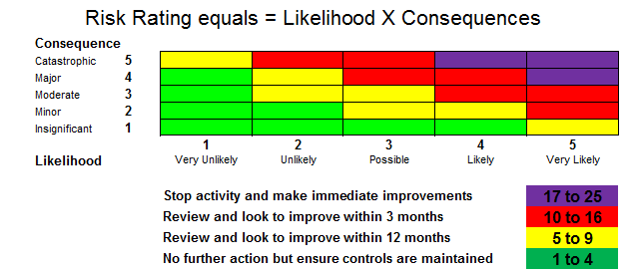

**For further information, please refer to the Risk Assessment Policy on our webpage:** [**Risk Assessment Procedures**](https://view.officeapps.live.com/op/view.aspx?src=https%3A%2F%2Fwww.stir.ac.uk%2Fmedia%2Fstirling%2Fservices%2Festates-and-campus-services%2Fdocuments%2FRisk-Assessment-Procedure-Final.doc&wdOrigin=BROWSELINK)