
THE TRUMPET
Stirling Law School’s Bulletin 1/2025
This bulletin is for sharing Stirling Law School’s achievements in research, teaching, and citizenship. This recognises the importance of celebrating successes, strengthening our sense of community, and creating opportunities for cross-Faculty and cross-University collaborations. We hope you’ll enjoy these snippets of Stirling Law School’s recent successes.
Table of Contents

Impact and engagement 1
Publications 3
Journal articles 3
Chapters 6
Esteem, network, and citizenship 7
Dissemination and media presence 9
Staffing 9
Get in touch 9

Impact and engagement

Workshop: “Charting Paths: Proposals and Emerging Frameworks for NGO Regulation and Accountability"

On 7th March 2025, the University of Stirling Law School hosted a one-day workshop “Charting Paths: Proposals and Emerging Frameworks for NGO Regulation and Accountability.” This event was organised by Dr Domenico Carolei and funded by the Society of Legal Scholars. It brought together academics, policymakers, and NGO practitioners from the UK, USA, Thailand, the OECD, and the EU Parliament. Amid growing scrutiny of NGOs due to sector scandals, funding cuts, and regulatory pressures, the workshop provided a timely platform to examine regulatory frameworks and accountability mechanisms for NGOs. Participants included representatives from Oxfam GB and Human Appeal, offering practical insights from the field. Discussions emphasised the urgent need for collaborative approaches to safeguard accountability, particularly to the communities NGOs serve. The workshop laid the groundwork for future initiatives, including an edited collection and a network to promote research in NGO regulation and accountability. A detailed post-event report is available on the University of Stirling website here.


Figure 1: The attendees of the SLS funded workshop organised by Dr Domenico Carolei

Impact and Engagement on Concussion in Sport

In early March, Dr Dave McArdle spent a week in Bali, carrying out fieldwork and research interviews for a project on sport-related concussion on behalf of Asia Rugby. The work, generously funded by a Faculty Impact Grant, involves working with local stakeholders on concussion-related policies, education and awareness with a view to ultimately improving local strategies for detection, prevention and treatment among youth and grassroots rugby union players, coaches and officials The project is focused on countries where rugby remains a minority sport and where medical and educational resources are scarce. He will submit his report by the end of May, to include recommendations that Asia Rugby can then seek to develop into policy and governance initiatives for use in Indonesia and other 'new' rugby communities. Those will be reinforced by recommendations for effective implementation and oversight.
Relatedly, Dr McArdle recently advised a sports governing body in relation to a dispute over the proper interpretation of its concussion return-to-play rules, and he has been appointed to the Scottish Government Concussion Advisory Group. This is a body of (predominantly) medical professionals which, as the name suggests, advise the Scottish government and publicly-funded bodies on public health issues relating to concussion awareness, prevention and response. He's only been to one meeting so far but reports that it was “all jolly interesting!”

On 9 April 2025, Dr Pontian Okoli delivered a guest lecture at the School of Oriental and African Studies (Arbitration and Dispute Resolution Centre).

The paper, “What Treaty Approach to Enforcing Sovereign Debts?”, offered a critique of international legal frameworks and an exploration of how sovereign debt can be characterised, contextualised, and effectuated. The main issues were situated within today’s global debt crisis, pointing to over 45 countries in the Global South that devote more national revenue to debt servicing than to health or education. He raised fundamental questions about the dominant legal actors and systemic gaps in global sovereign debt governance in the light of current work concerning the United Nations Framework Convention on Sovereign Debt.

Professor Martin Lau moderated the session which staff members, students, members of the research community and legal practitioners attended with incisive engagement.

Law Reform

The Scottish Law Commission (SLC) has recently published its Report on the Tenancy of Shops (Scotland) Act 1949 (Scot Law Com No 267, 2025), available here. In this, the SLC recommends the repeal of the 1949 Act, which allows tenants of shops to apply to court to seek a renewal of their leases when the landlord attempts to bring them to an end. Dr Craig Anderson was a member of the SLC’s Advisory Group, a panel of experts providing assistance to the SLC in its deliberations.

Dr Robbie Reid, Dr Tracy Kirk, Dr Craig Anderson, Dr Mo Egan, Dr Edit Frenyo, and former student and current teaching assistant Courtney Evison jointly submitted evidence to the Scottish Law Commission as part of its consultation on Civil Remedies for Domestic Abuse in Scotland. Their submission contributes academic insight to ongoing legal reform efforts aimed at improving protections and remedies for survivors of domestic abuse.

Publications

Journal articles

Dr Craig Anderson has recently published an article, “Liability for damage to third-party property” (2025) 182 Rep B 3, which considers a recent UK Supreme Court case on the question of liability for negligent damage to property where the loss is suffered by a hirer of that property.

Dr Alexander Houghton has published the following article: "Resolving Peer Disagreement about the Law" (2024) 30(3) Legal Theory 142. Open-access, and available here.

Abstract: Legal experts—lawyers, judges, and academics—typically resist changing their beliefs about what the law is or requires when they encounter disagreement from those committed to different jurisprudential or interpretive theories. William Baude and Ryan Doerfler are among the most prominent proponents of this view, holding it because fundamental differences in methodological commitments severs epistemic peerhood. This dominant approach to disagreement, and Baude and Doerfler’s rationale, are both wrong. The latter is committed to an overly stringent account of epistemic peerhood that dogmatically excludes opponents. The former violates the conjunction of three plausible epistemic principles: Complete Evidence, considering all epistemically permissible evidence; Independence, in which only dispute-independent evidence is epistemically permissible; and Peer Support, which involves epistemically permissible evidence. Instead, I argue for jurisprudential humility—we ought to be more willing to admit we do not know what the law is or requires, and take seriously conflicting views.

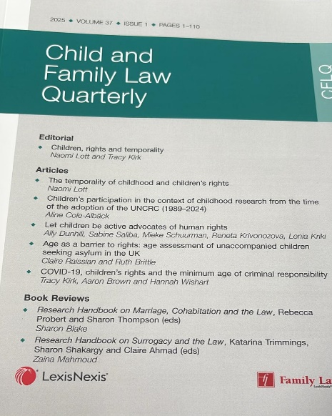
​Dr Tracy Kirk, working with Dr Naomi Lott (University of Reading), has co-edited a special edition of the Child and Family Law Quarterly journal focused on the theme of children’s rights and temporality. This collection features contributions from leading scholars across Europe, addressing topics such as the ‘anti-children’s rights movement’ and age assessments in immigration contexts.

Dr Kirk co-authored the peer-reviewed editorial with Dr Lott, titled "Children, rights and temporality", which opens the special issue:

This editorial introduces a special issue of the Child and Family Law Quarterly that explores the under-theorised intersection of children’s rights and temporality. Lott and Kirk reflect on how children’s rights scholarship has historically been dominated by family law and often disconnected from its roots in international human rights law. The editorial highlights the relevance of temporality to children’s rights—encompassing the evolving nature of childhood, the cyclical nature of rights implementation, and the framing of crises such as COVID-19 or digital expansion. The special issue expands this discourse through contributions examining topics including children’s participation, age assessments for unaccompanied minors, anti-child rights movements, and minimum age of criminal responsibility. By incorporating insights from sociology, neuroscience, and law, the collection aims to deepen theoretical engagement with children’s rights and foreground the importance of temporal contexts in shaping legal and policy responses. It invites further scholarship at the intersection of time, rights, and childhood.
Figure 2: Special edition of Child and Family Law Quarterly

Dr Tracy Kirk co-authored a substantial peer-reviewed article with Dr Aaron Brown and Dr Hannah Wishart on "COVID-19, children’s rights, and the minimum age of criminal responsibility (MACR)" in Child and Family Law Quarterly. The paper argues that the pandemic has significantly impacted children’s development and may warrant revisiting the UN Committee on the Rights of the Child’s current position on MACR.

Abstract: Recent preliminary studies highlight that the COVID-19 pandemic has significantly affected children. The nature and duration of the pandemic has adversely impacted their social and emotional development because they have grown up in isolation from their peers due to school closures and social distancing measures. Studies suggest this social exclusion may have prevented them from learning positive social behaviours which would usually occur through socialisation. The United Nations Committee on the Rights of the Child (CRC) highlights the importance of state parties having protections in place that recognise the importance of neurological, biological and sociological developments. It requires, in General Comment No 20, state parties to recognise the concept of evolving capacities as an ‘enabling principle that addresses the process of maturation and learning, through which children progressively acquire competencies, understanding and increasing levels of agency to take responsibility and exercise their rights’. The CRC recommended in 2019 a minimum age of criminal responsibility (MACR) of at least 14 years old. This paper will argue that the COVID-19 pandemic has impacted children to such an extent that the CRC should review its recommendations on the MACR and consider recommending a ‘developmental immaturity defence’, to enhance the rights of those who are now more developmentally vulnerable. This paper will explore these issues in the context of the United Kingdom.

Dr Tracy Kirk and Dr Kasey McCall-Smith (University of Edinburgh) have co-authored an article published in the Edinburgh Law Review titled "Been There. Done That. International Interpretive Materials and Evolving Children’s Rights":

Abstract: The article examines the impact of international interpretive materials—particularly those from the UN Committee on the Rights of the Child (CRC)—on the implementation of children’s rights in Scotland under the UNCRC (Incorporation) (Scotland) Act 2024. The Act requires that legislation be interpreted compatibly with the UNCRC, giving weight to non-binding but authoritative sources like CRC general comments and concluding observations. Using case studies on corporal punishment and the minimum age of criminal responsibility (MACR), the authors show how these materials have already influenced Scots law reform. The article argues that the 2024 Act builds on existing practice and that sustained engagement with international guidance is vital to realising children’s rights as evolving, enforceable standards in domestic law.

Dr Tracy Kirk and Advocate (and trusted TA) Frank Burr have published a paper in the Juridical Review examining the case MM v Glasgow City Council, which considers the interpretation of the Adoption and Children (Scotland) Act 2007 in light of the new 2024 Act. Their analysis was confirmed by the decision of the Inner House of the Court of Session:

Abstract: In this paper, the authors analyse the recent Sheriff Appeal Court decision in MM v Glasgow City Council. The case raised questions about the statutory interpretation of s.81(1) and (2) of the Adoption and Children (Scotland) Act 2007 (“the 2007 Act”). The case also prompts wider questions about the competence of regulating residence of 16- and 17-year-olds who are defined as children under the United Nations Convention on the Rights of the Child (Incorporation) (Scotland) Act 2024 (“the 2024 Act”). The paper starts with an overview of the case and an outline of the decision by the Sheriff Appeal Court. Thereafter, the 2024 Act will be considered to outline the age requirements in the United Nations Convention on the Rights of the Child (the UNCRC). The potential implications for the future granting of permanence orders for 16- and 17-year-olds will then be considered.

Professor Annalisa Savaresi published the following two articles in the Review of European, Comparative & International Environmental Law (RECIEL):

- A Savaresi “Verein KlimaSeniorinnen Schweiz and Others v Switzerland: Making climate change litigation history” (2025) 34(1) RECIEL 279, available here.

Abstract: This case note examines the landmark judgment issued by the European Court of Human Rights regarding the complaint brought by the NGO Verein KlimaSeniorinnen Schweiz and four individual applicants against Switzerland. It explores the groundbreaking nature of this judgment and its broader implications for climate change litigation at the national, regional and international levels.

- C Sasso, A Savaresi and S Vesa, “Piecing Together the LULUCF Jigsaw: Forests in the EU’s Fit For 55 Package” (2025) 34(1) RECIEL 23, available here.

Abstract: This article considers the intricate regulatory jigsaw of forest governance that has emerged from the Fit for 55 Package. It focuses on the 2023 revision of the Land Use, Land-use Change and Forestry Regulation, the treatment of forest biomass in the 2023 Renewables Directive, and Regulation on carbon removals and carbon farming. The article explores the interconnections between these instruments, their relationship with other relevant EU Law instrument, and their projected impacts. Recognising the evolving nature of law and policy in this area, we offer an initial assessment of this regulatory jigsaw, highlighting the challenges of balancing the cultural, economic, social, political, and scientific considerations intersecting in EU forest governance.

In addition to this, Professor Savaresi’s work “International human rights bodies and climate litigation: Don't look up?” was ranked within the top 10% of most-viewed papers published by the journal in 2023.

Chapters

Dr Domenico Carolei published the following chapters in edited books:

- D Carolei, Chapter 2: "NGO-NGO conflict" in M Z Deloffre & S Quack (eds), A Relational Approach to NGOs in Global Politics: Beyond Cooperation and Competition (Oxford University Press, May 2025), available here.

- D Carolei, Chapter 12: "Non-governmental organisation accountability" in M Flinders, G Dimova & C Monaghan (eds), Understanding Accountability: New Perspectives on a Fractured World (Routledge, July 2025), available here.

Professor Annalisa Savaresi published the following co-authored chapter:

C Hilson and A Savaresi “Regenerative Approaches and Environmental Law: Beyond Sustainability?” in C Hilson and J van Zeben (eds), Research Agenda for Environmental Law (Edward Elgar, 2025) 59, available here.

Esteem, network, and citizenship

Mooting

The 2024/25 academic year saw the re-establishment of the Stirling University Moot Competition, organised by Dr Alexander Houghton. The final took place in February 2025. The final judging panel consisted of our very own Professor Paul Beaumont, as well as Sheriff Patricia Pryce, and Greg Sanders (Advocate). The court gowns worn by the students were gratefully obtained by Dr Jayne Holliday via a successful application to the Vice Chancellor’s Fund. Dr Craig Anderson and Dr Robbie Reid were involved in writing moot problems and judging the initial rounds. Additionally, a Stirling Moot team was entered into several external national mooting competitions, such as the Sir Alexander Stone Competition.

An LLB student on the winning team of the final round of the University of Stirling Moot Competition, Niamh Doherty, said: “Mooting at the University of Stirling, so far, has been an incredibly rewarding and exciting experience. So far, I have been able to expand my connections in the legal field and with other students. The support from our lecturers and professors has been really encouraging, a few have even given their own time to coach us and watch our moots. I feel it makes such a difference being able to apply your legal knowledge and use it to argue a case before a court. We are also very fortunate as a University to have the court robes. I think it makes such a difference to our competitions as the experience becomes a lot more immersive and realistic, you start to feel so professional, like a real advocate!”


Figure 3: The finalists and judges of the internal mooting competition

Human Rights Journal Launch

Staff in the Law School have been involved in establishing the first student-led human rights journal in Scotland. The University of Stirling Human Rights Journal is an open-access, peer-reviewed journal dedicated to showcasing research in the field of human rights. As a multidisciplinary platform (including researchers from Law, Criminology, Social Work, Publishing, Education, and Journalism), it provides visibility and space for scholarship while serving as an educational tool to deepen critical thinking in this vital area. Work will be published by postgraduate students, early career researchers, and practitioners, fostering the next generation of human rights advocates. A number of colleagues in Law are acting as Academic Advisors to the Editorial Team: Dr Damian Etone, Dr Edit Frenyo, Dr Tracy Kirk, Dr Linda Mensah, Dr Domenico Carolei, Professor Annalisa Savaresi, and Dr Scarlet Robertson.

In addition to main publications, USHRJ features a blog section welcoming shorter contributions from postgraduate students, established academics, and human rights practitioners addressing topical human rights issues. A podcast section further engages audiences with discussions on pressing human rights matters, led by experts in the field. Further information can be found about on the journal’s website here.

This link also provides video footage from the Launch Event, which was held last month (see photo below), where you can hear from staff and students involved.
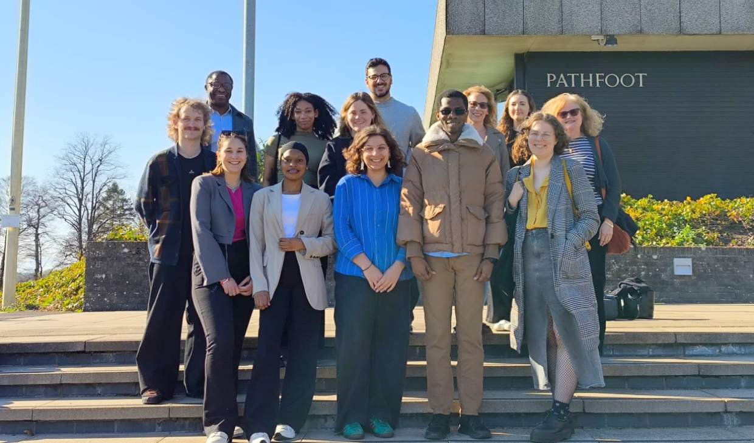
Figure 4: Some of the attendees from the launch event

Appointments

Dr Domenico Carolei has been appointed as a member of the Finance Committee of the International Society for Third-Sector Research (ISTR), an international society that brings together over 900 members in 90 countries working on NGO studies across disciplines.

Professor Annalisa Savaresi has been reappointed as a Member of the Board of Environmental Standards Scotland, with her new term running from 1 April 2025 to 31 March 2028.

Dissemination and media presence

Professor Annalisa Savaresi published the following on the Global Network for Human Rights and the Environment blog: M Wewerinke, A Savaresi and C Heri, “Saving the Green Deal: A Climate Justice and Human Rights Imperative” (24 February 2025), GNHRE: available here.

Professor Savaresi additionally gave the following talks in Italy on environmental and climate change law:

- “The protection of the environment through human rights protection instruments: new challenges for justice in Europe” Italian Judiciary Training School – Environment, Climate Justice, and Human Rights, Pescara (11 April 2025)

- “Rights of future generations in the context of climate change: methodological challenges, legal gaps and prospects” University of Salento, Lecce (9 April 2025)

Staffing

Since the last bulletin, we are pleased to have welcomed Claire Thorpe as Operations Officer for the Law and Philosophy Division, who started this role in January.

Congratulations also to Heather McIntosh on being appointed as Learning and Teaching Coordinator for the Division.

Get in touch

If you would like to contribute or suggest anything for future bulletins, please get in touch with Robbie here.

