
THE TRUMPET
Stirling Law School’s Research Bulletin 2/2025
This bulletin is for sharing Stirling Law School’s achievements in research, teaching, and citizenship. This recognises the importance of celebrating successes, strengthening our sense of community, and creating opportunities for cross-Faculty and cross-University collaborations. We hope you’ll enjoy these snippets of Stirling Law School’s recent successes.
Table of Contents

Impact, engagement, and funding 1
Publications 4
Books 4
Journal articles 4
Chapters 7
Esteem, network, and citizenship 9
Events, dissemination, and media presence 9
Staffing 12

Impact, engagement, and funding

Hague Conference on Private International Law (HCCH) Working Group on Jurisdiction

Professor Paul Beaumont continued to represent the EU in the Hague Conference on Private International Law (HCCH) Working Group on Jurisdiction. The latest meeting in The Hague in October 2025 finalised the latest version of a Draft Text for a Convention on Parallel Proceedings and Related Actions in Civil or Commercial Matters. The Working Group also helped the HCCH Secretariat (the Permanent Bureau) to finalise a consultation paper to accompany the Draft Text. For the first time in the history of the HCCH a Draft Text of a Convention is the subject of a global online consultation which is open until 9.00, 26th January 2026, see HCCH | Public consultation on the Draft Text.

2025 OECD DAC Civil Society Days

Dr Domenico Carolei was invited to speak as an academic expert at the 2025 OECD DAC Civil Society Days in Paris (June 2025). The event gathered over 320 participants from governments, civil society organisations, philanthropic foundations and multilateral institutions under the theme “Protecting Civic Space in a Turbulent World.”

Contributing to Session 3: “Strengthening CSO Accountability to Counter Shrinking Civic Space,” Dr Carolei addressed international institutions’ role in emerging accountability frameworks, the balance between self-regulation and oversight, and the importance of safeguarding civic freedoms.

Panel speakers included Oleksandr Yarema, State Secretary of Ukraine; Anne Lindeberg, Swedish International Development Cooperation Agency (Sida); Fredrick Olinga, DENIVA (Uganda); and Hans Rosenkranz Silva, Comunidad Organizaciones Solidarias (Chile). The session was moderated by Megan Colnar, Executive Director of Accountable Now. The full recording is available on OECD TV.
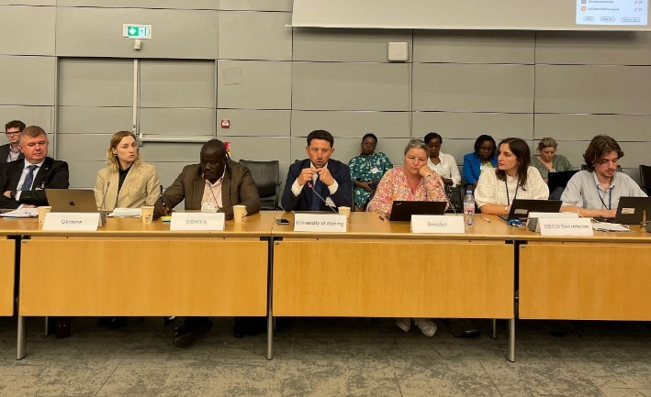
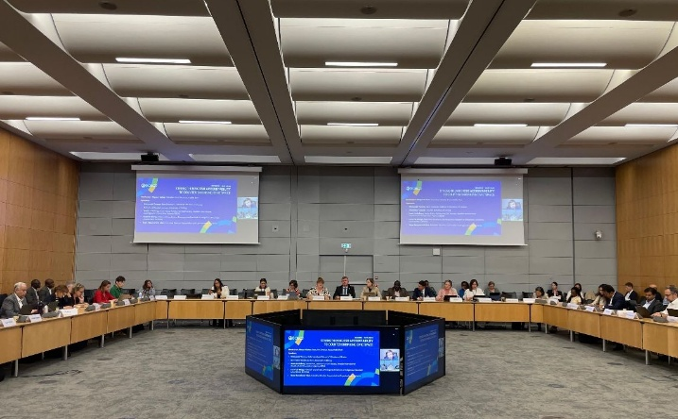

Figure 1: Photos from the event showing Dr Domenico Carolei on the panel.

International Notaries Conference

In the Spring of 2025, Dr Jayne Holliday provided an Expert Opinion for a cross-border succession case involving Scotland and Italy. As a result of that work, Dr Holliday and Professor Paul Beaumont were invited to speak at the International Notaries Conference in Edinburgh on 5th September 2025 where Dr Holliday had the honour of explaining Scots private international law rules of succession and the implied choice of law rule under article 83 of the EU Succession Regulation, to all who attended. See the conference programme for further details.

Webinar on COVID-19, Children’s Rights and the MACR

Dr Tracy Kirk alongside Dr Aaron Brown and Dr Hannah Wishart delivered a high-impact webinar translating emerging developmental research into actionable insights for youth justice reform. The session directly informed practitioners and policymakers about the long-term consequences of the COVID-19 pandemic on children’s social and emotional development, strengthening calls for a developmentally appropriate minimum age of criminal responsibility and influencing ongoing debates across the UK.

2026 CYCJ Youth Justice Conference

Dr Tracy Kirk was invited to present at the Annual CYCJ Youth Justice Conference 2026 in recognition of her leadership in shaping understandings of evolving capacities in youth justice. Her contribution is expected to influence professional practice at a national level, supporting more rights-compliant, developmentally informed responses to children in conflict with the law.

Participatory Research with International Reach

Dr Tracy Kirk is leading participatory research with international reach, working alongside young people as co-researchers to document their experiences of campaigning for UNCRC incorporation. This project elevates youth voice in both academic and policy spaces, models rights-respecting research practice, and is shaping international conversations on meaningful participation and children’s agency in law reform.

UNCITRAL Colloquium on Possible Updates Possible Updates to the Guide to Enactment and Interpretation of the UNCITRAL Model Law on Cross-Border Insolvency

At the invitation of the United Nations Commission on International Law, Dr Pontian Okoli spoke as a panellist at the UNCITRAL Colloquium on Possible Updates Possible Updates to the Guide to Enactment and Interpretation of the UNCITRAL Model Law on Cross-Border Insolvency in Vienna (11th-12th December 2025). Translations were available in all languages of the United Nations. He was on Panel 5 (Public Policy Exception & Adequate Protection of Creditors). The Panel’s insights, alongside others, “will be considered by the Commission at its next session in 2026, in conjunction with possible future work by UNCITRAL in the area of insolvency law.” As the Australian delegation observed, it was an important and unique opportunity to “shape the future adoption and implementation of the Model Law.”

2025 Business and Human Rights Forum Annual Conference

Professor Annalisa Savaresi served as a panellist at the 2025 Business and Human Rights Forum Annual Conference at BIICL on 15th December.

Professor Savaresi also contributed to BIICL’s Open-Access Online Training on “Global Perspectives on Corporate Climate Litigation” on 27th-28th November 2025.

Law Reform Contributions

- Earlier this year, Dr Pontian Okoli responded to the South Africa Law Reform Commission's Discussion Paper regarding the Singapore Convention on Mediation where he urged accession to the Convention. His “Response to Discussion Paper 168 (Project 94 – Alternative Dispute Resolution: A Mediation Act for South Africa)” was well received.

- Professor Emerita Elaine E. Sutherland submitted written responses to the Scottish Law Commission’s Discussion Paper on Civil Remedies for Domestic Abuse (Scot. Law Com. D.P. No. 178, 2024), 5th February 2025, and to the Civil Justice Council’s Public Consultation on the simplified procedures for divorce and dissolution (Edinburgh: Scottish Civil Justice Council, 2024), 8th May 2025.

On 30th September 2025, Professor Sutherland additionally gave oral evidence to the Equalities, Human Rights and Civil Justice Committee of the Scottish Parliament on the Children (Withdrawal from Religious Education and Amendment of UNCRC Compatibility Duty) (Scotland) Bill.

Funding awards

- Dr Alexander Houghton was awarded a small grant by the Society for Applied Philosophy to support organising and hosting the “Epistemology of Law” workshop, which was held on 27th October 2025. This was an interdisciplinary workshop on philosophical and epistemic questions as they relate to the law. The event included presenters and attendees from both the Law and Philosophy division at Stirling; local institutions (Glasgow & Edinburgh); further UK-based institutions (Aberdeen, LSE, and Oxford); and international institutions (Fordham New York, and UCLA California),

- Professor Hong-Lin Yu and Dr Burcu Can Buglalilar received an award of £267,243 from the UK Innovate, UKRI for a research project to test out whether the data extracted from law reports would provide a good basis for Large Language Models (LLMs) to predict compensation in commercial dispute resolution. This will be an opportunity to use natural language processing, machine learning and legal data analysis technologies to enable us to provide a creditable tool for access to civil justice.

Publications

Books

In November, Edinburgh University Press published The Law of Negligence by Francis McManus, Honorary Professor of Law. Further information is available here.

In this work, “Francis McManus provides a critical and comprehensive account of the development of the modern law of negligence, arguably the most important, and indeed, the most litigated area of the law of delict. McManus discusses the leading cases on the subject and reviews the relevant literature. Whilst the book concentrates on the law of Scotland, McManus also explores how certain areas of the law have developed in Commonwealth countries. Coverage spans the duty of care (including liability for omissions, negligent misstatements, pure economic loss, and psychiatric harm), the breach of the duty of care, factual causation and legal causation.”

Journal articles

Dr Gulay Cagla Firatli has had her article, “Compulsory Jurisdiction under UNCLOS: Obligations Pending Maritime Delimitation” (2026) 13 Journal of Territorial and Maritime Studies, 49-78 accepted for publication.
Abstract: the paper considers whether the scope of the optional exception to compulsory jurisdiction under article 298(1)(a)(i) of United Nations Convention on the Law of the Sea (UNCLOS) covers disputes arising pending delimitation and which relate to obligations of conduct under 74(3) and 83(3) of UNCLOS. This paper adds to the existing literature by arguing that a textual and contextual approach allows for the interpretation that obligations of conduct under paragraph 3 of articles 74 and 83 of UNCLOS are not excluded by a declaration under Article 298 of UNCLOS.

Dr Dave McArdle’s latest paper, on the interface between the First amendment to the US Constitution and the rights of students and student-athletes in US universities, was published in the Journal of Legal Aspects of Sport in August. It is available to view here.

Abstract: Co-authored with Beth Sorensen (formerly at the University of Colorado) and Sylvia De Mars (Newcastle University Law School), this 20,000-word tome explains that students and student athletes considering their college options ordinarily (and usually correctly) assume they are protected by the laws that prohibit educational institutions from discrimination based on sex. However, it is also the case that that those same laws also permit educational institutions which are controlled by religious organizations to claim exemptions and thus discriminate on the basis of sex while continuing to receive federal funds. The U.S. Department of Education’s Office for Civil Rights, whose aims include serving 'student populations facing discrimination', employs an exceptionally deferential standard in facilitating the religiously affiliated schools’ Title IX exemption claims. Consequently, 'student populations facing discrimination' should actually be prepared to experience discrimination if they attend faith-based institutions. In order to promote informed student choice, the paper provides an accessible, objective and authoritative source on nearly 250 religious educational institutions’ Title IX exemptions and, arising from that, a template that students and others can use to explore the Title IX exemptions that their potential institutions of choice currently enjoy.

Dr Pontian Okoli published the following article: “Ensuring the Effectiveness of Treaties in Africa – Case Studies of South Africa and Nigeria” was published recently: (2025) 57(2) Cornell International Law Journal 487-525. Available to read here:

Abstract: African countries have continued to witness a surge in international commercial transactions with other parts of the world. Although China has taken the center stage in Africa, the expansion of international dealings compels reflections on how to promote international trade. One such method is the use of treaties. In many African countries, treaties often do not have the intended maximum effect. This is an impediment to deriving benefits even when treaties are signed, because the treaty making processes of such countries do not support a clear approach that can facilitate treaty effectiveness. In considering some treaties that have commercial implications, this Article examines the impact of legal history and how this has shaped the current trajectory in Africa. Empirical research has also informed the overarching analysis. The institutional frameworks of South Africa and Nigeria are examined through trade, judgments, and the law of evidence. Key themes are examined through the United Nations Commission on International Trade Law, the Hague Conference on Private International Law and (sub)regional organizations: the South African Development Community, the Economic Community of West African States, and the African Union. The Article makes a case for a “front-loaded functionality” approach.

Dr Okoli also published “Promoting Treaties in Nigeria and Operationalising the Singapore Convention on Mediation” (2025) 17(2) African Journal of Legal Studies 164-195. Available to view here.

Abstract: In Nigeria, the United Nations Convention on International Settlement Agreements Resulting from Mediation (2018) has entered into force. This Convention was incorporated or domesticated by referring to it in the Arbitration and Mediation Act (2023), but statutes are often dedicated to the domestication of treaties. There is no consensus on the most pragmatic way(s) to facilitate Nigerian treaty engagement. This article examines the Nigerian legal regime on treaties and explores the extent to which the regime can be maximised considering the Vienna Convention on the Law of Treaties (1969). A case is made for a principled basis to underpin the domestication of treaties that facilitate international business, including dispute resolution treaties. This analytical basis should enable legislative flexibility already woven into the overarching legal regime. The article articulates how such flexibility can be used to promote the operationalisation of relevant treaties using the Arbitration and Mediation Act as a paradigm.

An article by Dr Pontian Okoli has recently been translated into Portuguese. In the article (published in April 2022 about 18 months before the seminal English High Court decision in P & ID [2023] EWHC 2638 (Comm) which favoured Nigeria), Dr Okoli argued that mega arbitration awards should be carefully considered especially those that have extremely adverse implications for the economies of developing countries. A pro-enforcement arbitration philosophy can and should coexist with discouraging corruption. This complementary approach is critical to enforcing cross-border obligations in an effective and credible manner. The article has now been translated into Portuguese: “Corrupção na arbitragem comercial internacional: efeito dominó na indústria energética, países em desenvolvimento e impacto da ordem pública inglesa”. He is grateful to the leading scholars in Brazil and around the world whose pivotal contributions have been included in Arbitragem e Corrupção (Thomson Reuters, 2025). Dr Okoli enjoyed working with the editors on a book that will influence law and policy in South America and other parts of the world.

In September 2025, Dr Robbie Reid published “Legal certainty restored? What the Hague Judgments Convention means for Scotland” in the Journal of the Law Society of Scotland: available here. In this short update aimed at practitioners, Dr Reid outlines the changes to the legal framework for the recognition and enforcement of foreign judgments in civil and commercial cases in Scotland following the incorporation of the Hague Judgments Convention 2019.

Professor Annalisa Savaresi published the following articles:

- A Savaresi, “Verein KlimaSeniorinnen Schweiz and Others v Switzerland: Making climate change litigation history,” Review of European, Comparative & International Environmental Law (RECIEL), 2025. Available here.
Abstract: This case note examines the landmark judgment issued by the European Court of Human Rights regarding the complaint brought by the NGO Verein KlimaSeniorinnen Schweiz and four individual applicants against Switzerland. It explores the groundbreaking nature of this judgment and its broader implications for climate change litigation at the national, regional and international levels.

- C Sasso, A Savaresi and S Vesa, “Piecing together the LULUCF jigsaw: Forests in the EU’s Fit for 55 Package,” Review of European, Comparative & International Environmental Law (RECIEL), 2025. Available here.

Abstract: This article considers the intricate regulatory jigsaw of forest governance that has emerged from the Fit for 55 Package. It focuses on the 2023 revision of the Land Use, Land-use Change and Forestry Regulation, the treatment of forest biomass in the 2023 Renewables Directive, and Regulation on carbon removals and carbon farming. The article explores the interconnections between these instruments, their relationship with other relevant EU Law instrument, and their projected impacts. Recognising the evolving nature of law and policy in this area, we offer an initial assessment of this regulatory jigsaw, highlighting the challenges of balancing the cultural, economic, social, political, and scientific considerations intersecting in EU forest governance.

Chapters

Professor Annalisa Savaresi has published the following chapters in edited books:

- A Savaresi, “Human rights-based litigation in the transition towards net zero societies: A double edge sword?’ in B Martinez Romera, L Nordlander, A Monti and J Elo Rytter (eds), Human Rights and Investment Law for Climate Change (Edward Elgar, 2025).

Abstract: Human rights-based climate litigation has been growing steadily in recent years, prompting state and corporate actors to take greater climate action. The same may, however, also be said of so-called just transition litigation, which relies on human rights law and remedies to challenge measures or projects designed to deliver climate change adaptation and/or mitigation. This chapter takes stock of these trends in human rights litigation, reflecting on how human rights arguments may be used both to support and to object to measures aimed at delivering the transition towards net zero emissions.

- A Savaresi “State Responsibility” in (Eds.) S Mead and M Wewerinke-Singh (eds) Cambridge Handbook of Climate Change Litigation (Cambridge University Press, 2025). Available here.

Abstract: Chapter 15 on State Responsibility provides an in-depth exploration of the circumstances under which States can be held responsible for climate change. The author starts by outlining the fundamental principles and conditions for State responsibility under international law. Her analysis bridges the gap between international and domestic law, shedding light on how each legal sphere influences the shape and contours of State responsibility in relation to climate change. Further, she enriches her analysis with insights drawn from key climate cases that have tested the limits of State responsibility. These cases reveal how courts and quasi-judicial bodies are grappling with the challenges of attributing climate harms to State actions and omissions, and the implications of holding States accountable for these harms. In distilling emerging best practice, the author identifies innovative judicial interpretations and legal strategies that have expanded the ambit of State responsibility in climate litigation.

- C Hilson and A Savaresi ‘Regenerative Approaches and Environmental Law: Beyond Sustainability?’ in C Hilson and J van Zeben (eds), Research Agenda for Environmental Law (Edward Elgar, 2025). Available here.

Abstract: Regenerative approaches are gaining traction across policy realms and academic fields. This chapter explores their implications for environmental law. It explores various interpretations of regenerative approaches and how they are reflected in recent EU legislation. It further considers whether there is need for a ‘regenerative’ principle in environmental law, and what its normative implications might be.

Professor Emerita Elaine E Sutherland published “Prioritising the Child’s Best Interests: Mixed Messages in the International Human Rights Arena” in Hege Stein Helland, Siri Gloppen and Marit Skivenes (eds), Child Protection and the European Court of Human Rights: Lessons from Norway in the Development and Contestation of Children’s Rights (Bristol: Policy Press, 2025). Available open access here.

Abstract: It is accepted in all European jurisdictions that the state has a role in protecting children where their parents or other family members are unable or unwilling to do so. Sometimes the state can discharge that function by supporting to families generally and providing additional assistance to those in difficulty. Controversy arises, however, over the criteria applied in justifying mandatory state intervention in the family and the appropriate intervention options, matters governed by each jurisdiction’s domestic law.
One measure of the legitimacy of that domestic law is to test it against human rights norms. In Europe, these norms are articulated primarily in the European Convention on Human Rights (ECHR) and the United Nations Convention on the Rights of the Child (CRC). The basic norms have been interpreted and amplified: in the case of the ECHR, by the European Court of Human Rights and, for the CRC, by the United Nations Committee on the Rights of the Child. A difficulty arises, however, if the norms themselves – or the way they have been interpreted and amplified – are inconsistent, since states may be left unclear about what is required of them and it may be impossible for them to comply with all of the norms simultaneously.
This chapter examines the priority accorded to the child’s best interests in the child protection context when weighed against the rights and interests of others, particularly the child’s parents. It evaluates whether states are being sent mixed messages and, if so, how that might be addressed.

Esteem, network, and citizenship

In August, the Law Society of Scotland renewed Professor Emerita Elaine E. Sutherland’s appointment to the Child and Family Law Committee and, as a result, she has now served on the Committee for a record 40+ years.

In November, Mohamed Omran graduated with a PhD in Law having successfully defended his thesis at a viva in July 2025. His topic was "Competition Law in relation to Cartels that have a Cross-Border Impact: Investigation, Enforcement and Co-operation - A Critical Appraisal of Practice in the EU, Algeria and Egypt", which has a large private international law element. His supervisors were Professor Paul Beaumont and Dr Pontian Okoli. His examiners were Professor Mihail Danov (University of Exeter), Dr David McArdle and Dr Robbie Reid.

Events, dissemination, and media presence

Lady Hale Lecture 2025

Professor Paul Beaumont organised the Lady Hale Lecture 2025 at the University of Stirling in his capacity as the Convener for Scotland of the Society of Legal Scholars (SLS). This was the first time that this highly prestigious lecture has come to Scotland. Professor Beaumont is very grateful to the SLS and the University of Stirling for covering the costs associated with the lecture. It was great to celebrate the 20th anniversary of Stirling Law School offering an LLB with such a high profile event showcasing that Stirling is an excellent research intensive Law School with highly engaged staff and students.

The Hale Lecture is the only annual lecture sponsored by the Society of Legal Scholars (the learned society for academic lawyers in the UK and Ireland) and it goes to different Law Schools every year. The Lady Hale Lecture 2025 was given by Lady Hood in the Logie Lecture theatre to an audience of well over 100 on Friday 17 October 2025. It was great to see so many staff and students attending the lecture and enjoying the soft drinks reception afterwards in Campus Central where they were able to chat with Lady Hale and Lady Hood. There was genuine joy at the chance to meet two highly successful female lawyers.

Professor Paul Beaumont had the pleasure at the lecture of introducing Lady Hale (who had three highly successful careers - Professor of Law at the University of Manchester, a member of the Law Commission for England and Wales, and a judge who rose to the highest judicial office in the UK - the first female President of the UK Supreme Court).

Lady Hale then introduced Lady Hood, elevated to the Court of Session bench as a Senator of the College of Justice in 2024 having been a very successful KC since 2015, who spoke on the private international law that applies in cases between the three different countries in the UK (England and Wales, Northern Ireland, and Scotland). This was the subject matter of her PhD thesis and of her Oxford University Press Monograph. She gave a learned lecture on the various options that could be taken to intra-UK private international law before giving one English/Scottish case as a clear example of what can go wrong. An English lawyer brought a case for personal injury damages in England in relation to a car accident in Scotland. Under the relevant private international law rules in Rome II the applicable law governing this personal injury claim was clearly Scots law. Unfortunately the claimant's lawyer thought that the limitation period for bringing the claim was governed by English law (the law of the forum) rather than Scots Law (the law governing the claim). The claim was in time under English law but out of time under the Scots limitation period. The lawyer was wrong because Rome II is clear that the law applicable to the personal injury claim also applies to the limitation period. The lawyer was saved from a large negligence claim by his client by the English judge applying the Scots law on limitation and exercising the Scots law discretion that a Scottish judge has to extend the limitation period partly because the claimant was so badly injured physically and mentally that it would have been very damaging to the claimant to require him to sue his own lawyer for negligence. Had the claimant been in better shape it is highly likely that the Scottish limitation period would not have been extended and the lawyer would have had to pay enormous damages for his clear negligence in not knowing the private international law rules. At the end of the lecture Professor Duncan Sheehan (immediate past President of the SLS) gave the vote of thanks to Lady Hood.

Private International Law is one of the research clusters at the University of Stirling and Lady Hood is an acknowledged expert in this field as well as a member of the Law School's external advisory Board. Stirling Law School enhanced its reputation throughout the UK and Ireland as an excellent Law School with a particular expertise in private international law through the widespread publicity created by the Society of Legal Scholars for the Lady Hale Lecture 2025.
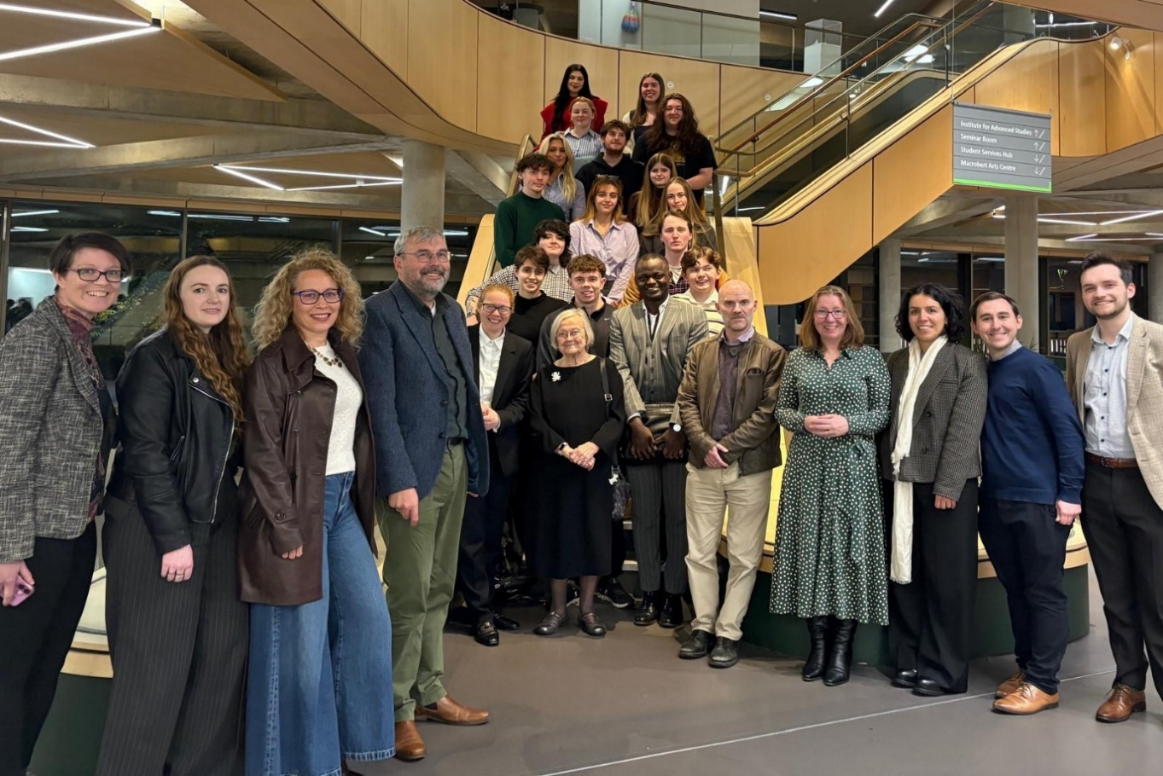
Figure 2: Photo taken in Campus Central at the end of the reception after the Lady Hale Lecture 2025. Front row from left to right: Dr Tracy Kirk, Dr Scarlet Robertson, Dr Edit Frenyo, Professor Paul Beaumont, Lady Hood (Senator of the College of Justice and the Lady Hale lecturer), Lady Hale (former President of the UK Supreme Court), Professor Duncan Sheehan (immediate past President of the Society of Legal Scholars), Dr Jayne Holliday, Dr Gulay Cagla Firatli, Dr Robbie Reid, and Dr Alexander Houghton.
Journal of Private International Law 20th Anniversary Conference

Professor Paul Beaumont as one of the two general editors of the Journal of Private International Law since its launch in 2005 was delighted to be one of four hosts of the Journal of Private International Law 20th Anniversary Conference at University College London from 11th-13th September 2025. Nearly 200 academics from all over the world participated in person at the conference with over 100 speakers (16 in plenary and the rest in 32 parallel sessions) across the whole range of private international law under the umbrella heading of "The Functions and Futures of Private International Law". The standard of the conference presentations was excellent (based on an open competition for abstracts) and the feedback to the conference organisers was exceptionally good. Professor Beaumont will be one of the co-hosts of the next Journal of Private International Law Conference at the University of Zurich from 1st-3rd April 2027. This is the only global conference dedicated to private international law scholarship and it is a vital part of developing the discipline. Previous conferences have been held in Aberdeen, Birmingham, New York, Milan, Cambridge, Madrid, Rio de Janeiro, Munich, and Singapore. Scholars meet each other and their papers are refined by expert feedback before the presenters submit the final version of their papers to the Journal which operates a rigorous double blind peer review system drawing on experts from all over the world.

Guest lecture and workshop (Rijeka University School of Law, Croatia)

In July, Dr David McArdle delivered a lecture and workshop at the Rijeka University School of Law in Croatia, as part of its annual Sports Law Summer School. This is funded by the European Commission as part of the Jean Monnet Chair in Sports Law, which Rijeka has held for the past three years. The paper, adapted from his forthcoming book on European Sports Law, explored the European Commission's changing approach to the regulation of gambling, which it no longer perceives as simply an aspect of free movement law but instead as an area where national sensibilities, perceptions and policies make it more suitable for national-level prohibition or regulation. An important exception would arise if illegal gambling could be linked to high-level criminal legal activities such that the EU's provisions on money laundering were engaged - but that would involve incidents linked to, or at least analogous to, terrorist funding activities. The EU is not particularly concerned with the social harm, public health implications or low-level criminality which gambling routinely promotes, having chosen instead to file those away in the 'too difficult' box; but the narrow scope of the Anti-Money Laundering Directives prevents useful action in that regard too.

Keynote: The ICJ Advisory Opinion and the Future of Climate Litigation

Professor Annalisa Savaresi gave a keynote The ICJ Advisory Opinion and the Future of Climate Litigation, University of Helsinki, 10th October 2025. The full programme from the event is available here.

Staffing

Since the last bulletin, we are pleased to have welcomed Dr Gulay Cagla Firatli and Mr Calum Stewart as Lecturers in Law, Eilidh Henderson as Learning and Teaching Administrator, and Roswitha Lucht as Learning and Teaching Coordinator. We would like to wish them all the best in their respective roles.

