# Facilities



Level 2: Enquiry

* Stairs/Lifts
* Toilets
* Information Centre Reception
* Self Issues/Self Return
* Print/Photocopy
* Open and Group Study Area



* Disability Team Rooms
* Archive
* Catalogue Terminals
* Well-being Space
* Click and Collect Shelves

# Loan Types

* Short Loan
* Laptop Loan

# Facilities



Level 3: Quiet study

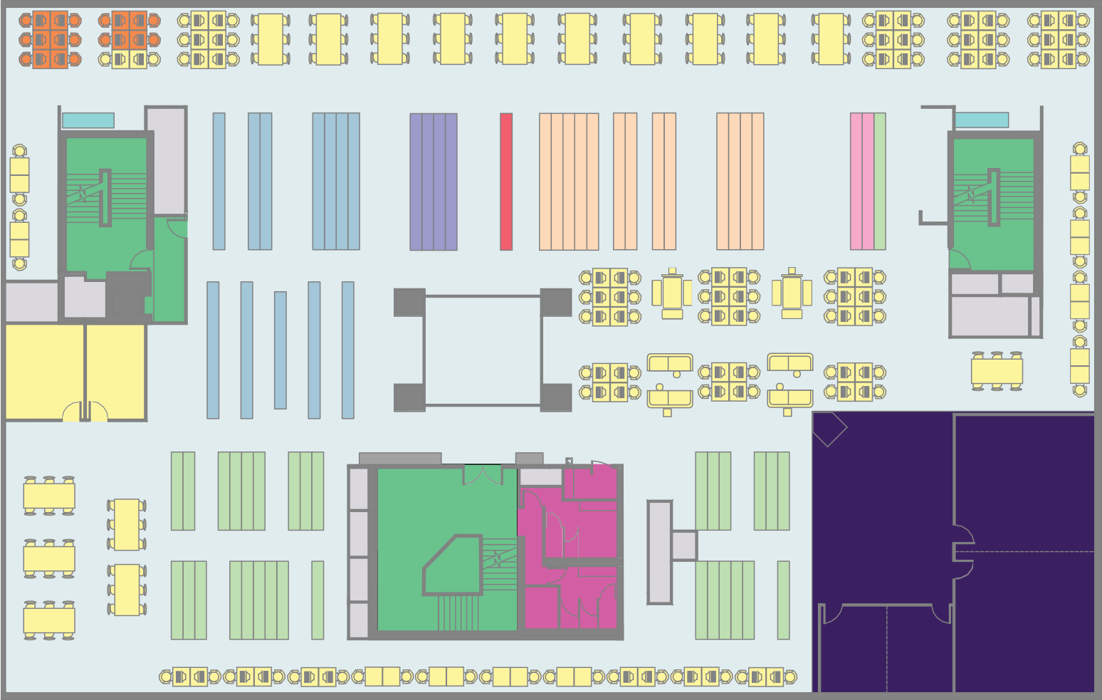

D-G

Law

Ref

Journals

Quarto A-B

A-D

1

2

LP-MA

D-G

G-LP

B-D

* Stairs/Lifts
* Toilets
* Print/Photocopy
* Open and Group Study Area
* Catalogue Terminals
* Library Training and

Study Suite

* Dual Monitor PCs

# Loan Types

* Popular Loan
* Long Loan
* Quarto
* Journals
* Law Collection

# Facilities



Level 4: Silent study

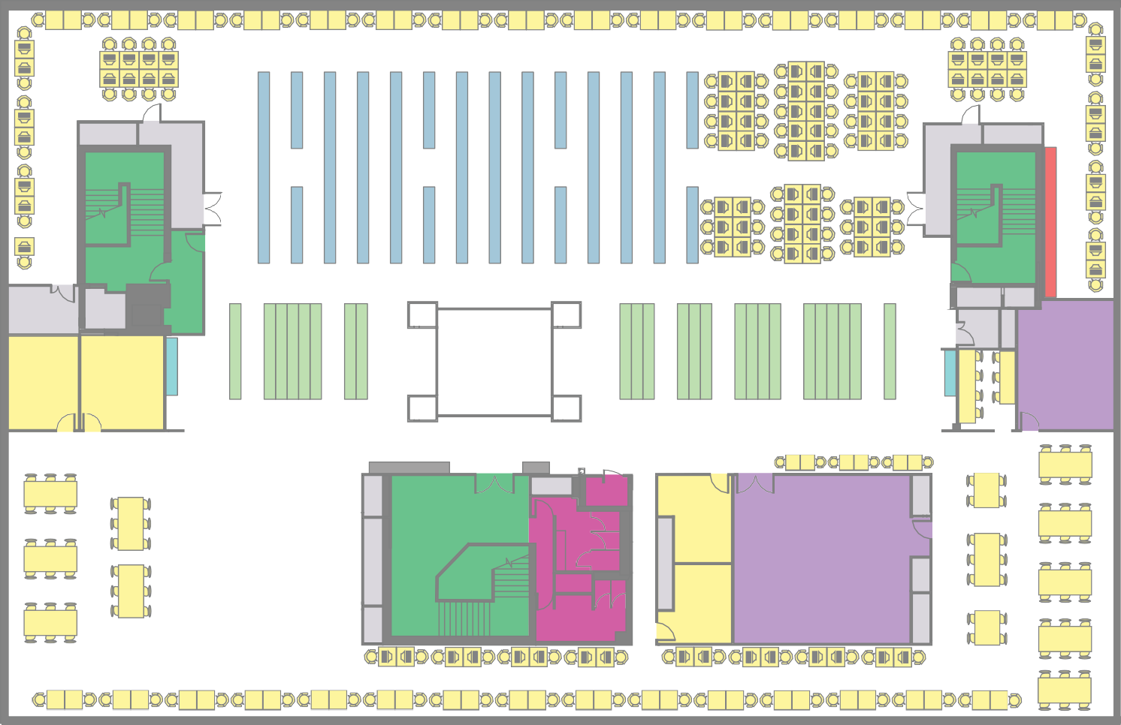

GS-Z

MA-MJ

MM-Z

3

4

Training room 2

9

Training room 1

10

* Stairs/Lifts
* Toilets
* Training Rooms
* Print/Photocopy
* Open and Group Study Area
* Catalogue Terminals

# Loan Types

* Popular Loan
* Long Loan
* Statistics/Reference
* Abstracts

|  |  |  |
| --- | --- | --- |
| 6 | 5 | |
| 7 | 8 | |
|  |  |

This publication can be made available in different formats.

