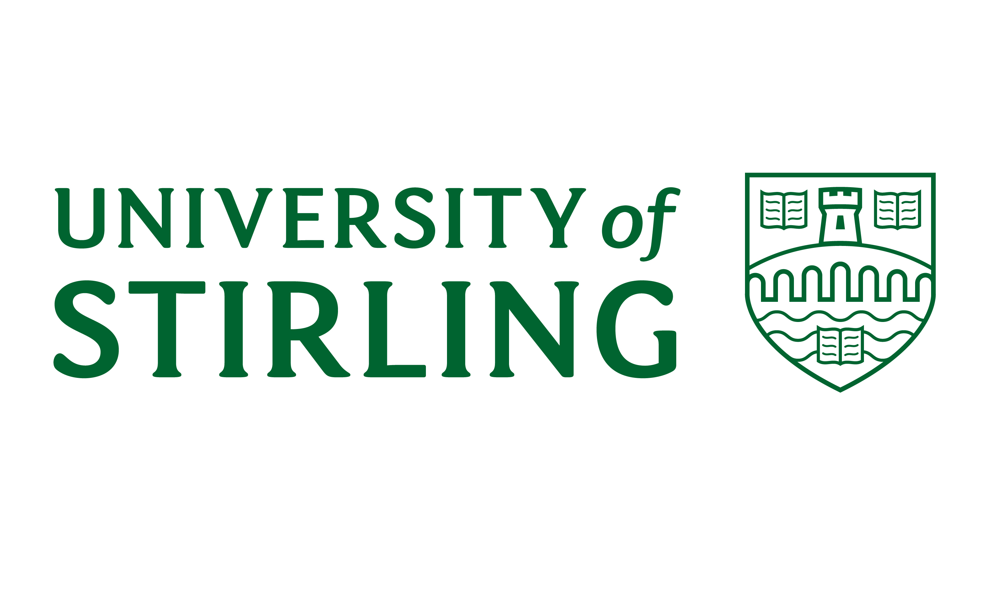

PART II
II - DISCIPLINARY PROCEDURE

1. Scope and Definitions

  - The University of Stirling recognises that it is the responsibility of all employees to ensure that acceptable levels of attendance, conduct, behaviour and performance are maintained at all times. This procedure is in accordance with the ACAS Code of Practice 1 and is intended to address situations where the conduct or behaviour of an employee falls below acceptable standards.
2. General Principles

2.1 The University reserves the right to start disciplinary procedures at any level depending on the seriousness of an alleged offence or where an earlier pattern of unacceptable attendance, conduct or behaviour has been established.

2.2 In some circumstances it will be appropriate for the Dean of Faculty/Department to make every effort to resolve matters by informal discussion and oral reprimand. Where this fails to bring about the desired improvement the formal disciplinary procedure may be implemented.

2.3 Matters of capability/performance will be dealt with under this procedure where appropriate to ensure that employees, who are experiencing performance difficulties, are managed appropriately.

2.4 In cases of alleged misconduct formal disciplinary action will not be taken against an employee until the alleged incident has been fully investigated. If deemed appropriate, the employee concerned may be suspended until the investigation has been completed.

3. Suspension from duty

3.1 In the context of this procedure, suspension is not a disciplinary act and the employee will remain on full pay, pending investigation. It is a neutral act which does not imply that misconduct has taken place. There should be no implication of guilt as a result of an individual having been suspended.

3.2 Under normal circumstances the Principal or University Secretary (and, as appropriate, delegated nominees) will have the authority to sanction a suspension. Suspension may be used because it is considered desirable to have the employee separated from contact with potential witnesses or evidence or to avoid other difficulties that might arise. The suspension will be confirmed in writing to the employee by the Dean of Faculty/Department as soon as is practicable within 5 working days, outlining the reason for suspension.

3.3 Normally, it is expected that a suspension will last no longer than 2 weeks. If, however, the case is particularly complex and the investigation protracted, it may be necessary to continue the suspension for a longer period.

4. Investigation

4.1 When an allegation concerning an employee’s conduct is brought to the attention of the manager to whom he/she is immediately accountable the Dean of Faculty/Department will inform the employee of the nature of the allegation and that it will be investigated. It will be the responsibility of the Dean of Faculty/Department to identify two investigating officers, normally from a different section to the one in which the employee works, to establish the facts of the matter.

4.2 Having completed the investigation and established all the relevant facts, the investigating officers will submit a written report to the Dean of Faculty/Department who will decide on the appropriate course of action. This will be one (or a combination) of the following:-
(i) no action;
(ii) action other than a formal disciplinary sanction, for example counselling, review, setting of standards, retraining, redeployment;
(iii) convening a formal disciplinary hearing.

If a disciplinary hearing is convened any written evidence to be used at the hearing will be made available to all parties prior to the hearing taking place. The employee will be informed in writing of the requirement to attend a formal disciplinary hearing. Normally such notice will be given at least 5 working days prior to the hearing.

5. Disciplinary Process

5.1 Stage 1 – Written Notification. - The Dean of Faculty/Department will set out in writing the allegation or reason for disciplinary action and invite the employee to attend a hearing to respond to the allegation or reason for disciplinary action.

5.2 Stage 2 – Hearing - A disciplinary hearing will take place to consider and discuss the matter. After the hearing the employee will be informed of the decision and advised of their right to appeal.

5.3 Stage 3 – Appeal - An employee who wishes to appeal will be required to submit the appeal in writing and an appeal hearing will be arranged. An appeal hearing need not take place before dismissal or disciplinary action takes place. After the appeal the employee will be informed in writing of the final decision.

5.4 Employees will be given at least 5 working days’ notice of any disciplinary hearing. At any disciplinary hearing, the employee will be given the opportunity to state his/her case.

5.5 The purpose of the disciplinary hearing will be to decide whether or not disciplinary action is necessary and, if so, to establish what level of disciplinary sanction is appropriate.
5.6 Disciplinary decisions will be made by the Dean of Faculty/Department conducting the disciplinary hearing who will be wholly responsible for the decision.

5.7 A formal disciplinary sanction cannot be imposed without a disciplinary hearing (this excludes cases where a hearing is heard in an employee’s absence). Other than in cases of gross misconduct or gross negligence (when the penalty may be dismissal without notice or payment in lieu of notice), no employee will be dismissed for a first offence.

5.8 An employee has the right to appeal against any disciplinary penalty imposed.

6. Outcomes and Sanctions

6.1 The decision may be that no disciplinary action is required. Disciplinary action, other than that relating to gross misconduct may vary. Kinds of disciplinary action can include the following;
- First written warning
- Final Written warning
- Dismissal (including summary dismissal)
Other sanctions may be appropriate in certain situations.

6.4 Any warnings issued will be confirmed in writing within 10 working days of the decision being made. The warning confirmation letter will contain the reason for the warning, any improvement expected, the duration of the warning and notification of disciplinary consequences of not meeting the requirements of the warning. The letter will also include information on the employee’s right of appeal.

6.5 A copy of the written warning will placed on the individual’s personal file together with any documents relating to the case.

6.6 First Written Warning - A first written warning may be issued if an employee’s misconduct is such that the Dean of Faculty/Department believes that a first written warning is appropriate. A first written warning will normally be regarded as spent after 12 months.

6.7 Final Written Warning - A final written warning may be issued if the employee fails to comply with the terms of a first written warning which remains “live” or the employee’s misconduct is serious and, although not considered by the Dean of Faculty/Department to be sufficiently serious to justify summary dismissal, justifies the issuing of a final written warning. A final written warning will normally be regarded as spent after 2 years.

6.8 Dismissal (including Summary Dismissal) - Dismissal with notice or pay in lieu of notice may be an appropriate disciplinary sanction if an employee fails to comply with the terms of a final written warning which is still live. Summary dismissal without notice payment or pay in lieu of notice will be an appropriate disciplinary sanction if an employee has committed an offence of gross misconduct.

If dismissal is a possible outcome of a disciplinary hearing, this will be indicated clearly in the letter sent by the Dean of Faculty/Department requiring the employee’s attendance at the hearing.

In cases of dismissal, the employee will be notified in writing of the appropriate notice period (other than in the instance of summary dismissal) together with the reason for dismissal, the date at which employment will terminate and details regarding the appeal process.
7. Appeals

7.1 An employee has the right to appeal against any disciplinary action taken against him/her as an outcome of the disciplinary process.

7.2 An appeal should be submitted in writing to the nominated officer of the University, as stated in the letter detailing the disciplinary decision, within 10 working days of written confirmation of the disciplinary decision and should state the reason(s) for appeal.

8. Rights of accredited Union Representatives

8.1 An accredited union representative may not be disciplined formally until all reasonable efforts have been made to discuss the circumstances of the case with the appropriate full time official or any person nominated by the full time official to act on his/her behalf.

8.2 Formal disciplinary action will not be taken against an accredited union representative until the appropriate full time official has been notified of the hearing and invited to attend. The full time official may nominate another person to attend the hearing on his/her behalf.

9. Conduct not directly related to the place of work

9.1 While it would be normal for only conduct at work, or on University premises, to be taken into account in matters of discipline relating to employment there are certain external matters which can have disciplinary consequences within the University.

9.2 The University reserves the right to take appropriate disciplinary action, including summary dismissal, in the following circumstances:
- bringing the University into disrepute
- misusing the University’s name or property
- breach of trust and confidence
- obtaining employment with the University by false declaration or concealment of information
- conviction of a criminal offence which makes the employee ineligible to carry out his/her duties
- Where continued employment could adversely impact on other staff or students.

10. Police or Legal Proceedings

10.1 The University reserves the right to take appropriate disciplinary action in circumstances where there is police involvement or legal proceedings. This will only occur where the nature of the circumstances appear to have a bearing upon the employee’s performance of his/her contract of employment with due regard to matters relating to the workplace.

10.2 Similarly, the University reserves the right to involve the police or other legal authorities in disciplinary matters where this is relevant, for example in cases of fraud, theft or violence.

