

Guidance for Writing a
Personal Emergency Evacuation Plan
(PEEP)

Aim
The aim of a Personal Emergency Evacuation Plan (PEEP) is to provide people who cannot get themselves out of a building unaided during an emergency situation, with the necessary information to be able to manage their escape from the building. This will also provide the Schools / Service Directorates concerned with the necessary information so as to ensure that the correct level of assistance is always available.

Responsibilities
It is the responsibility of the School / Service Directorate Safety Officer / Student Development and Support Services to talk to disabled staff or students to identify whether they require any assistance in the event of an emergency. If a member of staff or a student requires assistance the appropriate Emergency Evacuation Questionnaire should be completed (see Annex A, B and C). This should be completed by the disabled person with appropriate support from the School / Service Directorate Safety Officer, or Student Development and Support Services.

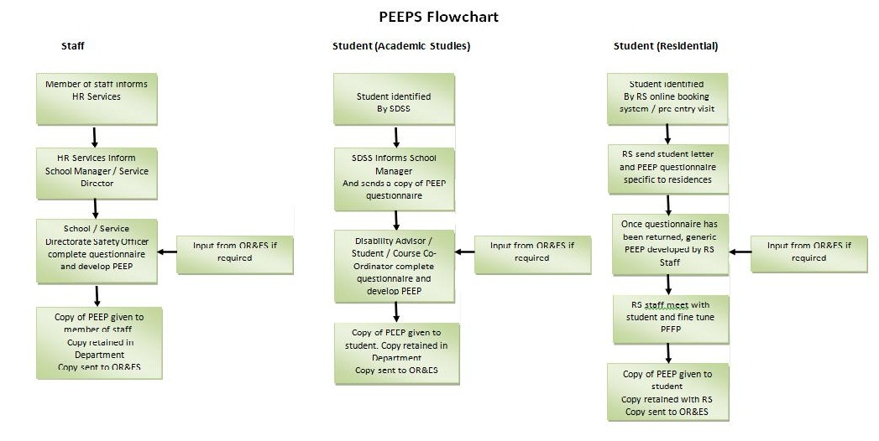

Writing the PEEP
From the information gathered in the questionnaire, a Personal Emergency Evacuation Plan (PEEP) should be formulated. Advice and support for writing the PEEP is available from Operational Risk and Environmental Sustainability (OR&ES).
Given the unique characteristics of buildings, disabled persons who regularly use different buildings may have to have a separate PEEP developed for each building.
If assistance with evacuation is required, the extent of such assistance should be identified in the PEEP i.e. the number of assistants and the methods to be used. These assistants may need training, in which case please contact OR&ES.
Evacuation in an Emergency
Where disabled persons are located above the ground floor there are a number of considerations. In all the following cases OR&ES will be able to give more advice and will assist with identifying Refuges.

a) Temporary Refuges -
A refuge is a designated temporary safe space where disabled people can wait for assistance. It is an area that is both separated from a fire by fire resisting construction and provides a safe route to final exit e.g. the head of a protected stairway - where there is sufficient space. The provision of a refuge will permit a staged evacuation to be implemented. A refuge area will be clearly signed and be of sufficient size to accommodate both people using it as a refuge and any people passing through on their way out of the building.
All designated refuges are provided with two way voice communication between the refuge and Security Control which is staffed on a 24 hour basis. The locations of all designated refuges within the University can be found in the Emergency Procedures Booklet. An evacuation chair is sited in all refuges.
A refuge is merely the first stage in the evacuation procedure for disabled persons; a specific procedure is required to ensure that persons are able to be evacuated from the refuge under safe and controlled conditions.
b) Lifts:
Lifts cannot be used in an emergency. Any lift used for the evacuation of disabled people must be either a “fire-fighting lift” or an “evacuation lift.” The lift at Cottrell AV has been upgraded to meet the specification of an Evacuation Lift. When the fire alarm is activated this lift will automatically return to the ground floor whereby Security can take control of the lift should the need arise to evacuate someone from this area.

NOTE:
Person(s) will only be evacuated from a refuge if the situation has the potential to put the individual at risk. Once the emergency is over, person(s) in the refuge will be notified via the communications link.
c) Safe Routes:
A PEEP should contain details of the escape route(s) the disabled person might be expected to use. Clear unobstructed gangways and floor layouts should be considered at the planning stage.

Wherever possible lateral (sideways) evacuation routes should be sought out so that the evacuating person can move freely into an adjacent fire compartment (this will normally be achieved by passing through several sets of fire doors) without having to negotiate steps or stairs and wait in safety for assistance. OR&ES can give advice on fire compartmentation.
If possible, alternative escape routes should also be identified in case the main route becomes inaccessible during the emergency.
It is especially important to ensure that locks, doors and other devices are all able to be operated by the evacuating persons. It is insufficient to have a route if the door furniture is inaccessible.
A copy of the PEEP should be forwarded to OR&ES

Deaf and Hearing Impaired persons
Generally, most deaf people working alongside hearing colleagues / students will not require special equipment, providing they have been made aware of what to do in the event of a fire. They will be able to see and understand the behaviour of those around them.

Some areas of the University have red flashing lights linked into the fire alarm system to indicate a fire alarm activation.

Blind and Partially Sighted persons
Both Staff and Students should be offered orientation training and, where applicable, this must include alternative ways out of the building. If a blind person uses a guide dog it is important that the dog is also given ample opportunity to learn these routes.

Annex A
Emergency Evacuation Questionnaire – Member of Staff

The University of Stirling is committed to providing a safe and accessible environment for all.

This questionnaire will allow us to ensure all your needs are met and to assist with the development of a Personal Emergency Evacuation Plan (PEEP)

Please complete and return this questionnaire to your School / Service Directorate Safety Adviser at

What is a PEEP?

A Personal Emergency Evacuation Plan (PEEP) is an individual plan tailored to the needs of a disabled person. It will define the route the person is likely to take, and what support they will need in the event of an evacuation.
What happens after I fill in the questionnaire?

You will be invited to attend a meeting with your School / Service Directorate Safety Adviser to devise and document your personal plan.

Name:

School / Service Directorate:

Division:

1.
Where is your normal place of work?

Please list Building(s), Floor(s) and Room Numbers.

1a
Do you routinely use any other buildings?

Yes No
If yes please provide details

2.
Are you a wheelchair user?

Never Regularly Occasionally

If never please go to question 3

2a
Is your usual wheelchair:

Manual (propelled by you) Manual (pushed by helper)
A powered chair / scooter

2b.
Are you able to move around indoors without your chair?

No Yes, using other mobility aids Sometimes

2c.

Are you able to transfer from your wheelchair :

Without any assistance With assistance from another person
Only with use of a hoist / other equipment

2d.
If you answered yes without any assistance, are there likely to be times when you are not able or less able to self transfer?

No Yes Please give further details ______________

3.
If you are not a regular wheelchair user do you use any other mobility aids?

Yes No Occasionally
Please give further details
4.
Are you able to get down stairs safely in an emergency?

Yes unaided Yes with human support No

5.
Do you have difficulty opening fire doors?

Yes No Not sure

6.
Can you hear the fire alarm?

Yes No

7.
Could you raise the alarm if you discovered a fire?

Yes No Not sure

8.
Are the signs which mark emergency exit routes clear enough for you?

Yes No

9.
Are you aware of the emergency evacuation procedures for the building(s) in which you work?

Yes No

9a.
Do you have a copy of the emergency evacuation procedures?

Yes No

9b.
Would you like a copy of the procedures in an alternative format?

Yes No

If yes, please state which format you would like

10.

Are there any other issues that would significantly delay your evacuation in an emergency?

Signature:
Date:

Annex B

Student Emergency Evacuation Questionnaire – Academic Studies

The University of Stirling is committed to providing a safe and accessible environment for all.

This questionnaire will allow us to ensure all your needs are met and to assist with the development of a Personal Emergency Evacuation Plan (PEEP)

Please complete and return this questionnaire to your Disability Adviser at the following address:

Disability Service
2A1 Cottrell Building
University of Stirling
Stirling
FK9 4LA

What is a PEEP?

A Personal Emergency Evacuation Plan (PEEP) is an individual plan tailored to the needs of a disabled person. It will define the route the person is likely to take, and what support they will need in the event of an evacuation.
What happens after I fill in the questionnaire?

The completed questionnaire will be forwarded to your academic schools. You will be invited to attend a meeting with your Departmental Disability Contact within your academic school / course coordinator to devise and document your personal plan.

Name:

Student Number:

Modules:

1.
Where do your classes normally take place?

Please list Building(s), Floor(s) and Room Numbers.

1a
Do you routinely use any other buildings?

Yes No
If yes please provide details

2.
Are you a wheelchair user?

Never Regularly Occasionally

If never please go to question 3

2a.
Is your usual wheelchair:

Manual (propelled by you) Manual (pushed by helper)

A powered chair / scooter

2b.
Are you able to move around indoors without your chair?

No Yes, using other mobility aids Sometimes

2c.
Are you able to transfer from your wheelchair :

Without any assistance With assistance from another person

Only with use of a hoist / other equipment

2d.
If you answered yes without any assistance, are there likely to be times when you are not able or less able to self transfer?

No Yes Please give further details ______________

3.
If you are not a regular wheelchair user do you use any other mobility aids?

Yes No Occasionally
Please give further details

4.
Are you able to get down stairs safely in an emergency?

Yes unaided Yes with human support No

5.
Do you have difficulty opening fire doors?

Yes No Not sure

6.
Can you hear the fire alarm?

Yes No

7.
Could you raise the alarm if you discovered a fire?

Yes No Not sure

8.
Are the signs which mark emergency exit routes clear enough for you?

Yes No

9.
Are you aware of the emergency evacuation procedures for the building(s) in which you study?

Yes No

9a.
Do you have a copy of the emergency evacuation procedures?

Yes No

9b.
Would you like a copy of the procedures in an alternative format?

Yes No

If yes, please state which format you would like

10.

Are there any other issues that would significantly delay your evacuation in an emergency?

Signature:
Date:

Annex C

Student Questionnaire – Resident in University Accommodation

The University of Stirling is committed to providing a safe and accessible living environment for all residents.

This questionnaire will allow us to ensure all your needs are met and to assist with the development of a personal evacuation plan.

Please complete and return this form to Residential Services, Geddes Court.

Forename: | Surname:

Please tick the appropriate box

Do you use your wheelchair:

Occasionally Regularly

Only outdoors Permanently

Is your usual wheelchair:

Manual (propelled by you) Manual (pushed by helper)

A powered chair / scooter

Are you able to move around indoors without your chair?

No Yes, using other mobility aids Sometimes

Please provide further information :

Are you able to transfer from your bed to your wheelchair in a reasonable time?

Without any assistance With assistance from another person

If you answered yes without any assistance, are there likely to be times when you are not able or less able to self-transfer?

No Yes Please provide further information ______________

Do you have difficulty unlocking / opening doors?

Yes No Please provide further information:

Can you hear the fire alarm?

Yes No Please provide further information:

Could you raise the alarm if you discovered a fire?

Yes No Not sure

Can you read and understand the action in event of fire notices?

Yes No

Are there any other issues that would significantly delay your evacuation in an emergency?

Signature:
Date:

PERSONAL EMERGENCY EVACUATION PLAN FOR

Name ___________________________________________________

Department ___________________________________________________
Building ___________________________________________________
Floor ___________________________________________________
Room Number ___________________________________________________

AWARENESS OF PROCEDURE
I am informed of a fire emergency requiring evacuation by :
existing alarm system q
visual alarm system q
Other (please specify) q ___________________________________

DESIGNATED ASSISTANCE:
(The following people have been designated to give me assistance to get out of the building in an emergency).

Name ___________________________________________________
Contact details ___________________________________________________

Name ___________________________________________________
Contact details ___________________________________________________

Name ___________________________________________________
Contact details ___________________________________________________

METHODS OF ASSISTANCE :
(e.g.: methods of guidance, etc.)
__________________________________________________________________________________
__________________________________________________________________________________

EVACUATION PROCEDURE :
(A step by step account beginning from the first alarm).
__________________________________________________________________________________
__________________________________________________________________________________
__________________________________________________________________________________
__________________________________________________________________________________
__________________________________________________________________________________
__________________________________________________________________________________
__________________________________________________________________________________

SAFE ROUTE(S) :
__________________________________________________________________________________
__________________________________________________________________________________
__________________________________________________________________________________
__________________________________________________________________________________
__________________________________________________________________________________

Signature.
Date.
Review date.

