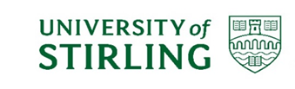

**Mainstreaming the Equality Duty Report**

**2021 – 2025**

**Infographic of Institutional Achievements (2021 – 2025)**

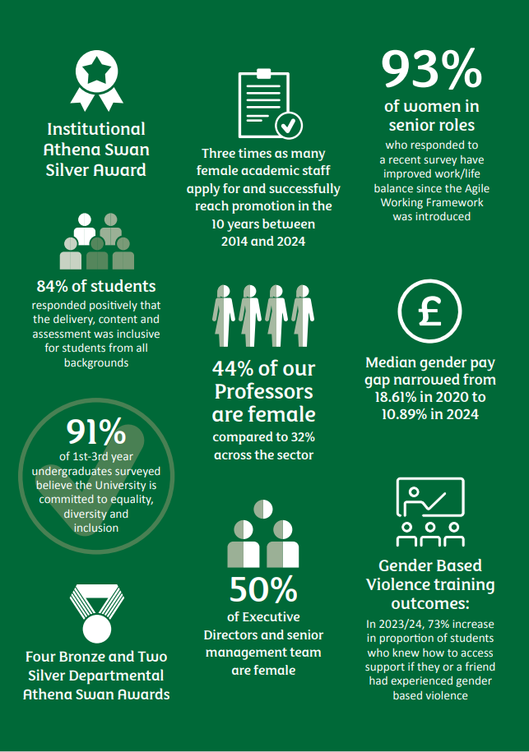

# Executive Summary

At Stirling we value ability, not background. We are a place where people transform both their lives and the lives of others. Inclusion is key to this vision; our rapid progress on equality, diversity and inclusion has been achieved through our people and their commitment, and we are incredibly proud of this.

Over recent years the University has significantly advanced. In terms of gender equality, this report highlights our many successes, from our sector-leading approach to gender-based violence, to our Agile Working Framework and gender-balanced leadership. Investment in our academic staff has increased by 5% since 2022 and representation of women has also increased, growing our pool of female academic leaders by 5.2% between 2018-2024. Forty-four percent of our professors, and 50% of our senior management team are female. The median gender pay gap has narrowed from 18.61% to 10.89% between 2020 to 2024, and the average pay of female staff increased by over 10% during the same period.

Our commitment is not restricted to gender and takes an increasingly intersectional approach. Our strategic approach to anti-racism, race equality and interculturalism has demonstrably contributed to student experience; Following dedicated campaigns to increase ethnicity disclosure, we have been able to start reporting our ethnicity pay gap, which is 6.23% for average pay with no pay gap for median pay between white and minority ethnic staff.

Similarly, our strong support for disabled students has led this population to be more likely to continue past their first year of study, and the proportion of disabled students attaining good degrees has also increased. This inclusive approach continues as students move into employment. The University of Stirling’s Enterprise Programme is enhancing engagement with entrepreneurship, illustrating how diversity drives innovation through the See it, Be it pilot, and the University’s Careers and Employability Service recently achieved a prestigious Silver Charter Award from LGBT Youth Scotland. For our disabled staff, the mean pay gap against non-disabled staff is 5.85% and we have meaningful actions to address rates of disclosure and understand the reasons behind the pay gaps, and the compounded effects experienced by our staff in multiple unrepresented groups.

Students at Stirling believe in the inclusive culture we are creating. In 2024, 91% of 1st–3rd year undergraduates surveyed believed that the University is “committed to equality, diversity and inclusion”. Our work on inclusive curriculum is also having demonstrable impact; in 2023, 84% of students responded positively that “the delivery, content and assessment was inclusive for students from all backgrounds”.  We are particularly pleased to note this positive feedback stems from evaluations across all modules and levels, meeting our institutional ambitions to embed inclusive practice across all areas of the University. This inclusive environment is also key to our external recognition; in 2024, our work on inclusion led Stirling to join the top 100 universities globally for Equality and Health & Wellbeing in the QS Sustainability Rankings.

Our ambitions do not rest on our current success. We have engaged with staff, students, and external stakeholders through the development of our new Strategic Plan to shape our shared vision towards 2030 and beyond: to make an impact on people’s lives and be a force for good in the world. Each of our five key areas of focus (staff; students; research; engagement; health and well-being) are drawn together with this inclusive thread; our resolution to be the difference. Despite our progress, we acknowledge more work is needed to address inequalities, and we are committed to this.

## Introduction

The University of Stirling was established in 1967 and is Scotland’s University for Sporting Excellence. Our first Chancellor, Lord Robbins, focused on ‘education with a purpose’, declaring that university places 'should be available to all who were qualified for them by ability and attainment'. The Robbins Report widened access to higher education, and his transformative thinking continues to inform our mission, vision and values.

Situated in the heart of Scotland, our 330-acre campus has been ranked 1st in the UK and top ten in the world for its campus environment (International Student Barometer 2024). Known as the 'Gateway to the Highlands', Stirling is shaped by the beauty of the Ochil Hills. As both the safest student city in Scotland (Complete University Guide 2023) and one of the top 3 happiest places in Scotland to live (Rightmove), we're proud to call Stirling our home.

The University comprises five academic [faculties](https://www.stir.ac.uk/about/faculties/), an [Institute for Advanced Studies](https://www.stir.ac.uk/research/research-degrees/institute-for-advanced-studies/), and ten professional service areas.

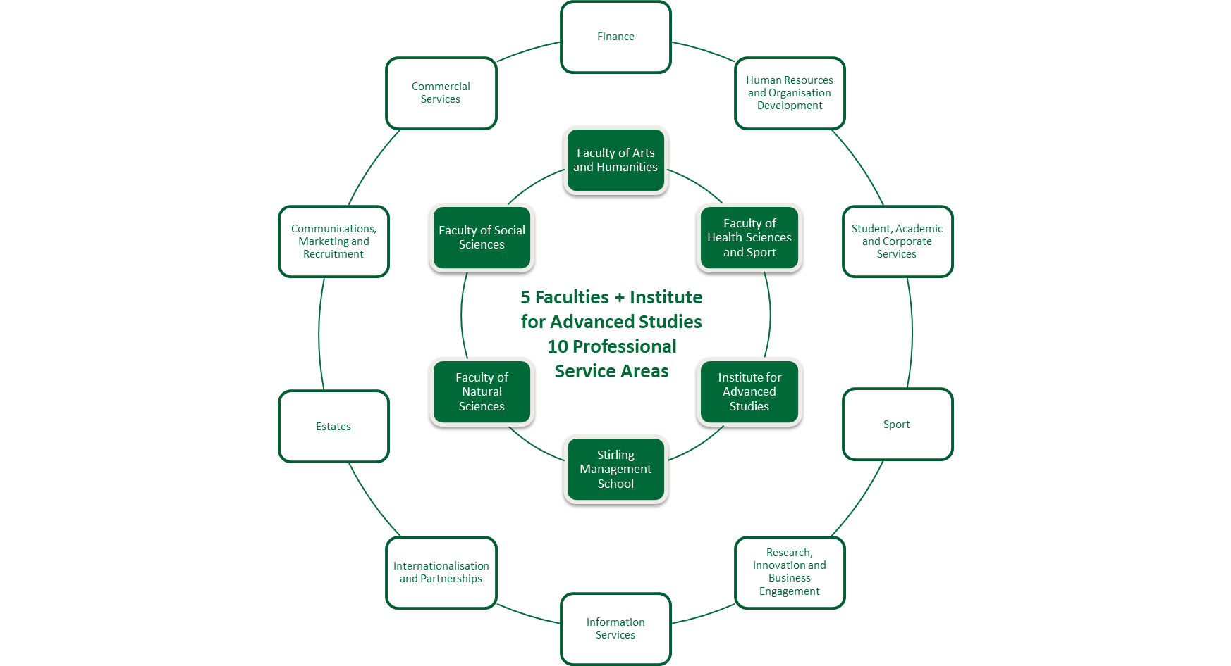

We are proud of our work to recruit students inclusively and there have been significant changes to our overall student demographic. While there has been a 5% decrease in the proportion of female students since 2018, overall representation of female students remains strong. Unregulated student numbers have increased by 47% since 2014/15, our international students now account for >30% of our overall population and the number of students disclosing a disability increased by 3.8% between 2018/19 and 2023/24.

The core strength of the University is our people. To build on our success we invest in the best staff from around the world to deliver our ambitious strategies for research, teaching and our international partnerships. Our 1800 staff guide and inspire our students to become graduates with knowledge and skills to help shape the world.

At Stirling, 60% of staff are female, surpassing the sector average of 54.6%, we have a higher proportion of female academics, 54%, compared to sector norms and many Scottish universities – 48% of all HE Providers in 2023/24 (HESA, 2025). Staff identifying as being disabled increased to 10% during the 2024-25 year from 5% in 2022/23, surpassing the 5% average in Scottish HEIs (Advance HE, 2022). The proportion of staff disclosing a mental health condition increased to 3.2% (1.5% rise from 2023). The proportion of Black, Asian and minority ethnic backgrounds increased from 7% to 11.3% with a higher proportion of Black, Asian and minority ethnic staff in academic roles in comparison to Professional, Technical and Operational roles.

## Institutional Vision Statement for Equality, Diversity and Inclusion

The University has a strong commitment to equality, diversity and inclusion, and seeks to make continued progress in ensuring everyone in the University community is treated fairly, promoting and encouraging diversity, adopting a range of practices that support inclusion, and eradicating discrimination, structural bias and inequalities.

The University’s approach to Equality, Diversity and Inclusion is set out in our institutional vision statement that seeks to develop, champion and nurture a welcoming and inclusive culture and environment that:

* Actively prevents and tackles discrimination, harassment and abuse;
* Respects and celebrates diversity and inter-culturalism;
* Enables staff and students to thrive and achieve their potential, regardless of their background or identification with a protected characteristic(s); and
* Identifies and eradicates systemic barriers to equality.

Our priorities in relation to equality, diversity and inclusion were identified through a period of engagement with the University community, and our Equality Outcomes for 2021 – 2025 were approved by University Court, our governing body.

## Governance and Equality, Diversity and Inclusion Work

Accountability for our commitment to equality, diversity and inclusion is vested in University Court. Consideration of equality, diversity and inclusion work feeds up to Court and Academic Council via the Joint Policy, Planning and Resource Committee (JPPRC) and University Strategy and Policy Group (USPG). JPPRC supports the integration of academic and corporate governance, and USPG leads the development and implementation of the strategic direction and policy of the University.

To create a culture where equality, diversity and inclusion is intrinsic to all that we do and make continued progress, the Principal and Vice-Chancellor is supported in his academic and strategic leadership of the University by the Senior Management Team comprising the Chief Operating Officer and University Secretary, Deputy Principals, Executive Directors and Deans.

To ensure that the University effectively discharges its responsibilities in respect of equality, diversity and inclusion, the University has an Equality Steering Group (ESG) – a strategic advisory group that reports regularly to University Court via University Strategy and Policy Group and the Joint Policy Planning and Resources Committee. Chaired by the Senior Deputy Principal, and with both staff and student representatives within its membership, the ESG oversees compliance with the statutory equality duties and ensures effective delivery of the University’s equality outcomes and supporting strategies.

## Staff Equality Monitoring Information

The University publishes a Staff Equality Monitoring Report biennially and profile data of our people is provided at **Appendix A**.

In recent years, we have placed a particular focus on increasing disclosure rates of equality characteristics to gain a more accurate and comprehensive understanding of our staff demographic. We view this data as a powerful tool in enabling us to continue to build an inclusive and supportive workplace for our people. This data also informs the development of targeted actions to strengthen our inclusive culture, ensuring every staff member at Stirling feels valued, respected, and heard.

To support this, we launched a dedicated campaign encouraging staff to review and update their personal equalities data where appropriate. This initiative led to a notable increase in disclosure rates. Enhancements to the data collection process included the introduction of new fields for disability and refinements to the language used around caring responsibilities, gender identity, and British Sign Language (BSL) users. These changes ensure that the data we collect is meaningful, enabling us to better identify differences in staff experience and reinforce the University’s strong tradition of inclusion.

Since the changes in September 2023, we have seen measurable improvements in disclosure rates. Disability disclosure has increased from 5% in 2022/23 to nearly 10% of our current staff population. The proportion of staff disclosing a mental health condition rose to 3.2%, representing a 1.5 percentage point increase from 2023. Sexual orientation disclosure has risen from 73% in 2022/23 to 82% of our current staff population. In addition, the proportion of staff with unknown ethnicity data fell by 6.5% in 2022 to 3.4% in 2024.

## Examples of Mainstreaming Equality

We are unable to highlight all examples of mainstreaming across the University, so this report focusses on key developments in mainstreaming activity. The following examples are structured under each of our equality outcomes and incorporate the three components of the Equality Act General Duty:

* Elimination of discrimination, harassment, victimisation, and other conduct prohibited by the Act.
* Advance equality of opportunity between people who share a protected characteristic and those who do not share it.
* Foster good relations between people who share a protected characteristic and those who do not share it.

**Equality Outcome 1 – Gender Equality**

**Improving representation of women in professorial and senior leadership roles and in governance committees.**

Our commitment to advancing gender equality across the University was validated in 2024 by being awarded the prestigious Institutional Athena Swan Silver award. The Athena Swan Charter is used globally to support and transform gender equality within higher education and research. This commitment is evidenced further by our departmental progress. The Faculty of Health Sciences and Sport and the division of Biological and Environmental Sciences gained a Silver Athena Swan award. Additionally, the Stirling Management School, the Institute of Aquaculture, the Faculty of Natural Sciences and the division of Psychology have all gained Bronze awards.

The University strives to have a diverse representation on its governance body, Court. As of August 2024, 58% of the membership of University Court, our governing body, were female. The University also met the objectives of the Gender Representation on Public Boards (Scotland) Act 2018, 50% of non-executive members were female (see Table 1).

Table 1: Membership of University Court

|  |  |  |
| --- | --- | --- |
| **Category of Membership** | **Sex** | **Proportion of Membership at August 2024** |
| All members of University Court[1] | Female | 58% |
|  | Male | 42% |
| Non-Executive Members of University Court[2] | Female | 50% |
|  | Male | 50% |

There is good representation of female leaders, and this reassures us that our culture is one in which women are encouraged, supported and empowered to progress into senior positions. Forty-four percent of our Professors and 50% of our Senior Management Team are female.

Since 2018, the University has invested over £100,000 in supporting 83 female employees to participate in Advance HE’s ‘Aurora Women in Leadership’ programme. The Aurora programme continues to make an important contribution to the development of female staff into leadership roles at Stirling and our commitment to gender equality. For the 2024/25 programme, we adopted a more targeted approach; prioritising funded places in areas where there is a clear opportunity to strengthen our pipeline of female leadership talent. This strategic investment aims to address identified imbalances and ensure that development opportunities make a tangible and sustainable impact on the future of leadership at Stirling.

**Progressive Working Practices**

The introduction of more inclusive and progressive working practices has enhanced gender equality, which includes the Agile Working Framework, established in 2021. This principles-based approach empowers leaders and teams to co-create effective working practices that suit local business needs. The Agile Working Framework has garnered positive feedback, with 79% of staff responding favourably (2022 pulse survey). Notably, it has widened opportunities for women in senior roles, with 93% reporting improved work/life balance. Feedback highlights its role in attracting and retaining women in senior positions, fostering an inclusive and progressive culture.

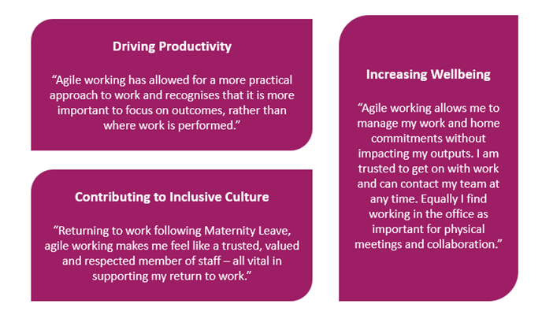

In May 2024, the University of Stirling's Agile Working Framework was recognised by Universities Human Resources (UHR) as an example of excellent practice in the sector at the annual UHR Awards for Excellence.

**Academic Promotions**

Over the last five years, we have transformed our Academic Promotionsapproach from a transactional procedure into a transformational enabler of organisation performance. Driven by a commitment to continuous improvement, we have ensured that our approach is consistently refined to contribute directly to career progression, institutional performance, and a more inclusive academic leadership pipeline.

Academic promotions is a cornerstone of our commitment to valuing, supporting, and recognising our people. Anchored in our institutional values of ambition, integrity, and respect, it plays a critical role in our People Strategy, ensuring fair, transparent, and sustainable reward and recognition mechanisms. This also makes a significant contribution to achieving our strategic objectives aligned to the three key strands of our People Strategy – Attract, Engage, Grow.

Successful promotion applications have increased from 88% in 2020 to 95% in 2024, demonstrating the approach’s effectiveness in fostering career progression.

There is a particular focus on underrepresented groups that include tailored training sessions for female staff, presented by senior colleagues, that provide an overview of the Academic Promotions process and explore the criteria, and the preparation required to submit a strong application. The proportion of female applicants has increased from 51% in 2022/23 to 54% in the 2023/24 promotion round, demonstrating how this approach is supporting the University to develop an equitable pipeline of academic talent. The success rate for female applicants has also improved; rising from 51% in 2022/23 to 58% in 2023/24. Notably, in 2023/24, 100% of all applications supported by Faculty Panels - regardless of gender - were successful at the final Committee stage, an improvement from the 95% success rate in 2022/23.

Progress is particularly evident at senior levels. In 2023/24, all female applicants for promotion to Professor were successful. Furthermore, the Committee promoted two female applicants to Professor who had originally applied for Associate Professor, and two additional female applicants were promoted beyond the level for which they had initially applied. These outcomes reflect meaningful progress in addressing gender disparities and reinforce the effectiveness of our promotion processes in recognising talent and potential.

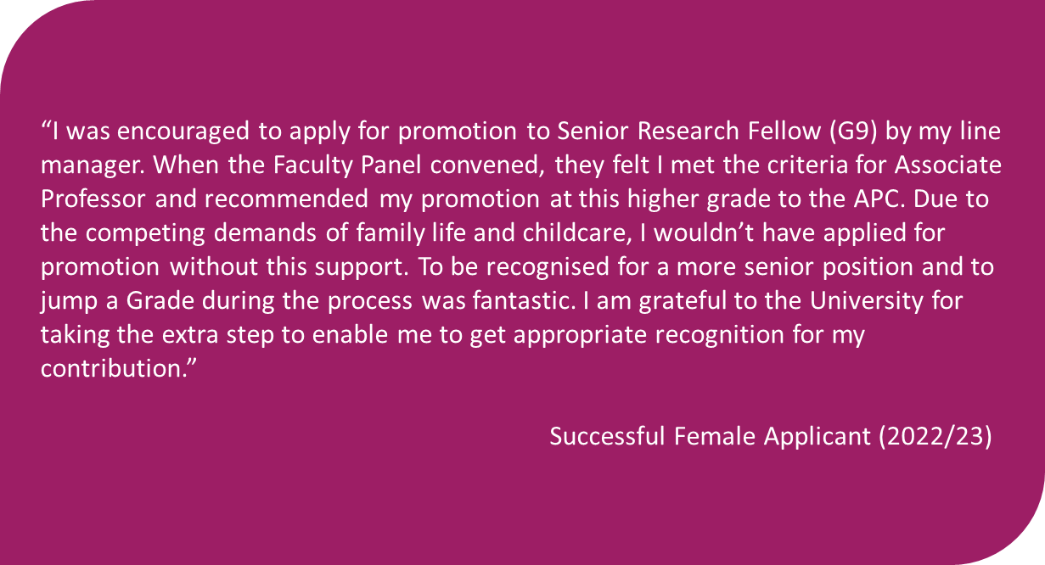

We remain committed to fostering an inclusive and supportive working environment where all staff can thrive. While equality, diversity, and inclusion are not explicitly mandated within the promotions criteria, our broad approach enables applicants to demonstrate their contributions in this area. Our criteria recognise the integral role academic staff play in cultivating an inclusive culture, ensuring that career progression reflects the values embedded in our University community. Notably, in 2023/24, a third of promotion applications explicitly referenced an individual’s commitment to EDI, highlighting that our people view contributing to an inclusive and diverse environment as an essential part of their academic career.

**Narrowing the Gender Pay Gap**

In 2020, our mean gender pay gap was 18.7% (18.6% median) in favour of males. In 2022, the mean gap narrowed to 14.1% and further to 12.34% in August 2024, with a concurrent narrowing of the median gap from 18.6% to 10.89% in the same period. We have been recognised for being one of two Universities to achieve the greatest improvements in the proportion of females earning maximum salaries across 67 other institutions, by 16 percentage points between 2014/15 and 2022/23 (Times Higher Education, August 2024). This is reflective of a tripling in the number of females applying for and achieving promotion since 2019, alongside a rise in the number of Grade 10 female staff. Despite this, the average salary for females at Grade 10 remains lower, although the gap at that grade has narrowed significantly, from 9.47% in 2022 to 3.64% in 2024. The pay gap of our Professoriate reversed between 2022 and 2024, going from 3.24% to -0.42% in favour of females. The University's Grade 10 framework enables agility and competitiveness in talent recruitment and retention, underpinned by benchmarking to ensure a considered and informed approach, with salaries monitored and reviewed by the Remuneration Committee.

Vertical segregation persists, with a larger proportion of females in lower-grade levels (Grades 1-6). Although females now make up almost half of Grade 10 staff, their concentration at lower grades perpetuates the gender pay gap. Occupational, horizontal segregation also persists in 2024, where we see that staff in more junior administrative roles and cleaning staff, were nearly 70% female. In contrast, 62% of the technical staffing group were male.

At August 2024, the mean ethnicity pay gap between our white staff and non-white staff is 6.23%, while median pay between the two groups is equal. This may be due to a high proportion of Black, Asian, and minority ethnic staff in mid-level grades (6 & 7). We have a significant proportion of staff, 6%, where we don’t know their ethnicity, either because it has not been updated, or the individuals have actively told us they do not want to share the information. In particular, the ethnicity of 20% of our senior staff is unknown. One of our targets is to reduce our unknown percentages to 5% of staff, by 2028. We understand that a result of increased disclosure may be that the pay gap does not narrow alongside that, however it will give us a greater understanding of these populations of staff.

The mean and median disability pay gaps in August 2024 are 5.84% and 5.59% respectively. Again, these gaps exist alongside a significant proportion of staff who have not disclosed a disability, 11%, and again with the target to reduce to 5% by 2028.

Further examination of gender, ethnicity and disability trends, including intersectionality within these groups, will inform strategies for narrowing the gap and increased representation at higher grades across academic and professional staff.

**A culture where gender-based violence is actively challenged, robustly tackled and people experiencing gender-based violence are respected, supported and empowered.**

Collaborating with the Students’ Union, our first ‘Preventing and Tackling Sexual Violence and Misconduct’ Strategy was published in 2017. With substantial investment, and in collaboration with local and national partners, the University and Students’ Union together developed a nationally recognised approach to tackling gender-based violence. Aligned with the Scottish Government’s Equally Safe Strategy, our institutional Gender-Based Violence (GBV) Strategy 2021-24 addressed all forms of GBV, providing a unified narrative that dispels myths, directs individuals to resources, and focuses on prevention efforts targeting perpetrators.

Future focus groups will tailor campaigns for specific groups (e.g. student sport clubs, international students, disabled women, mature students, LGBT+ women, and widening participation students) to better understand their GBV experiences. 

Investment in training Sexual Violence and Misconduct Liaison Officers (SVMLOs) and First Responders resulted in a 113% increase in the proportion of staff stating they have a good understanding of how to escalate a disclosure of gender-based violence within the University.

Utilisation of the Report and Support system has increased, reflecting growing confidence in disclosing incidents and seeking support. Expanding the system and targeted campaigns will further support our staff and students.

From 2020 to 2024, the University highly recommended all students complete a bespoke online GBV module for students called “Don’t be a bystander, be a friend”. In 2023/24 there was a 73% increase in the proportion of students who knew how to access support, if they or a friend had experienced gender-based violence.

In August 2024 the University launched a new GBV module for students, Consent Matters. This evidence based online course helps students to understand sexual consent and promote positive cultural change in our University community. It helps students to understand Stirling’s expectations, recognise acceptable boundaries and learn how to support friends and fellow students. In the first semester, from August to December 2024, over 1300 students completed the course with another 700 students in progress.

The University is working in partnership with the Students’ Union Sports President and Beyond Equality to deliver ‘Team Talk’, with 60 key sports club and society leaders being trained in 2024.  Team Talk promotes healthy conversation about sex and relationships, positive masculinity and active bystandership.

The University has joined key organisations across the region to support the White Ribbon Scotland Campaign, which encourages reflection and discussion that leads to personal and collective action among men to end violence against women. Professor Sir Gerry McCormac, Principal and Vice-Chancellor, is leading the University’s commitment to the campaign as a [White Ribbon Scotland Ambassador](https://www.stir.ac.uk/news/2023/12/giant-white-ribbon-to-light-up-stirling-campus-in-commitment-to-end-gender-based-violence/).

**Equality Outcome 2 – Mental Health and Wellbeing**

Our commitment to supporting a physically and mentally healthy community across our students and staff continues to be a key priority. In delivering the joint University of Stirling and Stirling Students’ Union Mental Health Strategy 2021-24 we continued to foster and nurture a culture and environment which recognises the link between mental health, wellbeing, performance and impact, and which enables our community to talk openly about mental health without stigma or fear. The University regularly introduces themed campaigns to foster a culture of respect and awareness around health and wellbeing matters.

As part of the University’s response to the impact of Covid19, in spring 2020, and in partnership with the Students’ Union, we launched ‘Be Connected’, a programme of social, health and wellbeing, learning and cultural activities to foster a sense of community and support wellbeing for both staff and students. The programme was inspired by the ‘5 ways to wellbeing’ and is based around the principles of: Connect with others; Get active; Learn something new; Give; and Take notice. This has successfully continued and offers a full programme of events, activities and resources year-round, in person as well as online.

The University has developed a suite of dedicated wellbeing spaces, including the Library Wellbeing Space, which is equipped with fiction, self-help literature and supporting materials, and provides a quiet safe space with views of the campus loch for students to relax and gather thoughts. 2022/23 also saw the launch of the Loch View Wellbeing Suite, a dedicated space in the Cottrell building to promote student wellbeing through a range of group activities, access to resources and wellbeing staff, a student-sponsored Sensory Room, and a range of sensitively designed spaces to promote wellbeing. In 2023, Loch View was shortlisted for a Times Higher Education Award in the category of Outstanding Support for Students, demonstrating the sector-leading work the University is doing towards maintaining and improving student wellbeing.

The University recognises the importance of ensuring that all staff are confident when providing support to our students, whilst not forgetting the importance of boundaries within roles - knowing when and how to signpost, refer and escalate student issues safely and efficiently. Having clear and coherent processes is vital for staff wellbeing, a positive student experience and managing risk within our institution.

The Supporting our Students framework includes, for example; a student support referral pathway to allow staff to know how to signpost, refer and escalate a number of student issues as safely and efficiently as possible; an urgent referral process allowing staff who have a serious concern for the wellbeing of a student to refer to the Mental Health team; first responder training for staff and a comprehensive Supporting our Students staff SharePoint site which provides a one stop shop for supporting students, providing clear guidance on the university’s expectations of staff whilst supporting a student with a concern.

Student leaders (e.g. sabbatical officer, clubs and society committee members, welfare officers) are all required to undertake First Responder Training.  Similar to the staff version, this focusses on signposting students to appropriate support and escalating student concerns to members of staff within the Students Union.  The purpose of this is to create well promoted, trained and supported points of contact within student clubs and societies to signpost and raise awareness of mental health and know how to escalate urgent concerns.  Evaluation feedback from 2023/24 shows a 177% increase in how confident students feel in escalating a disclosure of welfare issues.

Staff from the Mental Health team are trained to deliver the Student Minds “Look After your Mate” workshop and in 2023/24 delivered this in collaboration with the Students Union, to member of clubs and societies.  The session covers an introduction to student mental health and the student experience, understanding when a friend may be struggling, communication techniques, signposting and boundaries, self-care and looking after yourself whilst supporting a friend.

In August 2024 Student Leaders, including Residence Assistants from Accommodation and Welcome Assistants operating within the Student Services Hub, received a full day of training which included topics such as being a first responder and GBV, inclusion, neurodiversity, support for students with a disability and Look After your Mate, delivered by the Mental Health Team. 100% of students reported they had a good idea of how to escalate a concern regarding the welfare of a student following the event.

The University has invested significant resource to launch a 24/7 Student Support helpline in August 2023.  It is a free, confidential service that provides in-the-moment emotional wellbeing support to all students.   The service is available 24 hours a day, 7 days a week, 365 days a year to provide support for issues such as stress, anxiety, low mood, loss and grief, relationship problems, and more.  The helpline is provided by our partner, Spectrum.Life.

In May 2020, the University introduced an Employee Assistance Programme (EAP) to provide staff and their families with support for a range of personal or work-related issues. Engagement with support for staff through Stirling’s EAP has been notable, with 15% utilisation between 2022 and 2023 and an 18% usage rate between 2023 and 2024; compared to a UK average of 12% (EAPA UK, 2022). predominantly by females (72%). Evaluation indicates a high level of positive impact. In 2023/24, staff who accessed counselling support through the EAP reported an average symptom improvement rate of 90.6%, demonstrating the programme’s effectiveness in supporting staff wellbeing and contributing to a healthy staff community.

The introduction of the ‘Peppy’ app for menopause and men’s health support saw positive reception, with 175 registrations to date - surpassing the average usage rate. Engagement with menopause-related support has been particularly strong, with registrations 154% above target. Early evaluation indicates positive outcomes: 60% of users reported increased positivity towards the University as a result of access to Peppy and 17% reported improvements in menopause symptoms after 180 days of use. Whilst engagement with men’s health support reached 87% of the 2023/24 target, this remains a focus for further development as we continue to ensure our staff have the support they need to thrive, both physically and mentally.

**Fair Work**

The University values the skills, experience and the involvement of its employees and is committed to fostering an inclusive and supportive culture and working environment. We remain committed to Fair Work principles through providing a healthy work-life balance and through a commitment to paying the Real Living Wage to employees since 2015. We continue to apply supplements on the grading structure in line with the Real Living Wage published rates.

In addition, the University has made sustained progress in improving job security, actively and consistently moving away from the use of zero hours contracts. As part of our commitment to sustainable employment practices, a comprehensive review of resource planning and associated employment practices has been undertaken across 2023/24 and into 2024/25, ensuring our approach continues to meet the needs of both our staff and the institution.

**Staff Engagement**

​​​​​​​‘Be Heard’ is our dynamic approach to understanding and enhancing employee experience at the University, aligned with our core values of ambition, integrity and respect. Through regular feedback and open dialogue, we aim to better understand how our staff experience work and identify meaningful actions for improvement.

Pulse surveys are at the heart of this approach, providing a regular snapshot of how our staff feel about key aspects of working at Stirling. These insights support collaborative discussions and drive tangible actions that strengthen our culture and ensure that every voice contributes to shaping a positive and inclusive workplace.

The University’s Strategic Plan 2030 identified Health and Wellbeing as a strategic priority, recognising the importance of investing in our people’s physical and mental health. In November 2024, we launched a dedicated pulse survey focussed on understanding more deeply aspects of staff experience as related to physical wellbeing at the University. This survey achieved our highest ever engagement for a pulse, with 883 staff taking the opportunity to 'Be Heard'. Key findings included:

* **96%** of respondents said that supporting their wellbeing with physical activity is important to them.
* **9 out of 10** respondents would like to do more to support their wellbeing through physical activity.
* **1,065** individual comments provided valuable insights into how the University can continue to offer meaningful opportunities for staff to engage in physical activity.

In direct response to this feedback, the University expanded our physical wellbeing offering as part of [Wellbeing Week](https://www.stir.ac.uk/events/wellbeing-week/) (24 – 28 February 2025). Activities included:

* Staff Tennis sessions
* Dedicated lunchtime staff fitness classes including Legs, Bums and Tums, and HIIT workouts
* Yoga and mobility sessions
* A multi-sport drop-in session.

Throughout 2025, the University’s Sport Development Service will continue to use insights from the pulse to inform plans for improving access to physical wellbeing resources. These efforts will focus on ensuring that opportunities are realistic, engaging, sustainable, and tailored to the diverse needs of our staff community.

**Equality Outcome 3 – Student Success**

**Student Profile and Demographics**

Between the academic years 2019/20 and 2023/24, Stirling experienced a remarkable period of growth. Total applications surged by 80%, and the overall student headcount increased by 25%. This growth brought significant changes to our student demographic, and we take pride in our efforts to enhance the diversity of our student population:

* **International students**: Representing 40% of our total student body, our campus is enriched by diverse global perspectives.
* **Students with disabilities**: The number of students with disabilities has increased by 35%, with a notable 41% rise specifically among the undergraduate population.
* **Black, Asian and Minority Ethnic (BAME) Students**[3]: The number of UK-domiciled undergraduate students from Black, Asian and Minority Ethnic backgrounds has grown by one third, reflecting our commitment to inclusivity.
* **Mature students:** Undergraduate mature students studying in the UK have increased by nearly a third (32%), adding valuable life experience to our student community.

**Student Success Initiatives**

We are committed to fostering an inclusive and supportive environment, evidenced by a range of targeted initiatives aimed at enhancing student success. Examples of the breadth and depth of our work include:

* **Retention and Student Experience**: We established the Retention Working Group in June 2024. This group analyses data, identifies at-risk students, and implements targeted action plans. Early results for 2024/25 show improved retention amongst students with disabilities, BAME students, mature students, and both male and female students. Key strategies include revised Student Staff Feedback Committee (SSFC) mechanisms, an enhanced personal tutoring system, and improving transparency and access to retention related data across the organisation. Our newly established Commuter Student Task and Finish Group, and forthcoming implementation of the Progression and Award boards are also significant initiatives which will enhance retention whilst simultaneously assessing degree award classifications, all on a student-by-student basis enhancing decision making by introducing context.
* **Student Feedback and Support**: The student voice is crucial. We gather feedback through various channels, including Student Staff Feedback Committees, surveys, and "Thoughts on" campaigns. This feedback drives programme improvements. Support events for final-year students cover employability, dissertation writing, and career options and our "Help us help you" campaign promotes and directs students to available support services, especially personal tutoring.
* **Inclusive Practices and Disability Support:** We are addressing stress-inducing aspects of curriculum design and implementing inclusive assessment practices. Investment in Non-Medical Personal Help (NMPH) services has resulted in high satisfaction rates. NMPH support figures show a rise in students accessing these services, with 895 students receiving NMPH support in 2023/24, compared to 805 in 2021/22. Specifically, Mental Health Mentors supported 460 students in 2023/24, Study Skills Tutors supported 585, and Autism Support Workers supported 115.
* **Comprehensive Student Support Services:** We offer a wide range of support services, including study skills workshops, accessibility and inclusion support, individual tutoring, on-campus medical and dental care, free sanitary products, and counselling services. Accessible accommodation and facilities are provided. Career guidance, skills building, and employer engagement programmes are available to all. Our Enterprise Programme and My Stirling Award foster entrepreneurship and extracurricular achievement, and our Stirling Cares programme supports care-experienced, and estranged students.

**Student Satisfaction**

Significant progress was made in the new National Student Survey (NSS)[4] between 2023 and 2024 with overall student satisfaction increasing by 5.7 percentage points. Notably year on year overall satisfaction improved for students with disabilities (+9.1 percentage points), BAME students (+10.0 percentage points), mature students (+2.9 percentage points), females (+5.5 percentage points), and males (+6.2 percentage points). On a similarly positive note, the variance between students with disabilities and those without decreased, and BAME students outperformed white students. However, mature students were slightly less satisfied than young students, as were females compared to males.

While student satisfaction improved for the undergraduate population, especially for students with disabilities and BAME students, it declined for the Postgraduate Taught population, particularly for students with disabilities and those aged 30 plus.

**Student Retention**

In recent years, retention rates for all degree levels have generally declined, and disparities among different student groups have been identified, in particular Black, Asian and Minority Ethnic students at all levels and undergraduate mature students. The latest data for 2023/24 indicates undergraduate students with disabilities had similar retention rates to those without (88.3% vs. 89.2%), and undergraduate females had a greater retention rate than undergraduate male students (90.3% vs. 86.7%).

The retention rate for postgraduate students with disabilities remained relatively stable, even as overall the retention rate among their peers declined. Over the past three academic years, the retention rate of postgraduate students with disabilities was consistently greater than their peers without disabilities, with a retention rate of 93.8% compared to 84.1% in the 2023/24 academic year as an example.

In contrast, BAME students had a slightly higher retention rate (+1.1%) compared to their peers in 2019/20, by 2023/24 this had declined to a retention rate of 3.0% lower than their peers. The latest data shows that the retention rate for females is now 7.3% greater than their male peers. However, both groups have experienced a decline overall: females dropped from 94.8% in 2019/20 to 87.9% in 2023/24, while males fell from 95.5% to 80.6% over the same period.

**Attainment**

For undergraduate attainment, there was an overall decline over the years, with students from minority groups particularly disadvantaged compared to their peers. Results for the proportion of first-degree honours students achieving a first or upper second-degree classification show a variance of 5.8% in 2023/24 between female and male students. In 2023/24 a gap had widened to 4.0% between undergraduate students with recorded disabilities compared to those without disabilities consistently underperformed compared to those without disabilities, from -2.2% in 2019/20. Similarly, there was a variance of 8.8% in 2023/24 between BAME students compared to their non-BAME peers. Attainment levels of our younger students was greater that our mature students with a variance of 5.0% in 2023/24.

**Undergraduate Skilled Graduate Outcomes**

Graduate outcomes data reveals that students with disabilities, BAME students, mature students, and female students generally outperform their peers in securing highly skilled employment or further study. For instance, students with disabilities had a higher proportion of skilled graduate outcomes compared to those without disabilities, with a slight variance of 0.7% in 2021/22. Similarly, mature students consistently outperformed younger students, showing a significant variance of 14.1% in 2021/22. Female students also consistently outperformed male students, with a variance of 3.4% in 2021/22. However, BAME students, who had previously outperformed white students, underperformed in 2021/22 by 4.4%.

**Learning, Teaching, and Student Experience**

The University’s future strategic approaches related to Learning, Teaching, and Student Experience are expressed in four pivotal and interconnected objectives:

1. **Create a refreshed portfolio with curricula fit for the future:** We aim to refresh our programmes to ensure they are relevant and forward-thinking, preparing students for the challenges and opportunities of tomorrow.
2. **Enhancing Student Success:** Our focus is on creating a nurturing and compassionate environment where every student can thrive academically and personally, supported by tailored resources and initiatives that recognise and value the needs of our diverse student body
3. **Develop and upskill all student facing staff:** We are committed to continuous professional development for all student-facing staff, ensuring they are equipped with the latest skills and knowledge to support our diverse student body effectively.
4. **Strengthen collaboration and partnership with our students:** We believe in fostering a collaborative relationship with our students, empowering them to take an active role in shaping their educational journey and university experience.

A robust monitoring and evaluation framework is planned to ensure our commitment to viewing data through an Equality, Diversity, and Inclusion lens. We plan to systematically review a range of indicators of outcomes and levels of student satisfaction including module results, module evaluation surveys, student experience, academic attainment, and graduate outcomes data. These reviews will ensure that our efforts are inclusive and equitable. The findings will be reported to governing committees at key intervals, enabling timely action and response.

**Equality Outcome 4 – Anti-racism, Race Equality and Interculturalism**

Recognising the issues highlighted through the Tackling Racism on Campus collaborative project across the Scottish higher and further education sector, the University established a Court approved race equality strategy to ensure the University is an inclusive, welcoming and safe place.

Through this strategy, we implemented a range of measures to develop a greater understanding of our community, continue to foster a culture in which rights are protected, respected, supported and empowered, and tackle any behaviour which affects the safety or dignity of our community.

These measures included making it easier to report racism or incidents or harassment, continuing to strengthen our approach to misconduct investigations, enhanced training for staff on cultural competencies and an increase in staff resources for international students within Student Support Services, a greater understanding of changing demographics and cultures on campus and development of our relationship with key partners including Police Scotland.

To further diversify leadership and tackling the under-representation of Black, Asian and minority ethnic leaders at the University we have invested in supporting early-career academics and professional services staff from Black, Asian and minority ethnic backgrounds who are about to take their first steps into a leadership role through the Advance HE Diversifying Leadership Programme. The **Diversifying Leadership Programme** explores themes of power and influence, demystifying leadership, cultural identity and cultural capital, increasing visibility and authentic leadership and features leadership stories from high-profile HE leaders.

The University is working towards a curriculum which is inclusive for all its students. Our Learning and Teaching Quality Enhancement strategy and the strategies which support our Equality Outcomes all prioritise the development of inclusive curricula and approaches to teaching that challenge and seek to overcome systemic inequalities, including structural racism, gender inequity, mental ill health, and inaccessibility. We will ensure that our curriculum enables our students to recognise, understand and celebrate difference and delivery of our programmes is flexible and accessible to meet the needs of diverse learners.

In 2022/23, we established a new Inclusive Curriculum Working Group, bringing together academic experts in equality, inclusive curriculum development and pedagogy, along with student representation. The aims of the group are to stimulate discussion, reflection and action at Stirling whilst developing a cross-institutional network of colleagues who can share best practice and support collective enhancement to the curriculum and learning environment.   Significant progress has already been made to support our diverse student population. Numerous events and workshops have been delivered that focused on the inclusive curriculum, shared good practice from colleagues across the University, such as how we avoid a single story in practice and how we write inclusive module descriptors and shared good practice from across the sector on decolonising the curriculum and other inclusive curriculum resources. A dedicated Learning and Teaching Share Point site includes a wealth of guidance and good practice resources to support staff to develop inclusive curricula.

We continue to develop and build on these positive approaches as mainstream activity and will also focus on initiatives that promote interculturalism and will work to address systemic inequalities in learning and teaching including those arising from a legacy of colonialism, historic racial bias or other inequalities. The University is proud to attract an increasingly diverse student and staff population, with over 140 nationalities represented on campus. We recognise the importance and value of developing inclusive curricula and pedagogy that broaden critical thinking and reflect and harness the diverse experiences and cultural backgrounds of our global community.

The University recently revised its Communication Charter, with input from both students and staff. The Charter is intended to provide a set of principles on how staff and students will communicate with each other to build positive, meaningful and respectful relationships. This continues to be a key priority for future action. Staff and students are expected to abide by the Respect at Work and Study Policy. In addition, our Student Charter and the Code of Student Discipline set out our expectations of our student population to treat one another with dignity and respect.

The University reaffirmed its approach to bullying and harassment in 2023/24 with the creation of a microsite summarising its approach to preventing and tackling bullying and harassment, along with providing information about support available to those affected.

Students and staff can now report, and receive support, it they have experienced bullying, harassment, victimisation or discrimination by accessing the Report and Support system. A team of Bullying and Harassment Advisors within the Student Support team are available to provide support to students affected. Specific Bullying and Harassment guidance and resources for staff to support students are available on the Supporting Our Students SharePoint site.

In August 2024 the University launched a new Bullying and Harassment module for students, Tackling Harassment. This evidence based online course helps students to understand harassment and hate and the impact it can have on individuals and the wider community.

**Equality Outcome 5 – Inclusion**

Recognising that not everyone has the same path to university, and that lived experience is not always visible, the division of Biological and Environmental Sciences (BES) created the Visibility of Inclusion for Boosting Equity initiative (VIBE). Staff Visibility Champions provide students with support and information across a range of EDI areas, listening to student concerns and signposting relevant resources. Symbols representing five key VIBE areas are used as stickers on office doors of participating staff and a photo directory of the Visibility Champions is available to students. Feedback is giving new insight and indicates that VIBE is having a positive impact on staff and students, 45% of students surveyed reported being aware of the strategies BES is pursuing to improve equity and inclusion.

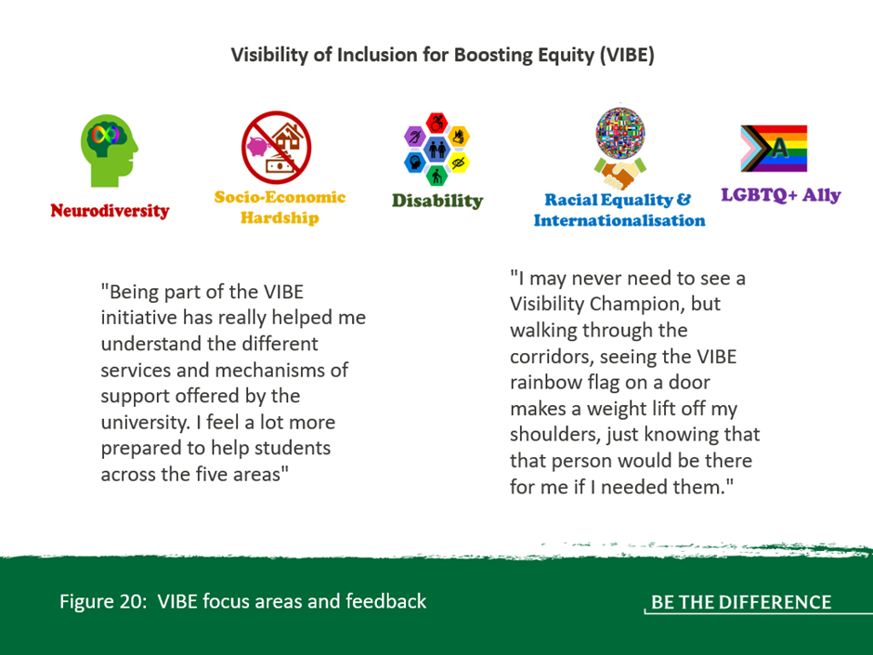

Providing a high-quality learning and teaching experience for all students, regardless of their background, is a core ambition of the University. We are proud to be a destination of choice for students, both home and internationally contributing to our vibrant student community.

Delivering a seamless learner journey and a high-quality student experience have remained at the core of institutional priorities throughout the turbulent period brought about by the pandemic. In 2021/22 the University developed a blended learning approach taking advantage of Technology Enabled Education (TEE) which focuses on engagement and connection by building and maintaining vibrant communities. Learning from the lessons of the pandemic this approach aims to retain and build on what was successful from online learning – considering the materials, resources and approaches that worked well digitally. Additionally, we have reviewed our approach to assessment, promoting authentic assessment and inclusive assessment by reducing our reliance on campus examinations which has been welcomed by many students with disabilities and specific learning difference. Accessibility of our online materials and website has also been improved and we have introduced laptop loans and free e-textbooks to improve accessibility and reduce the cost to students.

As a signatory of the Universities UK Fair Admissions Code of Practice, the University is committed to a fair and transparent admissions process that seeks to minimise barriers for applicants and address inequalities is outlined. Our approach to ensuring fair access is outlined in full within the Admissions Policy which also support recruitment of care-experience students, carers and estranged students.

Our Widening Access Strategy focuses on supporting success and identifies critical areas for expanding access, and our commitment is aligned with the Commission on Widening Access (CoWA) targets for 2026 and 2030.

In 2023/24, students continued to benefit from ICAS Foundation, Robertson Trust, and Reid Family Scholarships which offer critical financial support to Scottish students from widening participation backgrounds, helping with living costs and tuition fees. To date 42 students have benefitted from these scholarships, which form part of our wider offering in line with our ambition that our students feel supported and confident when embarking on their university career.

Stirling enrolled c.250 FTE undergraduate students from the 20% most deprived postcodes in Scotland in 2023/24, an increase from the previous year and reflective of 12% of our total undergraduate Scots intake. Students with a care experienced background represented 1.2% of our 2023/24 undergraduate intake. Outlined in our Corporate Parenting Plan, there is dedicated pre-application and transition support for care experienced students. The University continued to collaborate closely with the Scottish Wider Access Programmes (SWAP), as well as offering our own foundation Access courses. These part-time, campus-based courses are specifically designed for individuals with few or no formal qualifications. Along with subject-specific teaching, they provide tailored guidance, study strategies and support to ensure participants are university ready. The University recognises the importance of early engagement with students to build on and support students’ aspirations for higher education and continues to engage closely with all four SHEP agencies (LEAPS, Lift Off, Aspire North and Focus West). Additionally, the University has partnered with MCR pathways across the region to further support disadvantaged school pupils through a mentoring programme.

In partnership with Stirling Council, the University continues to offer guidance, information and on the different pathways into higher education for refugees and asylum seekers. Sanctuary Scholarships remained available for undergraduates (funded by the Carnegie Trust), postgraduates and students on Access courses in the UK who have applied for asylum or are staying in the UK as refugees or on humanitarian grounds. Additionally, the University maintained a key role in driving the activities of Scotland’s Community of Access and Participation Practitioners (SCAPP), as the host University for the Development Co-ordinator role. The network aims to support the development and professionalism of a strong widening access and participation community in Scotland, and by doing this embed, enhance and support effective practice in Scotland.

The University recognises the unique set of circumstances faced by estranged students, [care experienced students](https://www.stir.ac.uk/study/undergraduate/widening-participation/care-experienced-students/), and those with [caring responsibilities](https://www.stir.ac.uk/study/undergraduate/widening-participation/young-and-adult-carers/student-carers-policy/), and is committed to supporting these students throughout their student journey. Students can access comprehensive pre-application and transition support, and once they start at Stirling, they will be given a single point of contact to ensure an individualised package of support is implemented, including mental wellbeing support. The University has published a Student Carers Policy, which addresses the challenges that Student Carers may face, and it outlines the University’s commitment to providing support to this group of students. Additionally, the University was awarded the ‘Going Higher for Student Carers’ Recognition Award by Carers Trust Scotland.

We are committed to ensuring that our LGBTQ+ students and staff feel safe, respected and free to be themselves in their place of study and work. Students can access the LGBTQ+ Student Support Network which was created to provide tailored support for students who identify as lesbian, gay, bisexual or trans, and can also become a member of the student LGBTQ+ society. In 2022, the University’s Careers and Employability Service received a prestigious award from LGBT Youth Scotland. Achieving the LGBT Charter at Silver level recognised the hard work and dedication of staff to develop a comprehensive webpage on LGBT inclusion in the workplace which signposts to inclusive employers and resources, and welcomes training and the review of policies, practice and resources that aim to ensure that the Careers and Employability Service goes beyond meeting legislative needs and is as inclusive as it can be for students, staff and the wider community.

In a dedicated pulse survey in 2023, 92% of staff respondents reported feeling welcomed to the University upon joining, and 96% felt welcomed by their immediate team. Insights from this survey were used to enhance the induction experience for all staff, including the launch of our ‘Setting Up for Success’ induction event. This event is designed to help new colleagues feel part of the Stirling community by fostering connections, accelerating a sense of belonging, and creating opportunities for networking and collaboration.

Staff feedback also informed the development of an enhanced suite of induction resources. Created in collaboration with colleagues from across the University, these materials are designed to complement local induction activities and ensure all new staff have access to the information and support they need to settle in successfully. Key developments include a dedicated Induction Hub and improved resources for line managers to support the delivery of consistent and high-quality induction experiences.

We will continue to monitor the new joiner experience and take proactive steps to enhance it - ensuring every colleague feels valued, included, and part of the Stirling community from day one

# Appendix A – University of Stirling Staff Profile Overview data 2018-2024

**Gender**

*Table A: Overall Gender split at University*

*Table B: Gender Reassignment at University*

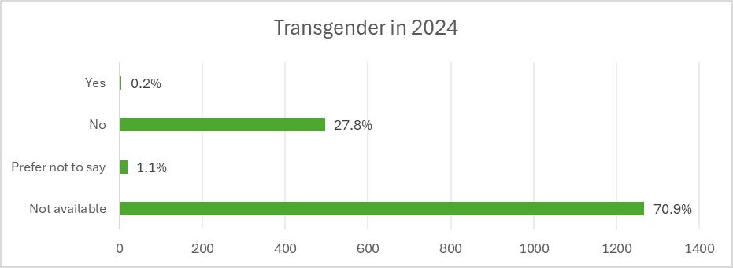

* The question set for Personal Characteristics was modernised in 2023 to bring it in line with national and sectoral standards. Staff are no longer asked whether their gender identity is the same as it was at birth, and they are now asked “Do you consider yourself to be trans or have a trans history?”. Therefore data for 2024 is only presented.

**Age**

*Table C: Overall Age Profile at University*

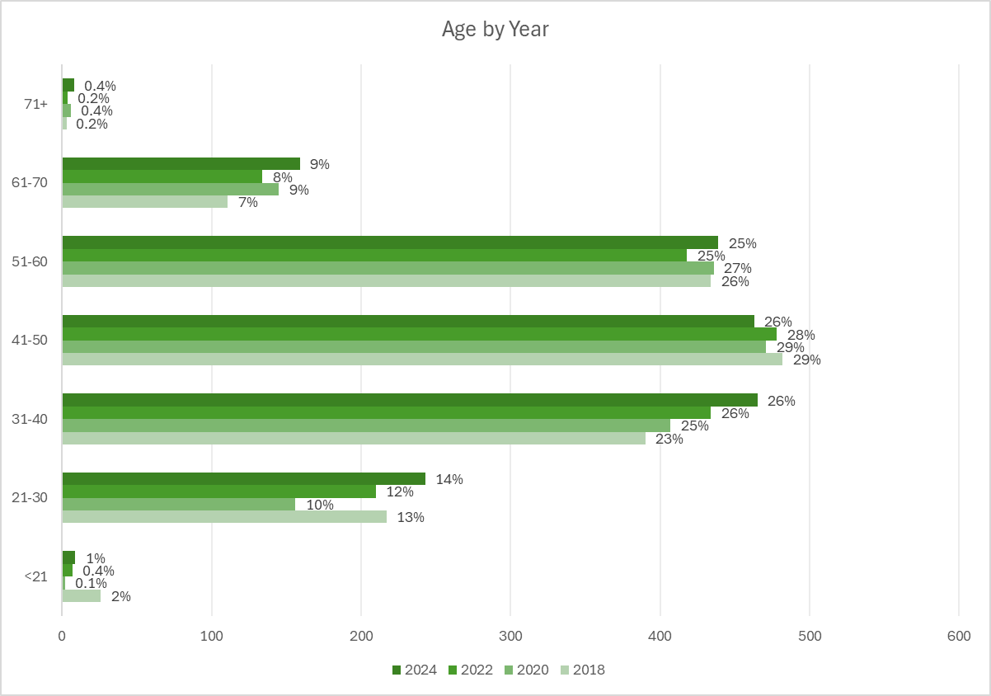

**Disability**

*Table D: Disability at University*

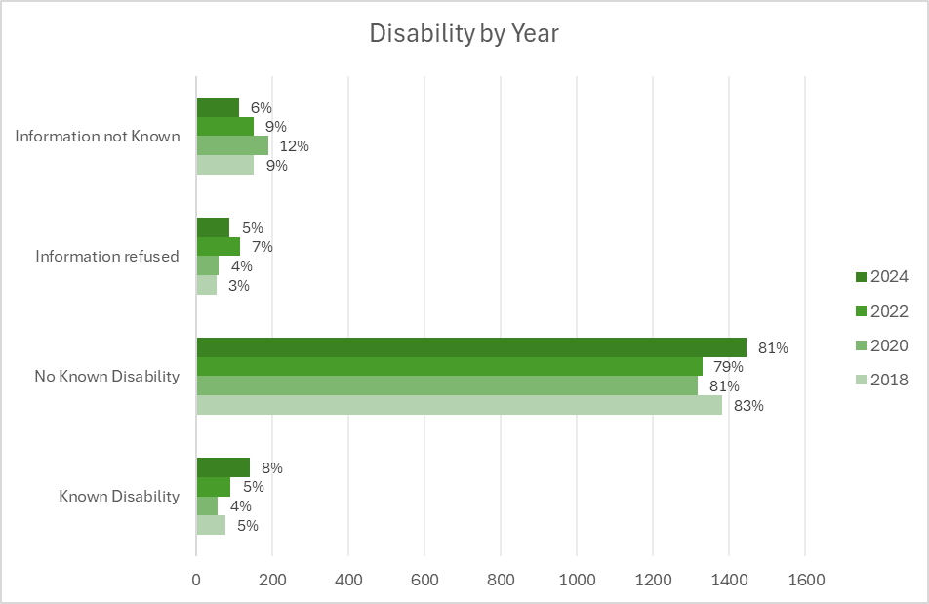

**Sexual Orientation**

*Table E: Sexual Orientation at University*

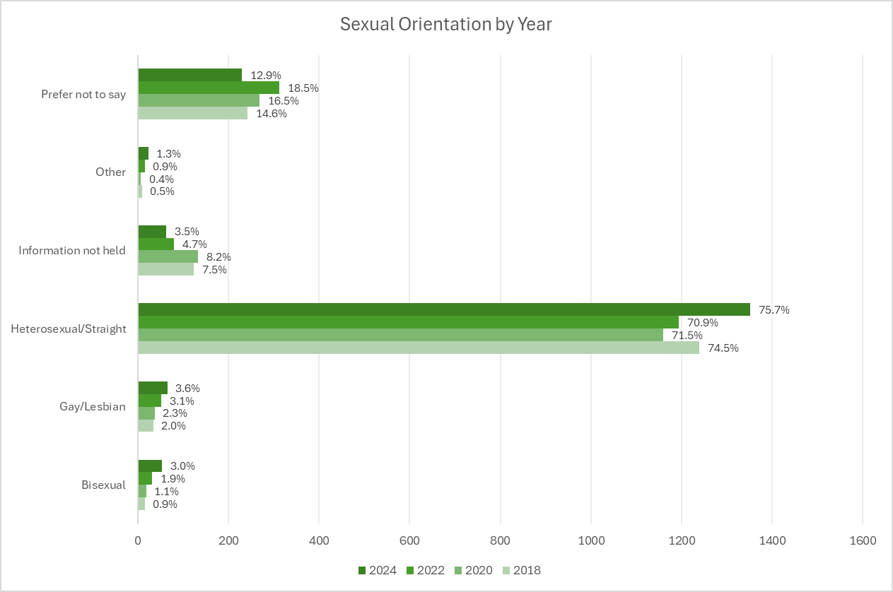

**Ethnicity**

*Table F: Ethnicity at University*

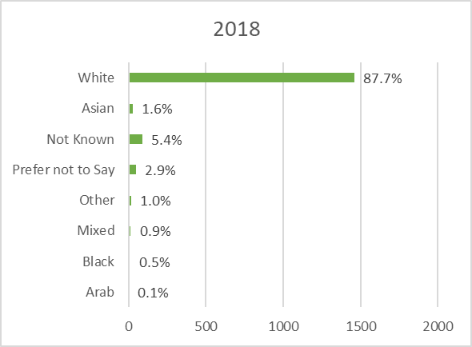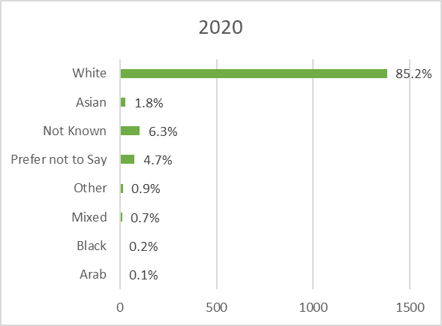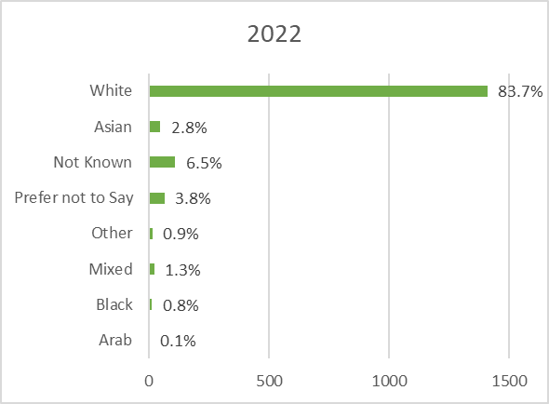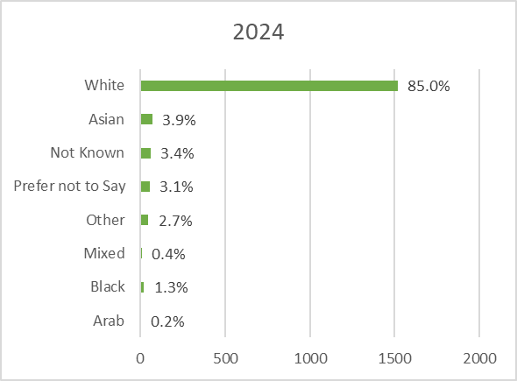

**Religion or Belief**

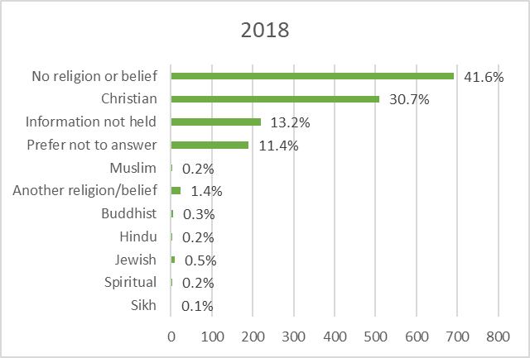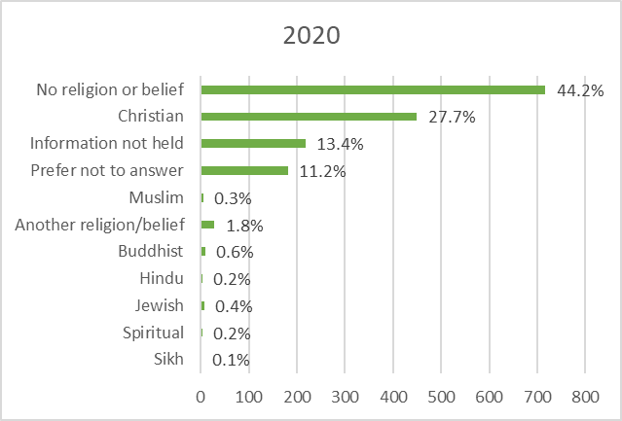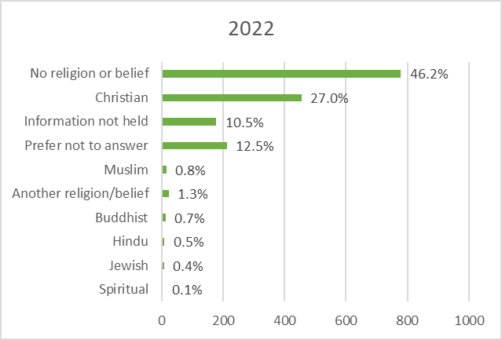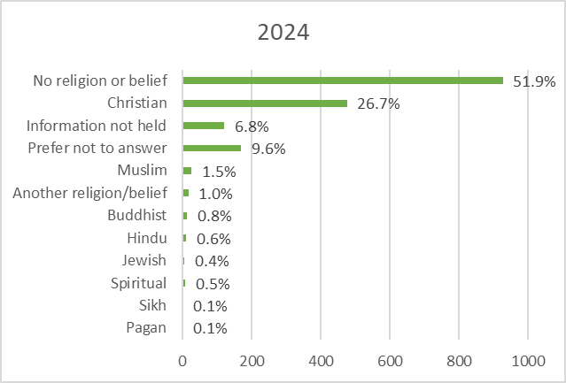

*Table G: Religion or Belief at University*

**New Staff from 1st August 2023 to 31 July 2024**

|  |  |  |
| --- | --- | --- |
| **Gender** | **Headcount** | **% of total** |
| Female | 290 | 57% |
| Male | 216 | 43% |
| **Age** | **Headcount** | **% of total** |
| <21 | 9 | 2% |
| 21-30 | 152 | 30% |
| 31-40 | 155 | 31% |
| 41-50 | 83 | 16% |
| 51-60 | 70 | 14% |
| 61-70 | 36 | 7% |
| 71+ | 1 | 0.2% |
| **Disability** | **Headcount** | **% of total** |
| Information not Known | 18 | 4% |
| Information refused | 58 | 11% |
| Known Disability | 65 | 13% |
| No Known Disability | 365 | 72% |
| **Ethnicity** | **Headcount** | **% of total** |
| Arab | 2 | 0.4% |
| Asian | 37 | 7% |
| Black | 15 | 3% |
| Mixed | 4 | 1% |
| Not Known | 28 | 6% |
| Other | 29 | 6% |
| Prefer not to Say | 15 | 3% |
| White | 376 | 74% |
| **Religion** | **Headcount** | **% of total** |
| Another religion/belief | 9 | 2% |
| Buddhist | 4 | 1% |
| Christian | 106 | 21% |
| Hindu | 6 | 1% |
| Information not held | 31 | 6% |
| Jewish | 2 | 0% |
| Muslim | 13 | 3% |
| No religion or belief | 269 | 53% |
| Pagan | 1 | 0% |
| Prefer not to answer | 64 | 13% |
| Sikh | 1 | 0.2% |
| **Sexual Orientation** | **Headcount** | **% of total** |
| Bisexual | 28 | 6% |
| Gay/Lesbian | 18 | 4% |
| Heterosexual/Straight | 355 | 70% |
| Information not held | 11 | 2% |
| Other | 7 | 1% |
| Prefer not to say | 87 | 17% |

**Leavers from 1st August 2023 to 31 July 2024**

|  |  |  |
| --- | --- | --- |
| **Gender** | **Headcount** | **% of total** |
| Female | 308 | 58% |
| Male | 227 | 42% |
| **Age** | **Headcount** | **% of total** |
| <21 | 6 | 1% |
| 21-30 | 138 | 26% |
| 31-40 | 144 | 27% |
| 41-50 | 91 | 17% |
| 51-60 | 90 | 17% |
| 61-70 | 63 | 12% |
| 71+ | 3 | 1% |
| **Disability** | **Headcount** | **% of total** |
| Information not Known | 433 | 81% |
| Information refused | 25 | 5% |
| Known Disability | 13 | 2% |
| No Known Disability | 64 | 12% |
| **Ethnicity** | **Headcount** | **% of total** |
| Arab | 1 | 0.2% |
| Asian | 21 | 3.9% |
| Black | 12 | 2.2% |
| Mixed | 4 | 0.7% |
| Not Known | 62 | 11.6% |
| Other | 24 | 4.5% |
| Prefer not to Say | 18 | 3.4% |
| White | 393 | 73.5% |
| **Religion** | **Headcount** | **% of total** |
| Another religion/belief | 7 | 1% |
| Buddhist | 4 | 1% |
| Christian | 116 | 22% |
| Hindu | 6 | 1% |
| Information not held | 43 | 8% |
| Jewish | 2 | 0% |
| Muslim | 5 | 1% |
| No religion or belief | 263 | 49% |
| Pagan | 1 | 0% |
| Prefer not to answer | 85 | 16% |
| Spiritual | 3 | 1% |
| **Sexual Orientation** | **Headcount** | **% of total** |
| Bisexual | 5 | 1% |
| Gay/Lesbian | 4 | 1% |
| Heterosexual/Straight | 59 | 11% |
| Information not held | 427 | 80% |
| Other | 1 | 0.2% |
| Prefer not to say | 39 | 7% |

1. The Equality Act 2010 (Specific Duties) (Scotland) Regulations 2012 includes duties relating to Board diversity. Scotland’s HEIs are subject to the duty to publish information about the sex of their board members.
2. As defined by Gender Representation on Public Boards (Scotland) Act 2018. The Gender Representation on Public Boards (Scotland) Act 2018 includes the following representation objective: a public board is to have 50% of non-executive members who are women.
3. We use HESA’s approach to the categorisation of students by ethnicity and ensure analysis by ethnicity is filtered to the UK-domiciled population in line with sector reporting.
4. The NSS underwent significant revision in 2023 and previous years data is not comparable.