“The labyrinth pattern is an archetypal form found all over the world. It dates back thousands of years. No one knows who created any of the labyrinth forms, but we do know from experience that embedded within each design is a pattern that somehow quiets our deep inner being……
Labyrinths are not mazes……..designed to make us lose our way……

Labyrinths have the exact opposite purpose: they are designed to help us find our way…….”

“The labyrinth offers a sacred and stable space to focus the attention and listen to the longing of the soul”

Rev Dr Lauren Artess, Veriditas, The World Wide Labyrinth Project

“The labyrinth is an effective spiritual tool, generic in nature, and personal in application. Most people who walk a labyrinth see the metaphor at once: it is like the twists and turns of their journey through life… It is a path which leads unfailingly (through circuitously) to the centre. It is a metaphor of journeying within to our deepest selves, to God.”
R Ferme

For further information contact: The Faith Centre/Chaplaincy
Tel: 01786 467164
Email: chap1@stir.ac.uk Website: www.chaplaincy.stir.ac.uk


LABYRINTH

A path of reflection
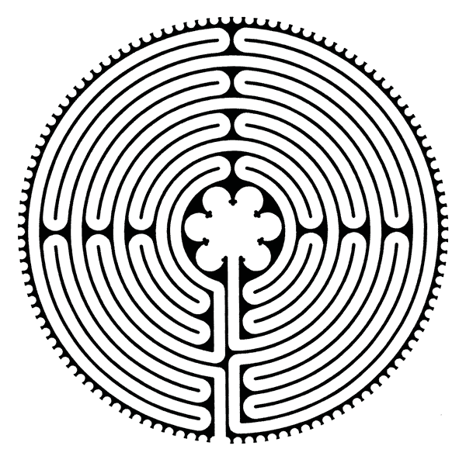

For all faiths and none
In its classical pattern, the labyrinth has been around for approximately 4,000 years. The pattern emerged around the shores of the Mediterranean, spreading north through Scandinavia and east along the Silk Route into Asia.

Labyrinths peaked in the late 15th Century but then fell out of favour. Today there is evidence of a revival and Stirling is one of a number of universities in Britain to have a labyrinth.

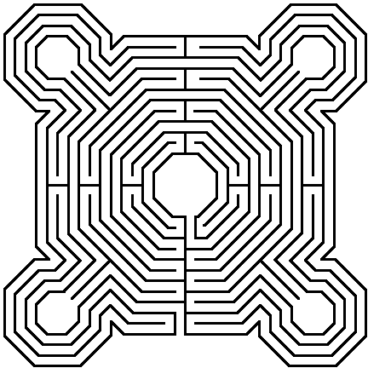

Slowly walking the path to the centre of the labyrinth and back out again gives you time to:

Slow down

Still the mind

Let go of everyday concerns

Renew inner calm

There are three stages of the walk:

Releasing (walking in)

Pause at the entrance. Breathe deeply, attentive to the stillness around you. As you begin your walk try to release and let go of what you do not need to carry. This attention to and letting go of thoughts and emotions begins to quieten the mind.

Receiving (at the centre)

When you arrive at the centre enjoy the space and stillness. Sit or stand, stay in there as long as you wish. It is a place of receiving.

Retrieving (walking out)

As you retrace your steps back out from the centre reflect on any insights or new thoughts and feelings. Attend to your inner spirit and walk back out open to an inner strengthening and renewing.
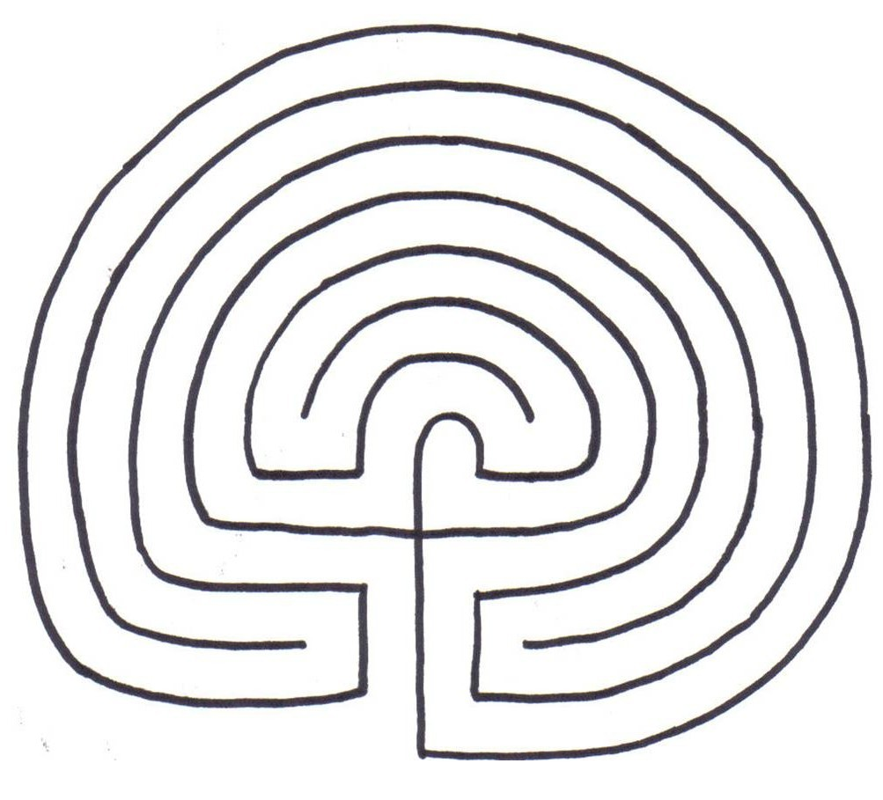

The new Labyrinth is on the north side of the campus, past Airthrey Castle and the golf academy. It is part of the memorial garden and the entrance gate is on the right, just before the entrance to Alexander Court.

